N35 – Ksp

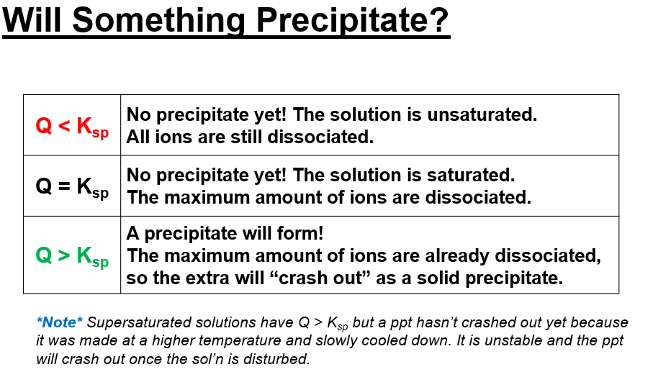

N35 – Ksp

N35 – Ksp

N35 – Ksp

N35 – Ksp

N35 – Ksp

N35 – Ksp

N35 – Ksp

