Unit 9 – SOLUTIONS – GLUE INS

N35 – Ksp

N33 - Solubility Trends

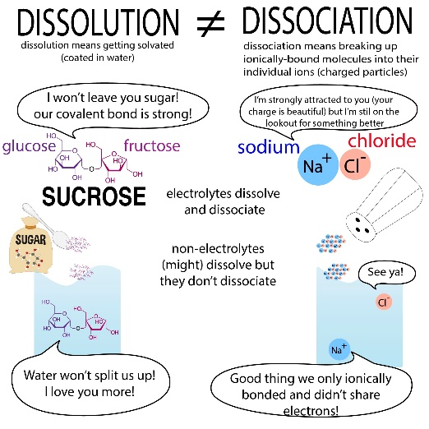

N32 – Heat of Solution

N31 – Separation Techniques and Concentration Calcs



