Name: Period: Seat#:
Worksheet #1

Write the definition and/or equation for each term and/or describe how it the technique works:
- Solute | - Solvent |  | - Solution |  | - Homogeneous |  | - Heterogeneous
- Filtration | - Decanting |  | - Distillation |  | - Paper Chromatography
- TLC Chromatography |  |  | - Column Chromatography |  |  |  | - Volumetric Flask
- Molarity (M) |  | - Molality (m) |  | - Mole Fraction (χ) |  | - Weight Percent (%)

Each of these concentrations involves grams or moles of solute, solvent, or solution. Determine those values based on the information at the top of the chart.
Assume you dissolve 2.56 g of malic acid, C₄H₆O₅, in half a liter of water (500.0 g).
Work and answer
- Molarity of acid in solution
- Molality of acid in solution
- Mole fraction of acid in solution
- Weight percentage of acid in solution
Fill in the blanks in the table. Aqueous solutions are assumed. Show all work.
Compound | Molarity | Weight Percent | Mole Fraction
NaI | 0.15
C₂H₄OH |  | 5.0
C₁₂H₂₂O₁₁ | 0.15

Separation Technique Questions – there are a few new ones mixed in! You can probably figure them out with common sense, otherwise look them up!
- Can be used to separate a mixture of Fe and Cu fillings  a) Magnetic separation  b) Crystallization  c) Evaporation  d) Distillation | - Could be used to separate aqueous CuSO₄ from water  a) Evaporation  b) Distillation  c) Chromatography  d) Decanting |  | - Could be used to separate tea from loose tea leaves  a) Chromatography  b) Decanting  c) Filtration  d) Crystallization
- A method of separation used to separate a mixture that comprises solutes that dissolve in the same solvent  a) Evaporation  b) Filtration  c) Chromatography  d) Sublimation | 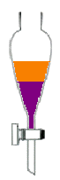  - Liquids that do not mix may be separated by using  a) a separating funnel  b) an evaporating dish  c) Liebig condenser  d) a filter funnel |  | - What type of chromatography should you use if you want to collect a purified sample of one of the components?  a) Paper  b) Thin Layer  c) Column
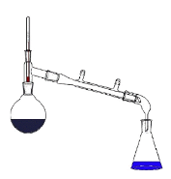  - What separation technique is shown below? | 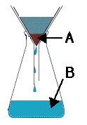  - The diagram shows the apparatus for separating solid and water. What are the labelled parts? |  | - The diagram shows the apparatus for separating solid and water. What are the labelled parts?
- Which two would be most easily separated via distillation?  Boiling Pts:  1 = 30°C  2 = 60°C  3 = 120°C  4 = 110°C | - The process of evaporating a liquid and then condensing the vapor by cooling it is known as  a) filtration  b) chromatography  c) decanting  d) distillation |  | - Chromatography separates chemicals based on differences in  a) mass  b) polarity  c) boiling point  d) particle size
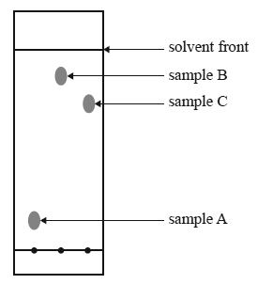  - The thin layer chromatography plate shown below has a polar stationary phase. It was developed using hexane as the solvent. Which sample is the most polar? |  | *Reminder*    Spend some time doing practice calculations from the honors chem version of the solutions chapter! There are lots of good practice problems there, no use in duplicating them onto this worksheet!  http://tinyurl.com/54kt53z3

