Name: Period: Seat#:
Worksheet #1

Write the definition and/or equation for each term and/or describe how the technique works. Some of these may be review from Honors Chem! If you don’t remember, then go back and review Honors!
- Solute | - Solvent |  | - Solution |  | - Homogeneous
- Heterogeneous | - Filtration |  | - Decanting |  | - Distillation
- Volumetric Flask | - Serial Dilution |  | - Dissolving |  | - Dissociating
- Saturated | - Unsaturated |  | - Supersaturated |  | - Electrolyte
- Paper Chromatography |  | - TLC Chromatography |  | - Column Chromatography
- Molarity (M) | - Molality (m) |  | - Mole Fraction (χ) |  | - Weight Percent (%)
Conceptual Questions
- Which of the following ionic compounds are insoluble in water? (Remember your solubility chart!) Explain what general “rule” from the chart gave you the clue that it was insoluble.  KCl, AgNO₃, BaSO₄, (NH₄)₃PO₃ | - Match each solute with its most appropriate solvent. Explain why you matched them the way you did.  Solute: Solvent:  Table Salt (NaCl) Pentane (C₅H₁₂)  Wax (C₃₁H₆₄₎ Butanol (C₄H₉OH)
- Which of these is NOT a solution? What is it instead? Explain/Define what it is since it isn’t a solution.  Clean air, Milk, Gatorade, Gold Alloy | - Which of these is NOT an electrolyte? Why is it not an electrolyte but the others are?  HCl, NaOH, NH₄Br, C₁₂H₂₂O₁₁

Separation Technique Questions – there are a few new ones mixed in!
You can probably figure them out with common sense, otherwise look them up!
- Can be used to separate a mixture of Fe and Cu fillings.  a) Magnetic separation  b) Crystallization  c) Evaporation  d) Distillation |  | - Could be used to separate aqueous CuSO₄ from water.  a) Evaporation  b) Distillation  c) Chromatography  d) Decanting |  | - Could be used to separate tea from loose tea leaves.  a) Chromatography  b) Decanting  c) Filtration  d) Crystallization
- A method used to separate a mixture that comprises solutes that dissolve in the same solvent.  a) Evaporation  b) Filtration  c) Chromatography  d) Sublimation |  | 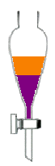  - Liquids that do not mix may be separated by using.  a) a separating funnel  b) an evaporating dish  c) Liebig condenser  d) a filter funnel |  | - What type of chromatography should you use if you want to collect a purified sample of one of the components?  a) Paper  b) Thin Layer  c) Column
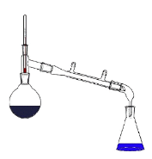  - What separation technique is shown below? | 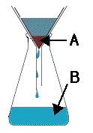  - The diagram shows the apparatus for separating solid and water. What are the labelled parts? |  | 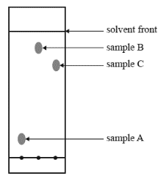  - The thin layer chromatography plate shown below has a polar stationary phase. It was developed using hexane as the solvent. Which sample is the most polar?
- Which two would be most easily separated via distillation?  Boiling Pts:  1 = 30°C  2 = 60°C  3 = 120°C  4 = 110°C |  | - The process of evaporating a liquid and then condensing the vapor by cooling it is known as  a) filtration  b) chromatography  c) decanting  d) distillation |  | - Chromatography separates chemicals based on differences in  a) mass  b) polarity  c) boiling point  d) particle size
- Describe three common lab errors that often occur during the filtering process. Explain whether each error would lead to a higher or lower % yield. |  |  |  |  | - Very helpful chromatography video to watch. Please watch!  http://tinyurl.com/3r33yuyc  

