**Name: Period: Seat#:**

**Worksheet #6**

~~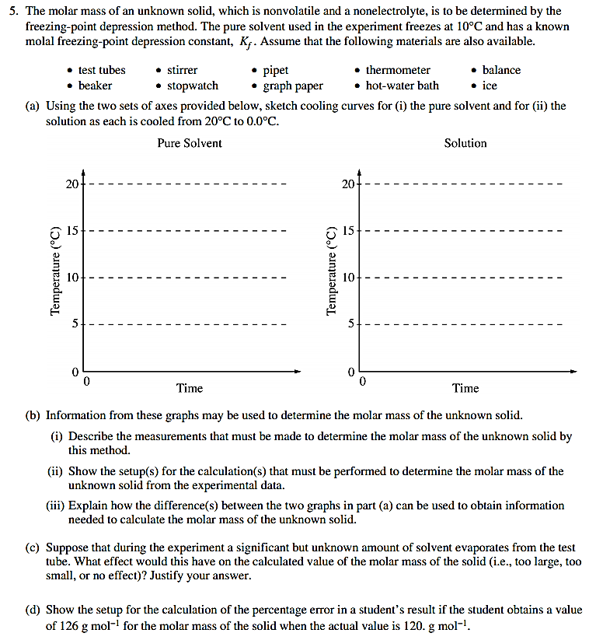2000~~

~~1991~~

~~B~~

2. The molecular formula of a hydrocarbon is to be determined by analyzing its combustion products and investigating its colligative properties.

(a) The hydrocarbon burns completely, producing 7.2 grams of water and 7.2 liters of CO2 at standard conditions.

(b) Calculate the mass in grams of O2 required for the complete combustion of the sample of the hydrocarbon described in (a).

(c) The hydrocarbon dissolves readily in CHCl3. The freezing point of a solution prepared by mixing 100. grams of CHCl3 and 0.600 gram of the hydrocarbon is -64.0 °C. The molal freezing-point depression constant of CHCl3 is 4.68 °C / molal and its normal freezing point is -63.5 °C. Calculate the molecular weight of the hydrocarbon.

(d) What is the molecular formula of the hydrocarbon?

~~1980~~

~~B~~

3. (a) A solution containing 3.23 grams of an unknown compound dissolved in 100.0 grams of water freezes at -0.97 °C. The solution does not conduct electricity. Calculate the molecular weight of the compound. (The molal freezing point depression constant for H2O is 1.86 °C kg mole¯1.)

(b) Elemental analysis of this unknown compound yields the following percentages by weight:   
H = 9.74%; C = 38.70%; O = 51.56%. Determine the molecular formula of the compound.

(c) Complete combustion of a 1.05-gram sample of the compound with the stoichiometric amount of oxygen gas produces a mixture of H2O(g) and CO2(g). What is the pressure of this gas when it is contained in a 3.00-liter flask at 127 °C?

~~1993~~

~~A~~

2. Elemental analysis of an unknown pure substance indicates that the percent composition by mass is as follows:

Carbon - 49.02%

Hydrogen - 2.743%

Chlorine - 48.23%

A solution that is prepared by dissolving 3.150 grams of the substance in 25.00 grams of benzene, C6H6, has a freezing point of 1.12°C. (The normal freezing point of benzene is 5.50°C and the molal freezing-point depression constant, Kf, for benzene is 5.12 C°/molal.)

(a) Determine the empirical formula of the unknown substance.

(b) Using the data gathered from the freezing point depression method, calculate the molar mass of the unknown substance.

(c) Calculate the mole fraction of benzene in the solution described above.

(d) The vapor pressure of pure benzene at 35°C is 150. millimeters of Hg. Calculate the vapor pressure of benzene over the solution described above at 35°C.

~~1998~~

~~B~~

2. An unknown compound contains only the three elements C,H, and O. A pure sample of the compound is analyzed and found to be 65.60 percent C and 9.44 percent H by mass.

(a) Determine the empirical formula of the compound.

(b) A solution of 1.570 grams of the compound in 16.08 grams of camphor is observed to freeze at a temperature 15.2 Celsius degrees below the normal freezing point of pure camphor. Determine the molar mass and apparent molecular formula of the compound. (The molal freezing-point depression constant, Kf, for camphor is 40.0 kg-K-mol¯1.)

(c) When 1.570 grams of the compound is vaporized at 300 °C and 1.00 atmosphere, the gas occupies a volume of 577 milliliters. What is the molar mass of the compound based on this result?

(d) Briefly describe what occurs in solution that accounts for the difference between the results obtained in parts (b) and (c).

1975

D

~~1984~~

~~C~~

~~1994~~

~~D~~

14. Alcohol dissolves in water to give a solution that boils at a lower temperature than pure water. Salt dissolves in water to give a solution that boils at a higher temperature than pure water. Explain these facts from the standpoint of vapor pressure.

4. Give a scientific explanation for the following observations. Use equations of diagrams if they are relevant.

(a) It takes longer to cook an egg until it is hard-boiled in Denver (altitude 1 mile above sea level) than it does in New York City (near sea level).

(b) Burning coal containing a significant amount of sulfur leads to "acid rain."

(c) Perspiring is a mechanism for cooling the body.

(d) The addition of antifreeze to water in a radiator decreases the likelihood that the liquid in the radiator will either freeze or boil.

5. Discuss the following phenomena in terms of the chemical and physical properties of the substances involved and general principles of chemical 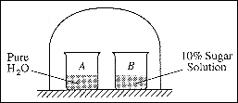and physical change.

(a) As the system shown on the right approaches equilibrium, what change occurs to the volume of water in beaker A ? What happens to the concentration of the sugar solution in beaker B ? Explain why these changes occur.

(b) A bell jar connected to a vacuum pump is shown on the right. As the air pressure under the bell jar decreases, what behavior of water in the beaker will be observed? Explain why this 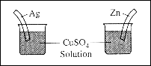occurs.

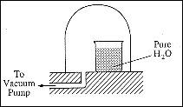

(c) What will be observed on the surfaces of zinc and silver strips shortly after they are placed in separate solutions of CuSO4, as shown on the right. Account for these observations.

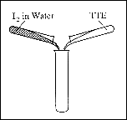

(d) A water solution of I2 is shaken with an equal volume of a nonpolar solvent such as TTE (trichlorotrifluoroethane). Describe the appearance of this system after shaking. (A diagram may be helpful.) Account for this observation.