Name: Period: Seat#:
Worksheet #6

Conceptual Questions
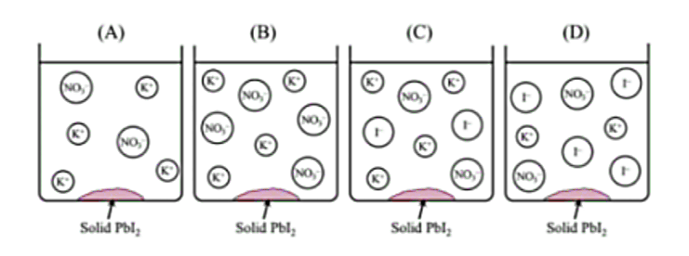
- A student mixes a solution of Pb(NO₃)₂(aq) with an excess amount of KI(aq). A precipitate of PbI₂(s) is formed. Which of the following particle diagrams accurately represents the major ionic species remaining in the solution after the reaction has been completed?
I-
I-
I-
I-
I-
I-
K+
K+
K+
K+
K+
K+
K+
K+
K+
K+
K+
K+
K+
NO₃-
NO₃-
NO₃-
NO₃-
NO₃-
NO₃-
NO₃-
NO₃-
NO₃-
NO₃-
K+
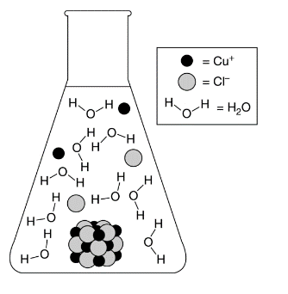
- The particle diagram shown represents the dissolution of CuCl(s) assuming an equilibrium concentration for Cu⁺ ions of about 4 x 10⁻⁴ M in a saturated solution at 25°C. The equilibrium being represented is shown in the following chemical equation: CuCl(s) ↔ Cu⁺(aq) + Cl⁻(aq) Which of the following changes to the particle diagram will best represent the effect of adding 1.0 mL of 4M NaCl to the solution?
- Some of the Cu⁺ and Cl⁻ ions combine to form CuCl(s)
because the K_{sp} will be lower than 1.6 x 10⁻⁷
- Some of the Cu⁺ and Cl⁻ ions combine to form CuCl(s)
because the molar solubility will be lower than 4 x 10⁻⁴ M
- More Cu⁺ and Cl⁻ ions will be in solution because
the molar solubility will be higher than 4 x 10⁻⁴ M
- More Cu⁺ and Cl⁻ ions will be in solution because
the K_{sp} will be higher than 1.6 x 10⁻⁷.

Net Ionic and Particle Diagram Questions: For the following reactions below write/draw:
- Balanced equation (make sure to predict the products and write good neutral formulas! WITH PHASES!)
- Balanced ionic equation (if applicable)
- Balanced net ionic equation (if applicable)
- Particle diagram (make sure to show the spectator ions that are in solution. If you are told a concentration, then have each circle represent one mole of the substance. Make sure the placement of the particles is representative of the phase that they are in.)

Example: 3.0 M aqueous sodium chloride and 3.0 aqueous silver nitrate will combine to produce...
- NaCl(aq) + AgNO₃(aq) NaNO₃(aq) + AgCl(s)
- Na⁺(aq) + Cl⁻(aq) + Ag⁺(aq) + NO₃⁻(aq) Na⁺(aq) + NO₃⁻(aq) + AgCl(s)
- Cl⁻(aq) + Ag⁺(aq) AgCl(s)
- +
AgCl
AgCl
AgCl
NO₃⁻
NO₃⁻
Na⁺
Na⁺
NO₃⁻
Na⁺
NO₃⁻
NO₃⁻
NO₃⁻
Ag⁺
Ag⁺
Ag⁺
Cl⁻
Na⁺
Na⁺
Na⁺
Cl⁻
Cl⁻

- 2.0 M potassium sulfide reacts with 2.0 M calcium chloride.

+

- 1.0 M ammonium bromide reacts with 2.0 M silver nitrate.

+

- 2.0 M carbon monoxide and 2.0 M diatomic oxygen combine to form carbon dioxide

+

- Calcium iodide reacts with ammonium carbonate.

+

- Silver chloride and a 2nd product is produced when starting with silver nitrate and a calcium containing compound.

+

Net Ionic Questions: For the following reactions below write/draw:
- Balanced equation (make sure to predict the products and write good neutral formulas! WITH PHASES!)
- Balanced ionic equation (if applicable)
- Balanced net ionic equation (if applicable)
- Particle diagram is optional if you feel like you need more practice than go ahead and draw some!

- _______Al(s) + _______Pb(NO₃)₂(aq) →

- _______Cl₂(g) + _______NaBr(aq) →

- _______Na(s) + _______H₂O(l) →

- _______Ag(s) + _______Fe(C₂H₃O₂)₂ →

- _______Cd₃(PO₄)_{2(aq)} + _______ (NH₄)₂S_{(aq)} →

- A solution of silver nitrate with a solution of potassium chloride →

- _______Na₂CO_{3(aq)} + _______H₂SO_{4(aq)} → _______ H₂O + _______ CO₂ +

- _______Al₂(SO₄)_{3(aq)} + _______Ca₃(PO₄)_{2(aq)} →

- Silver acetate plus potassium chromate →

- A solution of ammonium carbonate is mixed with a solution of calcium acetate

- A solution of sodium chromate is mixed with a solution of barium sulfate

