Name: Period: Seat#:
Worksheet #9

Perform the following calculations, be sure to include units and show work to an AP level.
- The molar solubility of NiCO₃ is 3.74 x 10⁻⁴ mol/L. Find the Ksp value. 1.4 x 10⁻⁷ | - The molar solubility of Ca(OH)₂ is 6.875 x 10⁻³ mol/L. Calculate the Ksp value. 1.3 x 10⁻⁶
- The Ksp of Ag₃PO₄ is 1.8 x 10⁻¹⁸.What is the [Ag⁺] in a saturated solution? 4.82 x 10⁻⁵ M | - Mg₃(AsO₄)₂(s) ⇌ 3 Mg²⁺(aq) + 2 AsO₄^{3–}(aq)  The solubility of magnesium arsenate is very low. Based on this, which of the following is/are true?  a) There is a significant [AsO₄³⁻] in solution  b) Almost all of the salt remains in its solid form  c) At equilibrium, there is almost no Mg₃(AsO₄)₂ left
- The Ksp for lead (II) phosphate is 1.0 x 10⁻⁵⁴. Calculate:
  - Molar solubility

  - The [PO₄³⁻] in a saturated solution

  - and the solubility in grams per liter.

6.21 x 10⁻¹² mol/L, 1.24 x 10⁻¹¹ M, 5.04 x 10⁻⁹ g/L
- The Ksp for PbF₂ is 4.0 x 10⁻⁸. Calculate:
  - Molar solubility in a solution of 0.5 M NaF

  - Molar solubility in water.

  - Explain the difference in solubility that you calculated.

1.6 x 10⁻⁷ mol/L, 2.15 x 10⁻³ mol/L
- The Ksp of Mg(OH)₂ is 1.8 x 10⁻¹¹. What effect would each of the following changes will have on the solubility of Mg(OH)₂ in an aqueous solution? Explain.
- Decrease the pH
- Increasing the pH
- Adding NH₃ to the solution
- Adding Mg(NO₃)₂ to the solution
- Based on Le Chatelier’s principle, explain what will happen to the solubility of AgCN when
a) HClO₄ is added to the solution
b) NaCN is added to the solution
- Based on Ksp values, which has a greater molar solubility between MgF₂ (Ksp = 5.16 x 10⁻¹¹) and
PbI₂ (Ksp = 9.8 x 10⁻⁹)? Justify your answer.
- Based on Ksp values, which has a greater molar solubility between MgF₂ (Ksp = 5.16 x 10⁻¹¹) and
MgCO₃ (Ksp = 3.5 x 10⁻⁸). Justify your answer.

- Based on the Ksp values in the table below, a saturated solution of which of the following would have the highest concentration of chloride ions? Justify your answer.
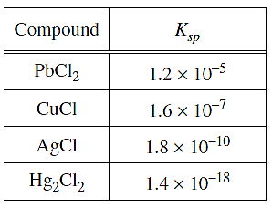
- Identify the compound that has the smallest Ksp value from the following general ionic compounds and their molar solubilities in pure water.
a) M₂X, molar solubility = 3.52 x 10⁻⁴ M
b) MX₃, molar solubility = 2.54 x 10⁻⁴ M
c) MX, molar solubility = 4.23 x 10⁻⁴ M
- What is the required minimum pH to completely precipitate Cd(OH)₂ (Ksp = 2.5 x 10⁻¹⁴) so that the remaining concentration of Cd²⁺(aq) is less than 1.0 part per billion (1 ppb = 1 μg/L, 1 μg = 1x10⁻⁶ g)? pH 11.22
- The [Pb²⁺] and [AsO₄³⁻] in a certain saturated Pb₃(AsO₄)₂ solution are both equal to 8.3 x 10⁻⁸. In a saturated solution with [Pb²⁺] = 0.0200 M, what is [AsO₄³⁻]? 7.0 x 10⁻¹⁶ M
- Lead (II) chloride, PbCl₂, is a sparingly soluble salt with a solubility product (Ksp) of 1.60 x 10⁻⁵ at 25°C. Calculate the molarity of a saturated solution of PbCl₂ at 25°C. 0.0159 M
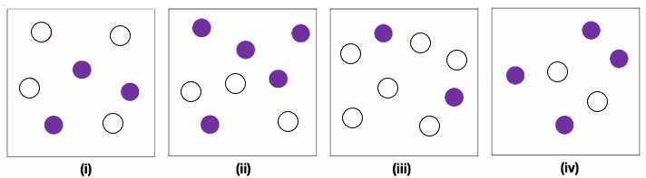
- The images below show solutions of Cu₂CO₃ where the grey spheres represent the Cu⁺ ions, and white spheres represent the CO₃²⁻ ions. Note that other ions may be present in the solution but are not shown. Image (i) shows the solution in equilibrium with solid Cu₂CO₃.

- Using diagram (i) calculate the value of Ksp for Cu₂CO₃

- Calculate the Q values for diagrams (ii) – (iv)

- Which of the solutions shown in images (ii) – (iv) will form a solid Cu₂CO₃ precipitate? Explain.

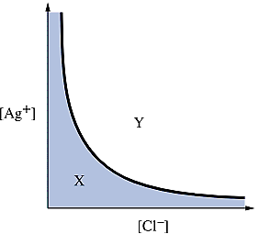
- The curve below represents the concentrations of Ag⁺(aq) and Cl⁻(aq) for which the product [Ag⁺][Cl⁻] is equal to the value of Ksp for AgCl. Which of the following provides the correct comparison of Q and Ksp, and describes the overall process that occurs at any point in the unshaded region Y of the graph?
  - Q > Ksp and dissolution of AgCl(s) occurs
  - Q < Ksp and dissolution of AgCl(s) occurs
  - Q > Ksp and precipitation of AgCl(s) occurs
  - Q < Ksp and precipitation of AgCl(s) occurs
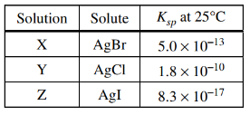
- Three saturated solutions (X, Y, and Z) are prepared at 25°C. Based on the information in the table above, which of the following lists the solutions in order of increasing [Ag⁺]?
  - X < Z < Y
  - Y < X < Z
  - Z < Y < X
  - Z < X < Y
- Which of the following ranks the compounds listed in the table above in order of increasing solubility?
  - Cu(OH)₂ < Co(OH)₂ < FeOH
  - FeOH < Cu(OH)₂ < Co(OH)₂
  - Co(OH)₂ < FeOH < Cu(OH)₂
  - Cu(OH)₂ < FeOH < Co(OH)₂

