N31

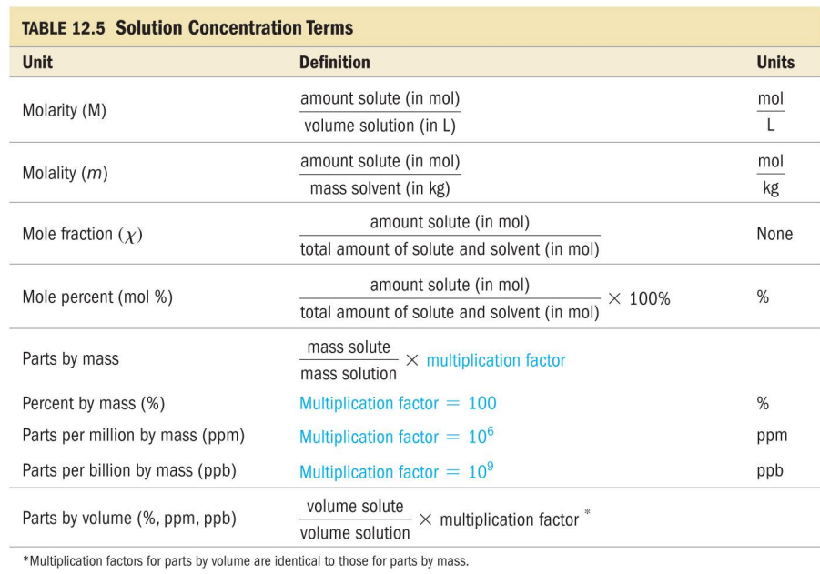

N31



N31



N31



N31



N31

