N33   
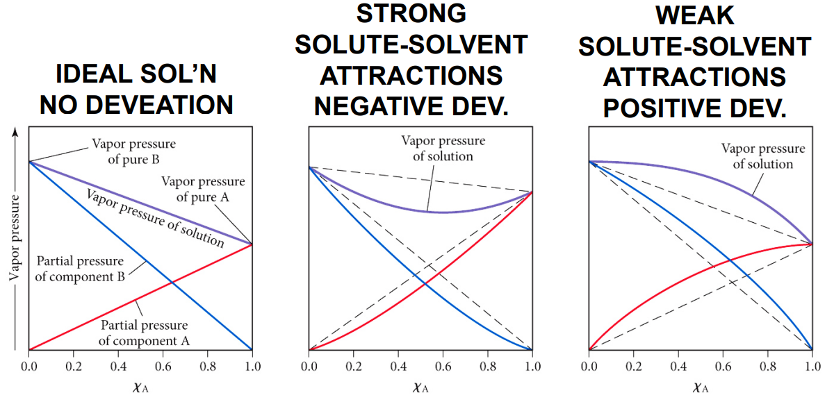

N33   


N33   


N33   


N33   


N33   


N33   


N33   
