Name: Period: Seat#:
Worksheet #4

Directions: Show all work. Box final answers.

- At 333 K, substance A has a vapor pressure of 1.0 atm and substance B has a vapor pressure of 0.20 atm. A solution of A and B is prepared and allowed to equilibrate with its vapor. The vapor is found to have equal moles of A and B. What was the mole fraction of A in the original solution? x = 0.17

- 30.0 mL of pentane (C₅H₁₂, d = 0.626 g/mL, v.p. = 511 torr) and 45.0 mL of hexane (C₆H₁₄, d = 0.655 g/mL, v.p. = 150. torr) are mixed at 25.0 ° C to form an ideal solution.
  - Calculate the vapor pressure of this solution. 307 torr
  - Calculate the composition (in mole fractions) of the vapor in contact with this solution.
Pentane: 0.724, hexane: 0.276

- What is the vapor pressure (in mmHg) of a solution of 4.40 g of Br₂ in 101.0 g of CCl₄ at 300 K? The vapor pressure of pure bromine at 300 K is 30.5 kPa and the vapor pressure of CCl₄ is 16.5 kPa. 128 mmHg

- A solution has a 1:3 ratio of cyclopentane to cyclohexane. The vapor pressures of the pure compounds at 25 °C are 331 mmHg for cyclopentane and 113 mmHg for cyclohexane. What is the mole fraction of cyclopentane in the vapor above the solution? 0.494

- Acetone and ethyl acetate are organic liquids often used as solvents. At 30.0 °C, the vapor pressure of acetone is 285 mmHg and the vapor pressure of ethyl acetate is 118 mmHg. What is the vapor pressure at 30.0 °C of a solution prepared by dissolving 25.0 g of acetone in 22.5 g of ethyl acetate? 223 mmHg
>> Special bonus question for fun! Determine the composition (expressed in mole fraction) of the vapor above
this solution acetone: 0.8028, ethyl acetate: 0.1972

- A solution containing hexane and pentane has a pressure of 252.0 torr. Hexane has a pressure at 151.0 torr and pentane has a pressure of 425.0 torr. What is the mole fraction of pentane? 0.3686

- The vapor pressure above a solution of two volatile components is 745 torr and the mole fraction of component B (χ_{B}) in the vapor is 0.59. Calculate the mole fraction of B in the liquid if the vapor pressure of pure B is 637 torr. 0.69

- Label each diagram with whether it is showing a strong solute-solvent interaction, or a weak solute-solvent interaction. The dashed line is the ideal solution.

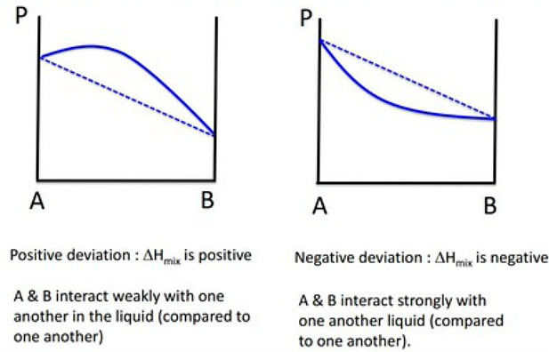
Strong or Weak
Solute-solvent interaction ? ________________ ________________

- Draw a particulate diagram showing the difference between a pure solvent and a solution made by adding a nonvolatile solute to the pure solvent, and then a new solution made by adding a volatile solute to the pure solvent. Make sure to include a color coded key indicating which particles are which.

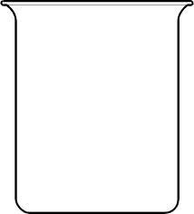
Key:
Solvent
Nonvolatile solute
Volatile solute

Pure Solvent + Nonvolatile Solute + Volatile Solute

- Draw a particulate diagram showing the difference between a pure solvent and a solution made by adding an electrolyte and a non-electrolyte. Make your own key to indicate which particles are which.

Key:

Pure Solvent + Electrolyte + Non-electrolyte

