**Name: Period: Seat#:**

**Worksheet #5**

**Directions:** Show all work and/or annotate with an AP Chem level explanation for non-math answers.

**1999 NChO Exam**

1. The aqueous solubilities of several compounds between temperatures of 0 °C and 80 °C are shown in this diagram. Which compound can be recovered with the highest percent yield by dissolving a sample in water at 80 °C and cooling to 0 °C?
   1. 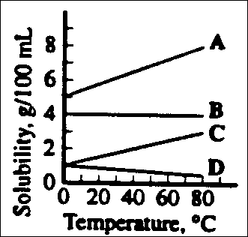A
   2. B
   3. C
   4. D

**13.** What is the molarity of the chloride ion in 250 mL of a solution containing 1.90 g of MgCl2? (The molar mass of MgCl2 is 95.2 g mol¯1

(A) 0.020 M

(B) 0.040 M

(C) 0.080 M

(D) 0.16 M

**15.** What is the molarity of an H2SO4 solution if

25.00 mL is exactly neutralized by 32.63 mL of

0.164 M NaOH?

(A) 0.107 M

(B) 0.126 M

(C) 0.214 M

(D) 0.428 M

**1998 NChO Exam**

**1.** Which gas is most soluble in water?

* 1. ammonia
  2. hydrogen
  3. methane
  4. nitrogen

**11.** What volume of 0.15 M HCl can be made from 7.5 mL of concentrated HCl (12M)?

(A) 0.060 L

(B) 0.60 L

(C) 6.0 L

(D) 6.0 x 102 L

**13.** How many moles of Mg(OH)2 can be precipitated when 15 mL of 0.20 M MgCl2 solution is mixed with 25 mL of 0.18 M KOH?

(A) 0.0015 mol

(B) 0.0022 mol

(C) 0.0030 mol

(D) 0.0045 mol

**15.** A student wants to prepare 250. mL of 0.10 M NaCl solution. Which procedure is most appropriate? (The molar mass of NaCl is 58.4 g mol¯1)

1. Add 5.84 g of NaCl to 250. mL of H2O
2. Add 1.46 g of NaCl to 250. mL of H2O
3. Dissolve 5.84 g of NaCl in 50 mL of H2O and dilute to 250. mL.
4. Dissolve 1.46 g of NaCl in 50 mL of H2O and dilute to 250. mL.

**34.** Which species dissociates most completely in water solution?

(A) NH4+

(B) H2CO3

(C) HNO3

(D) HSO4-

**35.** When one mole of (NH4)2HPO4(s) dissolves in water, the number of moles of ions present is closest to which value?

* 1. 16
  2. 8
  3. 4
  4. 3

**60.** Which compound is most soluble in water?

* 1. ethylamine
  2. chlorobenzene
  3. methyl acetate
  4. pentane

**1997 NChO Exam**

**1.** Which gas is least soluble in water?

* 1. H2
  2. CO2
  3. NH3
  4. SO2

**13.** What mass of calcium chloride hexahydrate must be dissolved in sufficient water to prepare 200 mL of a solution with a chloride ion concentration of 0.50M? The molar mass of CaCl2 **.** 6H2O is 219 g mol¯1

* 1. 5.6 g
  2. 11 g
  3. 22 g
  4. 44 g

**14.** The major commercial source for bromine is deep brine wells in Arkansas where the concentration of bromide ion can be as high as 5000 parts per million by mass. What is this concentration when expressed as a mass percentage?

(A) 0.005%

(B) 0.05%

(C) 0.5%

(D) 5%

**25.** When Na2S2O3 **.** 3H2O dissolve in water, the solution gets cold. Which energy diagram best represents the behavior of this solution process?

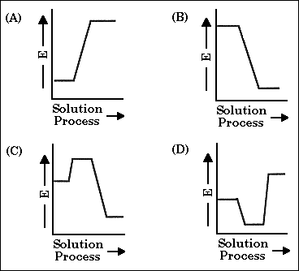

Answers

*1999 1998 1997*

6) C 1) A 1) A

13) D 11) B 13) B

15) A 13) B 14) C

15) D 25) A

34) C

35) D

60) A