Dissolves, but doesn’t dissociate (most or all of the time)
HNO₂
HClO₂
H₂CO₃
HF
C₆H₁₂O₆
CH₃OH
C₂H₅OH
H₃PO₄
Weak Acids
Soluble Covalent Compounds
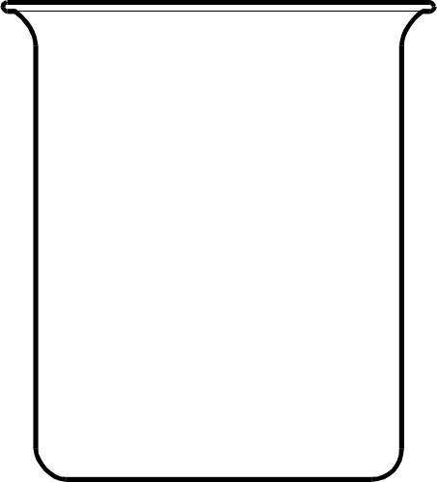

Doesn’t dissolve or dissociate (most or all of the time)
PbI₂
BaSO₄
AgCl
Mg(OH)₂
Ag₂CrO₄
Ca₃(PO₄)₂ (bones)
Al(OH)₃
Cu(OH)₂
Ni(OH)₂
Weak Bases
Insoluble Ionic Compounds

Dissolves AND dissociates completely
HNO₃
HCl
HClO₄
HClO₃
HI
HBr
NaCl
K₃PO₄
Ni(C₂H₃O₂)₂
AgNO₃
NaOH
LiOH
(NH₄)₂SO₄
Strong Acids
Strong Bases
Soluble Ionic Compounds
Strong electrolyte

