Endothermic Process
Converts heat energy into potential energy
ΔH_{RXN} = +
Potential energy of the products is higher than the potential energy of the reactants
Heat energy is required (or some other form – maybe electrical)
The surroundings get colder
Energy is written on reactant side of the reaction
Ice melting

A piece of copper heating up from 25ºC to 29ºC
Water boiling
Mix 2 solutions that react and the temperature of the solutions gets colder
Energy is transferred from the surroundings to the system
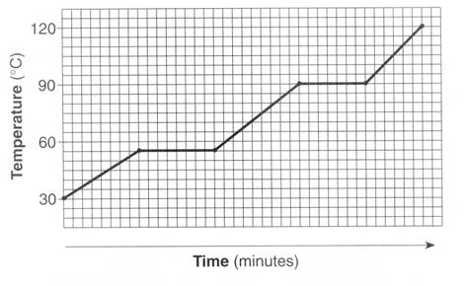
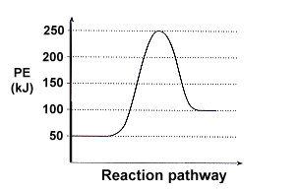

Exothermic Process
Converts potential energy into heat energy
ΔH_{RXN} = -
Potential energy of the products is lower than the potential energy of the reactants
Heat energy is released
The surroundings get warmer
Energy is written on product side of the reaction
Bomb exploding
Water freezing
Water condensing
A piece of copper cooling down from 29ºC to 25ºC
Combustion
Mix 2 solutions that react and the temperature of the solutions gets warmer
Energy is transferred from the system to the surroundings
