Ionic
Electrons are transferred
Forms a crystal lattice
Smallest part is called a formula unit
Metal + nonmetal
Metal + polyatomic ion
Polyatomic ion + nonmetal
Polyatomic ion + polyatomic ion
Brittle
Electrolyte when in aqueous or liquid phases
Lewis structure is depicted like so:
A B
Strength of bonds is measured by lattice energy
High electronegativity difference between bonding elements
When dissolved:
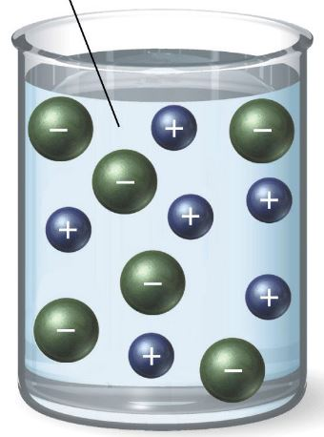
Formed from the electrostatic attraction of oppositely charged ions
High ionic character

Covalent
Electrons are shared
Smallest part is called a molecule
May be polar or nonpolar
Formed from all nonmetals
Nonelectrolytic when dissolved
Lewis structure is depicted like so:
A B
May have single, double, or triple bonds
Strength of bonds is measured by bond energy
Low electronegativity difference between bonding partners
Bonding within polyatomic ions
When dissolved:
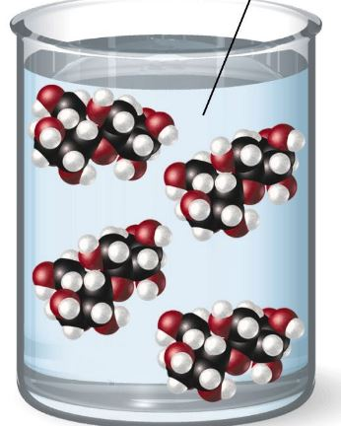
Nonelectrolyte in all phases of matter
Formed from the electrostatic attraction of 2 nuclei for shared electrons
Low ionic character

