Midpoint of a weak acid titration
pH = pK_{a}
half of the acid has been neutralized
[HA] = [A⁻]
The identity of the substance being titrated might be determined based on Ka
Occurs at half the VOLUME that the other point occurs at
Is in the middle of the buffer region of a titration curve
pH doesn’t change much around this point.
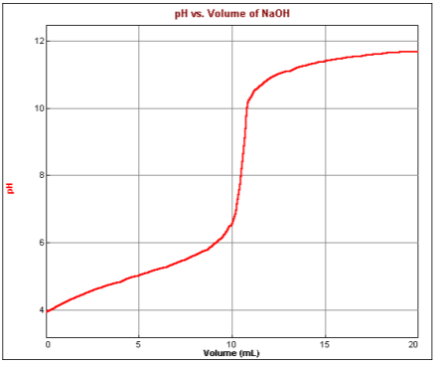
Half equivalence point
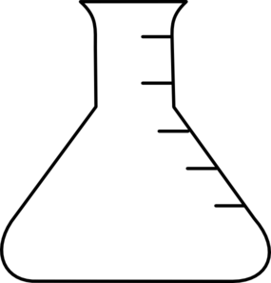

Equivalence Point of a weak acid titration
Only the conjugate base exists; no weak acid remains
The concentration of the acid being titrated can be determined by M_{a}V_{a} = M_{b}V_{b} using the volume at this point
Ideally, the indicator should change color here
To calculate the pH, do a RICE problem using the conjugate base of the weak acid being titrated + water to determine the concentration of OH⁻. Then, take the -log [OH⁻] and subtract from 14.
Occurs at twice the VOLUME that the other point occurs at
Is in the middle of the steep slope portion of a titration curve
The identity of the substance being titrated might be determined based on molar mass
pH changes dramatically at this point

