Zero Order | 1st order | 2nd order
Rate = k | Rate = k[A] | Rate = k[A]²
[A]_{t}= -kt + [A]_{o} | ln [A] _{t} = -kt + ln[A]_{o} | 1 = kt + 1  [A]_{t} [A]_{o}
[A]_{t} - [A]_{o} = -kt | ln [A]_{t} - ln[A]_{o} = -kt | 1 - 1 = kt  [A]_{t} [A]_{o}
[A] vs. t gives a plot with a straight line | ln [A] vs. t gives a plot with a straight line | 1/[A] vs. t gives a plot with a straight line
Straight line graph has slope = -k | Straight line graph has slope = -k | Straight line graph has slope = +k
t_{1/2} = [A]/2k | t_{1/2} = 0.693/k | t_{1/2} = 1/k[A]
rate does not depend on [A] | rate decreases over time since the amount of [A] decreases over time | rate decreases over time since the amount of [A] decreases over time
rate is constant over time | half-life is constant over time since [A] is not part of the half life equation | half-life is NOT constant over time since [A] is part of the half life equation
a particle with this order might be in the fast step of the mechanism | Likely occurs when a single molecule splits rather than collides with another molecule in the slow step of the mechanism | A bimolecular collision in the slow step of the mechanism may cause this
since [A] is part of the half-life equation, half-life is NOT constant over time | Radioactive decay is this type
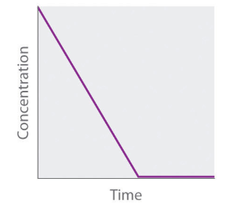 | 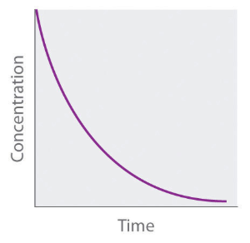 | 