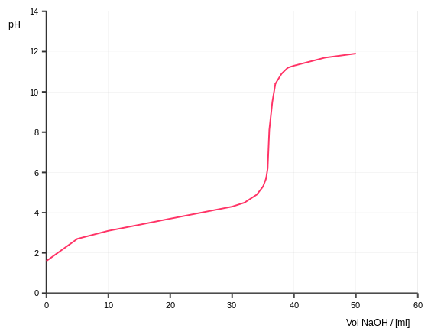

**Region B**

**Region A**

Point 3

Point 2

Point 1

**Point 1**

Before the titration begins

To get the pH: Do a RICE problem with the initial [ ] of acid

**Point 2**

Midpoint

pH = pKa

[HA] = [A-]

Moles of base added equals half the moles of acid you started with.

Volume of titrant added equals half the volume of titrant added at equivalence point.

Can be used to determine the identity of an unknown acid

**Region A**

Before the equivalence point

To get the pH: Determine the moles of acid remaining and the moles of conjugate base produced, divide both by the new total volume, plug into the Henderson-Hasselbach equation to get the pH.

[HA] > [A-] in this region before the midpoint. [A-] > [HA] after the midpoint.

The middle part of this region doesn’t change pH much because it is a buffer.

**Point 3**

Equivalence Point

To get the pH: Determine the moles of conjugate base produced, divide by the new total volume, use a RICE problem of the conjugate base with water to determine the pH.

[HA] = 0 (pretty much)

Moles of acid you started with equals the moles of base added

The indicator should (if chosen correctly) change color here.

The indicator should have a pKa equal to the pH at this point.

Can be used to calculate the molarity or weight % of the analyte

Can be seen on a pH curve by picking a point halfway up the rapid-rise region

**Region B**

Beyond the equivalence point

To get the pH: Determine the moles of base/titrant remaining, divide by the new total volume, and take the -log [base] and subtract from 14.

[A-] can be ignored, but is present!

Excess base has been added beyond the point at which all acid has been neutralized

Clearly, the above titration is the titration of a _______________ (strong/weak) _____________ (acid/base) with a _______________ (strong/weak) _____________ (acid/base).

You can tell this because the pH starts low and the pH at the equivalence point is _____ 7.

The pH at the equivalence point is NOT 7 because of the presence of the _________________ __________ in the water.

Before the equivalence point

Midpoint

Beyond the equivalence point

Equivalence Point

Before the titration begins

Volume of titrant added equals half the volume of titrant added at equivalence point.

Moles of base added equals half the moles of acid you started with.

Excess base has been added beyond the point at which all acid has been neutralized

Moles of acid you started with equals the moles of base added

[HA] = [A-]

[HA] = 0 (pretty much)

[HA] > [A-] in this region before the midpoint. [A-] > [HA] after the midpoint.

[A-] can be ignored, but is present!

Can be used to calculate the molarity or weight % of the analyte

Can be used to determine the identity of an unknown acid

The middle part of this region doesn’t change pH much because it is a buffer.

To get the pH: Determine the moles of conjugate base produced, divide by the new total volume, use a RICE problem of the conjugate base with water to determine the pH.

To get the pH: Do a RICE problem with the initial [ ] of acid

To get the pH: Determine the moles of acid remaining and the moles of conjugate base produced, divide both by the new total volume, plug into the Henderson-Hasselbach equation to get the pH.

pH = pKa

To get the pH: Determine the moles of base/titrant remaining, divide by the new total volume, and take the -log [base] and subtract from 14.

The indicator should (if chosen correctly) change color here.

The indicator should have a pKa equal to the pH at this point.

Can be seen on a pH curve by picking a point halfway up the rapid-rise region

**Point 1**

**Point 2**

**Region A**

**Point 3**

**Region B**