Mass Number | Atomic Number | Average Atomic Mass
Not found on the periodic table | The whole number in every box on the periodic table | The decimal number in every box on the periodic table
Equal to the approximate mass of an atom, in amu | Equals the number of protons | The weighted average of the masses of all the isotopes of a given element
number of neutrons + number of protons | Defines an element | Takes into account that some isotopes are more abundant than other isotopes
Each isotope of a given element has its own distinct number of this | 1 – 118 are possible values for this number | The average mass of all atoms in a sample of an element, no matter where the sample is found
Represented by A | Represented by Z
${}_{93}^{238}{Np}$ | ${}_{93}^{238}{Np}$
Carbon - 14 | 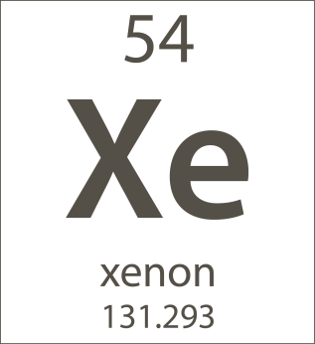

proton | neutron | electrons
Discovered by Thompson  (or proposed by) | Discovered after the other 2 subatomic particles | Discovered by Thompson
Found in the nucleus | Found in the nucleus | Found outside the nucleus
Weighs about 1 amu | Weighs about 1 amu | Weighs about 0.0005 amu (almost nothing!)
Positively charged | No charge | Negatively charged
Equals the atomic number (Z) | Equals the mass number (A) – atomic number (Z) | Equals the number of protons in a neutral atom
Defines the element |  | Doesn’t really contribute to the weight of the atom
 |  | Found in the “empty space” of the atom

