John Dalton | J.J. Thomson | Ernest Rutherford
Proposed the first modern atomic theory | Discovered the electron | Discovered the nucleus
Said that atoms were indivisible (which isn’t true) | Proposed the plum pudding model of the atom | Discovered the nucleus was very small in size but contained nearly all of the mass of the atom
Said that all atoms of a given element were exactly alike (which is no longer considered true! Why?) | Performed cathode ray tube experiments | Gold foil experiment: He shot alpha particles at gold foil and most went straight through, but a very few were deflected.
Said that atoms could be combined in simple whole number ratios to make compounds | Proposed the existence of protons, even though he discovered the electron, since he knew atoms were neutral. | Proved that most of the volume of the atom is empty space
Said that in chemical reactions, atoms are combined, separated, or rearranged. |  | Discovered that the nucleus of the atom is incredibly dense.
Said that all matter is composed of extremely small particles called atoms. |  | Discovered the nucleus was positively charged
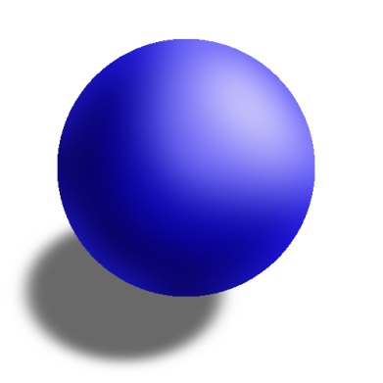 | 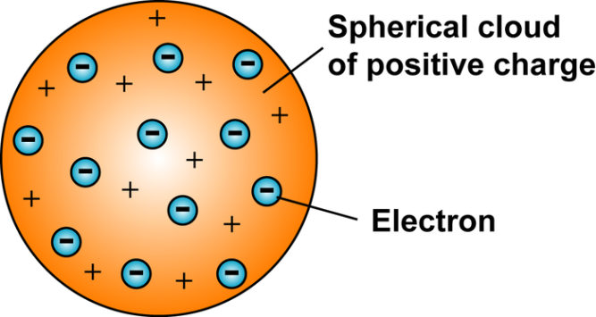 | 