Dalton’s model | Plum Pudding model | Rutherford’s model | Bohr’s model | Quantum model
Atoms are indivisible | Atoms have positive and negative charges scattered throughout the atom | Gold foil experiment | Electrons are in energy levels, orbiting the nucleus as planets orbit the sun | Electrons are in orbitals within sublevels within energy levels
No protons, neutrons, or electrons | No neutrons | Protons are all concentrated together at the center of the atom, making up the nucleus. | Electrons have specific amounts of energy determined by their distance from the nucleus | Orbitals are regions where an electron has a 90% chance of being.
Said that all atoms of a given element were identical (later proven to not be completely true) | First to mention negatively charged particles | First to say electrons are located outside of the protons | Evidence for this model includes line emission spectrum of hydrogen | Electrons act as waves
5 postulates made up his atomic theory | Proposed the existence of protons | First to say the atom was mostly empty space | Electrons can move from one energy level to the next | Uses Schrodinger’s wave equation to predict electron location
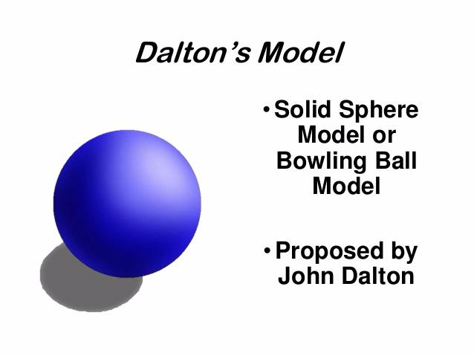 | 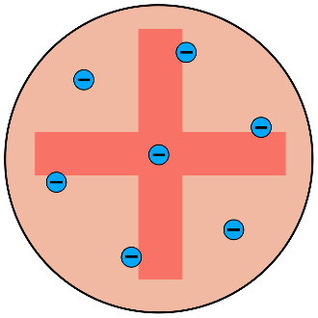 | 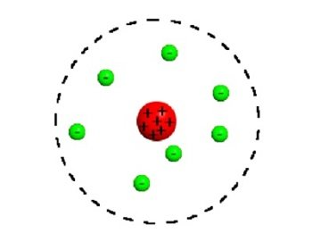 | 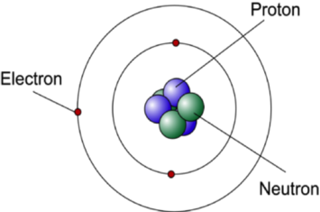 | 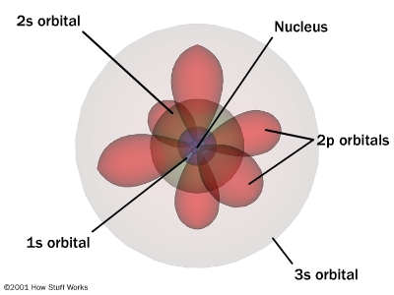
Introduced the idea that atoms make up everything around us | Proposed by JJ Thomson | No neutrons | Includes protons, neutrons, and electrons | Includes protons, neutrons, and electrons
 | Positive charge is evenly spread throughout atom | The nucleus contains nearly all of the weight of the atom, but occupies less than 1% of the volume |  | Most modern model of the atom; currently accepted view of the atom
 |  | The nucleus is incredibly dense |  | Electrons have specific amounts of energy determined by their distance from the nucleus
 |  |  |  | Electrons’ positions can be represented by orbital notation or electron configuration

