N-15

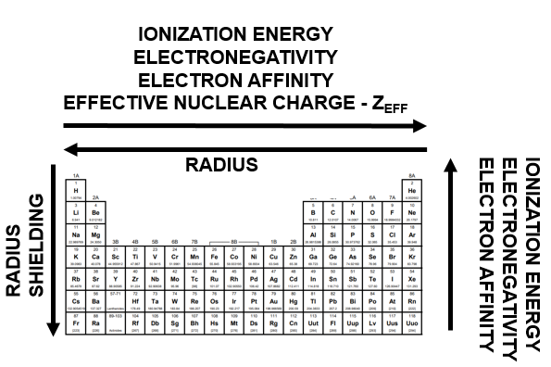 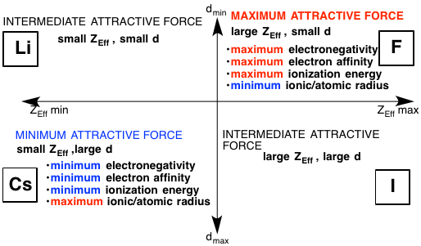

|  |  |
| --- | --- |
| **Steps to Draw Lewis Dot Structures**   1. **Count** and sum valence electrons 2. **Place** atoms    * Least electronegative atom in the center  * Hydrogen is always on the outside  1. Bond all atoms with a **single bond** 2. Give all atoms a **full shell** 3. **Re-count** the # of e- used 4. **Used too few?** Give them to the central atom 5. **Used too many?** Try double or triple bonds to fix it!    * Take a pair away from two neighboring atoms    * Put a pair between them to form the extra bond    * *“Take two away, put one back in between”*  * Correct number of valence electrons used ??? * Is each atom “happy” now ??? | **Exceptions to the Octet Rule**  *Some elements have a tendency to break the octet rule. This is a list of the common ones that break the rule. Please know that you should always draw the best structure possible, and sometimes that means something will break the octet rule even if it isn’t listed here. You can only do the best you can do!*  *http://t2.gstatic.com/images?q=tbn:ANd9GcR-jWLeCEsAY6ZwrE54Kyp10IUaP1yKfkPo5b-EgCl763cYbZZrPg:www.mikeblaber.org/oldwine/chm1045/notes/Geometry/Hybrid/IMG00001.GIF*   * **H – 2** * Image result for sf6**http://t0.gstatic.com/images?q=tbn:ANd9GcS-5BDdMOu-MdEzdj9_7VEv4mw3aXcbmVyipxC08o4JziKTKlseLi - 2** * **Be - 4** * **B - 6** * **P - 10** * **S – 12** |

N-18

N-17

**Eventually we should do this in our head! When asked to show work you will use this “crossing over” method.**

1. Write cation first then anion
2. Write the charges with each symbol
3. The superscript of one atom, becomes the subscript of the other. Use the absolute value! This is “crossing over”
4. Reduce your subscripts to the lowest numbers possible while maintaining the correct ratio
5. You do not need to put the 1s for subscripts!
6. CAREFUL WITH POLYATOMIC IONS!

N-20

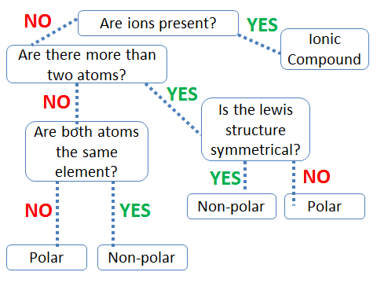

N-21

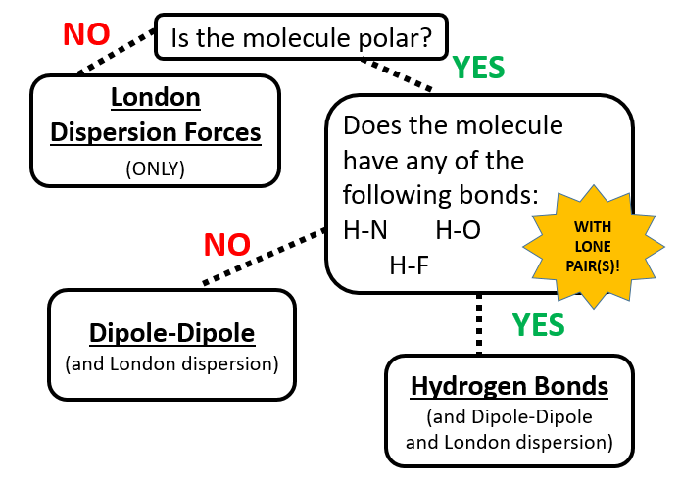

N-22

Rules for Balancing Equations  
1) Get a pencil! Stay calm.

2) Write the skeleton equation – this

means convert the names of chemicals

into formulas.

3) Be sure that all formulas are written

correctly.

4) Count atoms of each element on each

side of the arrow to figure out what

needs to be balanced.

5) Change ONLY coefficients to balance,

***NEVER change subscripts!***

6) Reduce coefficients to lowest ratio.

(i.e. 2:4 ration, is 1:2)

7) Check your work when done.

N-22 **PRACTICE PROBLEMS**

***Show your work in your notes the way Mrs. Farmer does!***

1. ______ ZnS (aq) + ______ O2 (g) 🡪 ______ ZnO (aq) + _____ S (s)
2. **______** Cu + ______ AgNO3 🡪 _____ Ag + ______ Cu(NO3)2
3. ______ H3PO4 + ______ NaOH 🡪 ______ Na3PO4 + ______ H2O
4. ______ Ca3(PO4)2 + ______ H2SO4 🡪 ______ CaSO4 + ______ H3PO4
5. ______ H2O + ______ CH4 🡪 ______ H2 + ______ CO2
6. ______ Cl2 + ______ NaBr 🡪 ______ NaCl + ______ Br2

N-23  
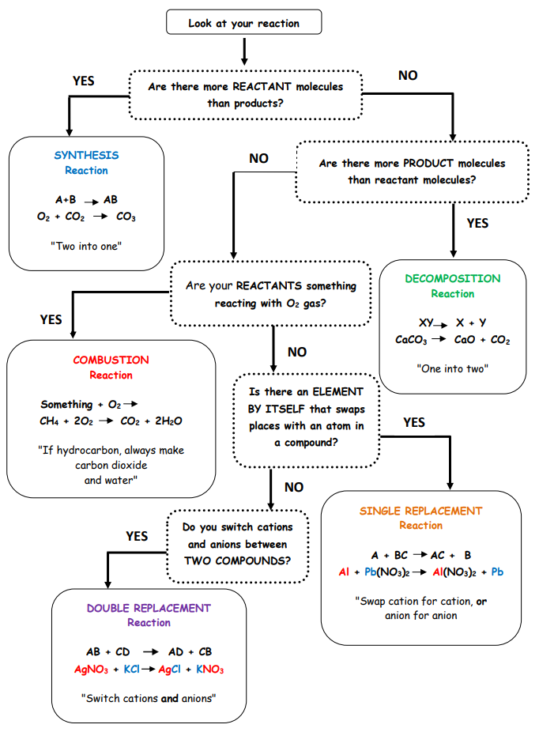

N-24

**Steps to Predicting Products**

1. ***Write out reactants*** as formulas, balancing charges correctly (know your ions…) using subscripts
2. ***Identify type of reaction*** as synthesis, decomp, combustion, single replacement, or double replacement
3. ***Predict products*** based on type of reaction identified
4. ***Write products correctly*** by balancing charges using subscripts
5. ***Balance***your reaction using coefficients
6. *For single replacement reactions, use an ***activity series*** to determine if reaction will actually take place
7. **For single and double replacement reactions, must write them in **NET IONIC** using solubility rules when requested

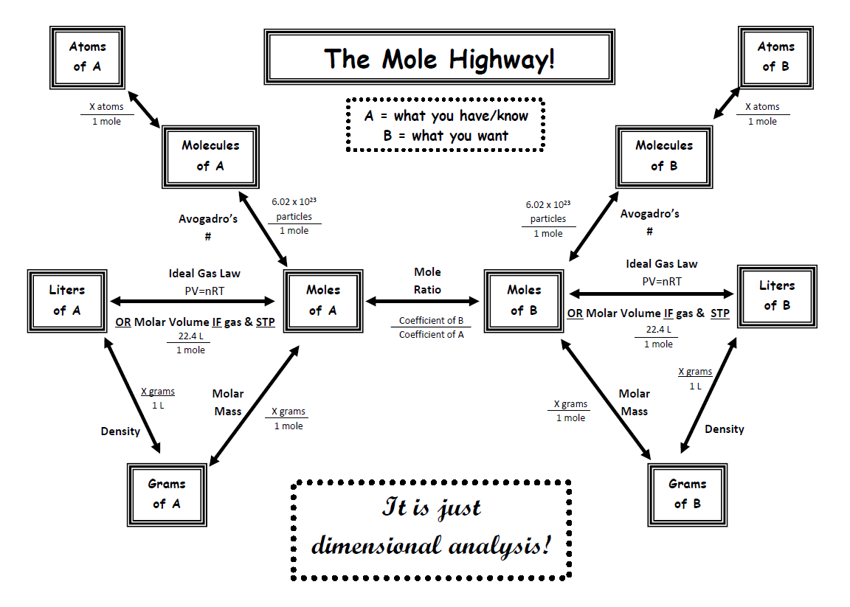

N-26

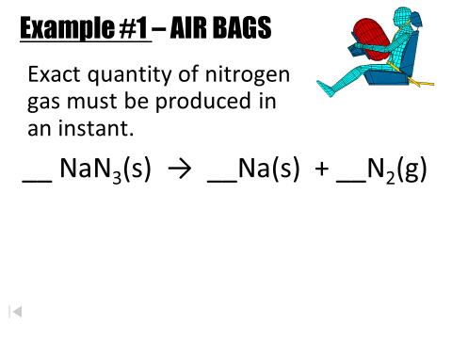N-27

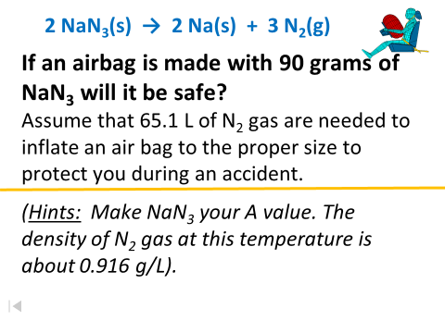

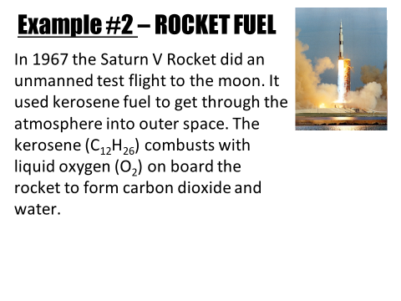  
 Balanced Equation:

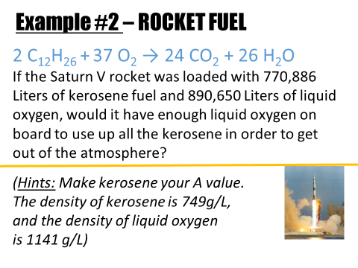

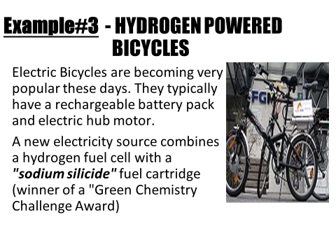

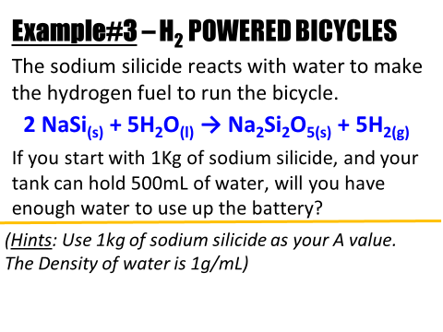

N-28

**Regular stoich or limiting stoich?**

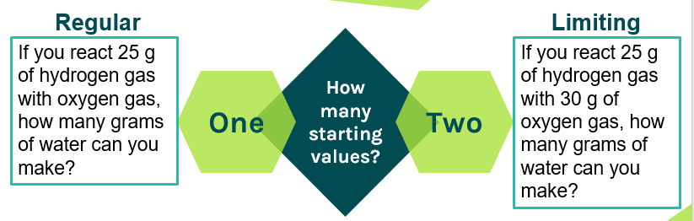

**Three main types of problems:**

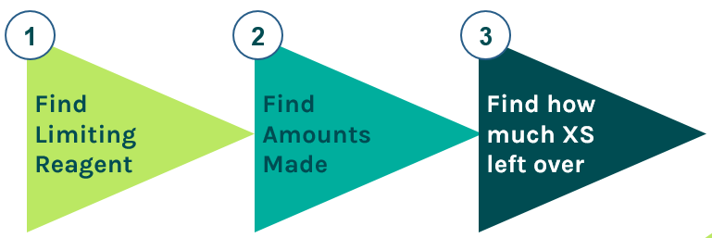

N-28

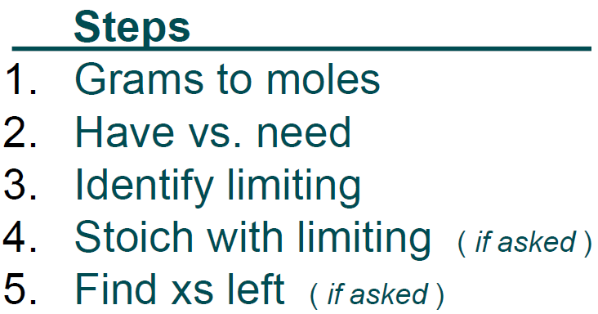

**Practice Problem #1:**

**If you reacted 150.0 g of K with 225 g of Br2, how may g of KBr can be made? How much excess reagent is left?  
 2K + Br2 🡪 2KBr**

**Practice Problem #2:**

**If you react 13.2 g of Fe with 6.34 g of O2, how may g of Fe2O3 are made? How many grams of excess are left?  
 4Fe + 3O2 🡪 2Fe2O3**

N-30  
Important Points to Know  
***Please annotate this list to the side in your notes! It is important that you actually process it and learn it!***

* All Carbon ends up in the CO2
* All Hydrogen ends up in the H2O
* Oxygen has to be found by subtracting since it ends up in multiple places
* Other elements like nitrogen must be found by doing a separate experiment
* Must know the mass of the unknown substance before burning it
* The unknown will be burnt in pure oxygen, present in large excess
* The amount of oxygen will be determined by subtraction.
* The combustion products always have CO2 and H2O. Might have extra products if other elements are present!
* Nitrogen product can come in different forms. N2, NH3, etc. Will be given more info if needed. Often given as a separate experiment – will need to convert all to %’s if this is the case! Nitrogen is the problem child in combustion analysis.
* All the carbon winds up as CO2 and all the hydrogen winds up as H2O.

N-29

% Composition Steps

1. Find the molar mass   
   of the molecule
2. Divide each element’s atomic mass by the molar mass of the molecule
3. Multiply by 100 to put answer in terms of an actual %

*Note* If you add up the % for each element it should add up to 100%...but rounding answers may make it not quite add up to 100%. That’s ok.

Determining Empirical Formula Steps

1. Given: % composition
2. Assume you have 100g sample to make #s easier
3. Use the poem!  
    *- Percent to mass  
    - Mass to Moles  
    - Divide by small  
    - Multiply by whole*

*Note*   
When multiplying by whole, you need to multiply each element by the same number!

Determining Molecular Formula Steps

1. Find molar mass of the empirical formula
2. Divide molecular formula mass by empirical formula mass
3. Multiply empirical formula subscripts by the multiplier # found in step 2  
    *- No cute rhyme this time…sorry!* ☺

*Note* When finding the multiplier in step 2, you will usually have to round a little bit until you get a whole number. That is ok.

N-30  
Steps to Solve  
***Please annotate this list to the side in your notes! It is important that you actually process it and learn it!***

1. **Determine the mass of each element present in the   
   original compound using dimensional analysis**

* C is always in CO2 in the ratio of 1 mole CO2 = 1 mole C
* H is always in H2O in the ratio of 1 mole H2O = 2 mole H
* N can be (NH3, N2, N, NO2, etc…). If data from a separate experiment, make sure to convert masses to % values!

1. **Subtract to solve for oxygen**

* Sample mass – (Cmass+Hmass+Nmass if necessary, or any other random element)

1. **Now continue with the Rhyme from before!**

* Mass to moles
* Divide by small
* Multiply until whole

N-30

Practice Problems  
***Please solve these in your notes the way you see your teacher doing them! They are not optional, they are part of the notes!*Remember that sig figs can be a total pain for these problems…a little bit of rounding can make a problem impossible to solve. Some problems will require you to use more decimal places than others. If in doubt, you can always ask how many to use.**

**Example #1**

A sample of a compound that is known to contain only carbon, hydrogen, and oxygen is combusted, and the CO2 and H2O produced are trapped and weighed. The original sample weighed 8.38 g and yielded 16.0 g CO2 and 9.8 g H2O. What is the empirical formula?

**Example #2**

Lysine is an amino acid which has the following elemental composition: C, H, O, N. In one experiment, 2.175 g of lysine was combusted to produce 3.94 g of CO2 and 1.89 g H2O. In a separate experiment, 1.873 g of lysine was burned to produce 0.436 g of NH2. The molar mass of lysine is approximately 150 g/mol. Determine the empirical and molecular formula of lysine.

(N-31 part 2 on next page, The rest of N-37 after N-36)

N-31

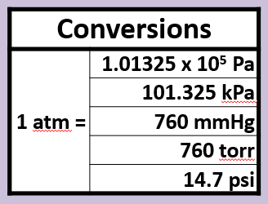

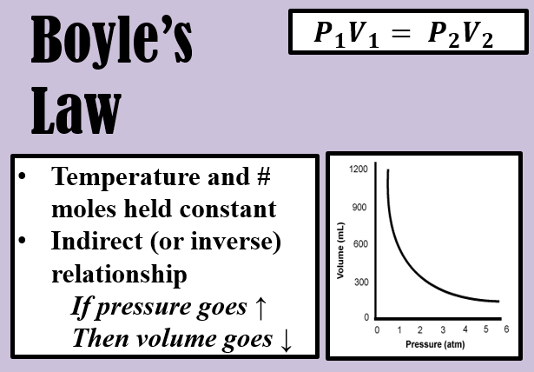

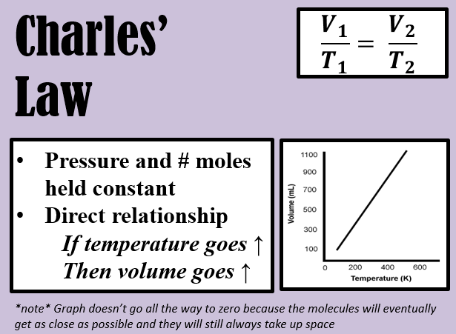

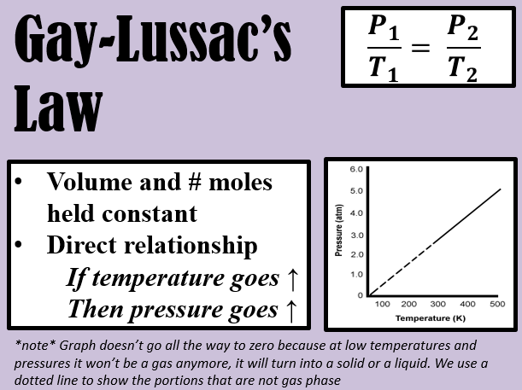

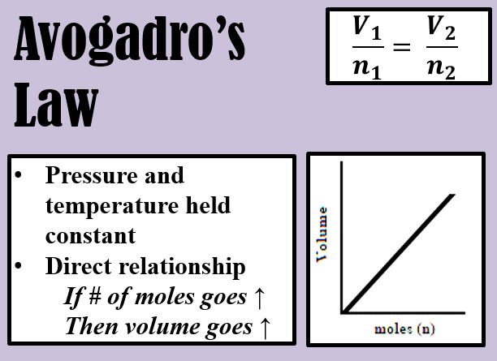

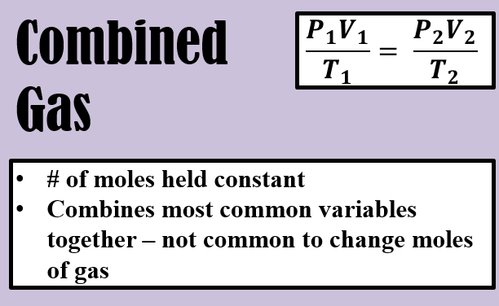

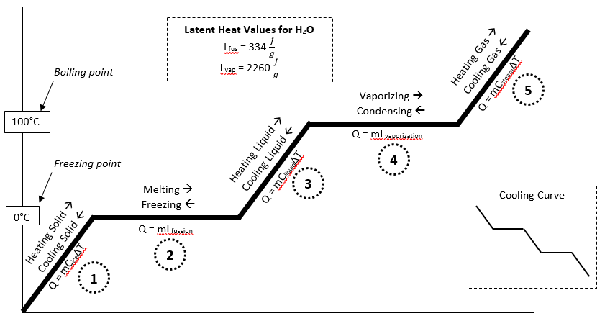N-37

N-31

|  |  |  |  |
| --- | --- | --- | --- |
| **Gas Laws Summary Sheet** | | | |
| **Boyle’s Law** | **Charles’s Law** | **Gay-Lussac’s Law** | **Combined Law** |
| for a given mass of gas at constant temperature, the volume of a gas varies inversely with pressure | the volume of a fixed mass of a gas is directly proportional to its Kelvin temperature if the pressure is kept constant | the volume of a fixed mass of a gas is directly proportional to its Kelvin temperature if the pressure is kept constant | combines Boyle’s, Charles’, and Gay- Lussac’s Law into one equation |
| $$P_{1}V_{1}=P_{2}V_{2}$$ constants  amount of gas (moles) temperature | $$\frac{V_{1}}{T_{1}}=\frac{V_{2}}{T_{2}}$$ constants  amount of gas (moles) pressure | $$\frac{P_{1}}{T_{1}}=\frac{P_{2}}{T_{2}}$$ constants  amount of gas (moles), volume | $$\frac{P_{1}V_{1}}{T_{1}}=\frac{P_{2}V_{2}}{T_{2}}$$ constant  amount of gas (moles) |

|  |  |  |  |
| --- | --- | --- | --- |
| **Avogadro’s Law** | **Ideal Gas Law** | **Dalton’s Law** | **Graham’s Law** |
| equal volumes of gases at the same temperature and pressure contain an equal number of particles  the volume of a gas at constant temperature and pressure depends on the number of gas particles present | relates the pressure, temperature, volume, and mass of a gas through the gas constant ‘R’ | at constant volume and temperature, the total pressure exerted by a mixture of gases is equal to the sum of the pressures exerted by each gas  Gas Collection Over Water A mixture of gases results  whenever a gas is collected by displacement of water. Water vapor is always present at a constant pressure, dependent on temperature, called the vapor  pressure of water. | the rate of effusion/diffusion of two gases (A and B) are inversely proportional to the square root of their molar masses (M).  **NOT PART OF HONORS CHEMISTRY** |
| $$\frac{V_{1}}{T_{1}}=\frac{V_{2}}{T_{2}}$$ constants  temperature, pressure |  |  |  |

|  |  |  |
| --- | --- | --- |
| **Abbreviations** | | **Standard Conditions** |
| atm = atmosphere, mm Hg = millimeters of mercury, torr = another name for mm Hg, Pa = Pascal, kPa = kilopascal, K = Kelvin  °C = degrees Celsius | | 0°C = 273 K  1.00 atm = 760 mm Hg = 76 cm Hg = 101.325 kPa = 101,325 Pa = 29.9 in Hg |
| **Conversions** | **Gas Law’s Equation Symbols** | |
| K = °C + 273  1 cm3 (cubic centimeter) = 1 mL (milliliter)  1 dm3 (cubic decimeter) = 1 L (liter) = 1000 mL | subscript (1) = initial condition / subscript (2) = final condition  TEMPERATURE MUST BE IN **KELVIN!**  *n* = number of moles $$R=8.314\frac{L∙kPa}{mol∙K};0.0821\frac{L∙atm}{mol∙K};62.4\frac{L∙torr}{mol∙K}$$ In order to solve, you **must** have a common set of units in the problem. | |

N-36

1. Calculate the specific heat of a metal if 2.36 x 102 grams of it at 99.5°C is added to 125.0 mL of water at 22.0°C. The final temperature of the system is 25.4°C.
2. A lump of chromium (Cr) has a mass of 95.3 grams and a temperature of 90.5°C. It is placed into a calorimeter with 75.2 mL of water at 20.5°C. After stirring, the final temperature of the water, Cr metal, and calorimeter is 28.6°C. What is the specific heat of Cr metal?
3. A 100.0 gram sample of water at 50.0°C is mixed with a 50.00 gram sample of water at 20.0°C. What is the final temperature of the 150.0 grams of water?

|  |
| --- |
| 1. What is the energy needed to melt 326 grams of ice and heat it to 100°C? |
| 1. Determine the energy required to convert 21.1 grams of ice at -6°C to steam at 100°C |
| 1. What is the heat transfer involved when you convert 51 grams of water 0°C to ice at -20.3°C? |
| 1. What is the energy absorbed when you melt 75 grams of ice at -5°C to water at 90°C? |

N-37

|  |  |
| --- | --- |
| **Q = mC∆T**  Cice = 2.09 J/g°C | The **SPECIFIC HEAT OF ICE** is the heat used to make the molecules in the ice crystal move faster. They start vibrating more and break loose of the organized structure. This causes the temperature to increase.  *What’s Happening?*  *Speeding up Solid*  *Temperature goes up* |
| **Q = mL**  Lfusion = 334 J/g  (+) if melting  (-)if freezing | The **LATENT HEAT OF FUSION** is the energy used to break the attractions between the ice molecules. This spreads them out. All the energy is going to the molecules being spread out, they do not move faster, therefore, the temperature does not go up.  *What’s Happening?*  *Spreading out molecules Phase Change: Solid 🡪 Liquid* |
| **Q = mC∆T**  Cwater = 4.18 J/g°C | The **SPECIFIC HEAT OF WATER** is the heat used to make the water molecules move faster in liquid form. This causes the temperature to increase.  *What’s Happening?*  *Speeding up Liquid*  *Temperature goes up* |
| **Q = mL**  Lvaporization =2260 J/g  (+) if vaporizing  (-) if condensing | The **LATENT HEAT OF VAPORIZATION** is the energy used to break the attraction between the liquid molecules. This spreads them out. All the energy is going to the molecules being spread out, they do not move faster, therefore, the temperature does not go up.  *What’s Happening?*  *Spreading out molecules*  *Phase Change: Liquid 🡪 Gas* |
| **Q = mC∆T**  Csteam = 1.87 J/g°C | The **SPECIFIC HEAT OF STEAM** is the heat used to make the steam molecules move faster in the gas form. This causes the temperature to increase.  *What’s Happening?*  *Speeding up gas*  *Temperature goes up* |

N-39 N-42

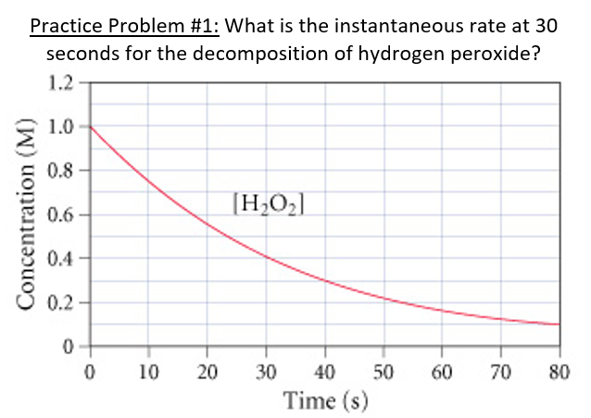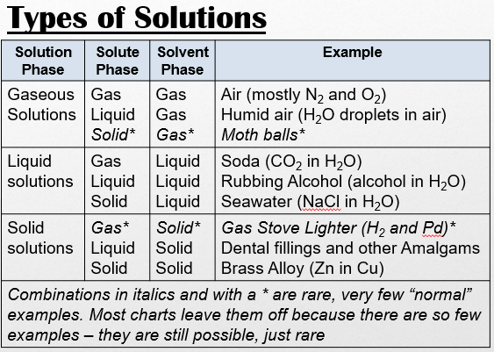

N-41

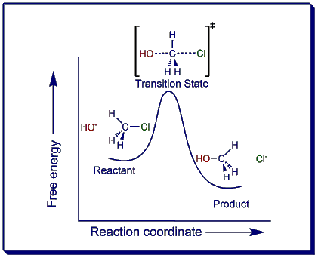

N-42

**STEPS FOR FINDING RATE LAWS**

1. Write your “skeleton rate law”
2. Look at your experimental data (chart)
3. Find two trials in which:
   * The [ ] of one substance is held constant
   * The [ ] of another substance is being changed
4. Look to see how the rate changes when you vary the [ ] of ONLY one substance.
5. Figure out what exponent on the [ ] change would result in the observed change to rate – that is the “order”
6. Repeat for each additional reactant

**\*NOTE* If you don’t have two trials that hold everything but one reactant constant, solve for the orders you can, then pick two trials and plug in the values you do know to determine what you couldn’t figure out!**

What counts as showing my work?

|  |  |  |  |  |
| --- | --- | --- | --- | --- |
| **Trials being used** | **Which  [ ] is held constant** | **Which [ ] is being changed and by what factor is it changed by** | **What factor is the rate changed by** | **Order based on rate data** |
| 1 & 3 | [H2] | [O2] x 2 | x 2 | 1 |

*Does not have to be in chart format!   
Basically you need to tell me which trials to look at,   
and what they tell you*

Practice Problem #1

Practice Problem #2

|  |  |  |  |
| --- | --- | --- | --- |
| **Run #** | **Initial [A]  ([A]0)** | **Initial [B]  ([B]0)** | **Initial Rate  (v0)** |
| 1 | 1.00 M | 1.00 M | 1.25 x 10-2 M/s |
| 2 | 1.00 M | 2.00 M | 2.5 x 10-2 M/s |
| 3 | 2.00 M | 2.00 M | 2.5 x 10-2 M/s |

Practice Problem #3

|  |  |  |
| --- | --- | --- |
| **[NO(g)]  (mol dm-3)** | **[Cl2(g)]  (mol dm-3)** | **Initial Rate  (mol dm-3 s-1)** |
| 0.250 | 0.250 | 1.43 x 10-6 |
| 0.250 | 0.500 | 2.86 x 10-6 |
| 0.500 | 0.500 | 1.14 x 10-5 |

Practice Problem #4

|  |  |  |  |
| --- | --- | --- | --- |
| **Exp.** | **[S2O82-]** | **[I-]** | **Initial Rate (*M*/s)** |
| 1 | 0.08 | 0.034 | 2.2 x 10-4 |
| 2 | 0.08 | 0.017 | 1.1 x 10-4 |
| 3 | 0.16 | 0.017 | 2.2 x 10-4 |

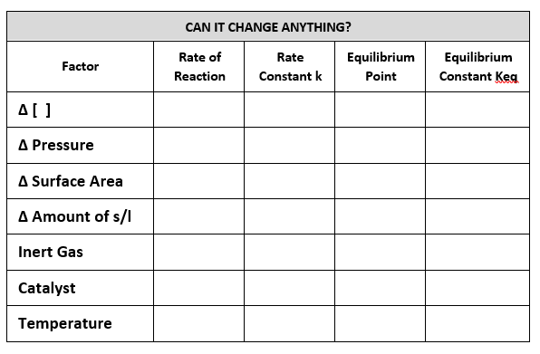N-43 N-44

|  |  |  |
| --- | --- | --- |
| Things to look for BEFORE answering an equilibrium Q | | |
| **Stressor** | **Question** | **What does it tell us?** |
| **Increase or decrease   [ ] products or reactants** | **Which phase?** | * **Gas, aqueous - change things** * **Solid, Liquid – DON’T CHANGE ANYTHING!** |
| **Increase or decrease T** | **Endo or exo?** | * **Endo = absorbed, so it is a REACTANT** * **Exo = released, so it is a PRODUCT** |
| **Increase or decrease total Pressure**  *(Same as ∆ in V or # of moles of gas)* | **How many moles of GAS are on each side of the equation?** | * **Increase pressure = move to side with FEWER moles of gas** * **Decrease pressure = move to side with MORE moles of gas** |

(the rest of N-43 on next page)

|  |  |  |  |
| --- | --- | --- | --- |
| **Q#**  N-43  (You have to be told what the stressor is – you will be told during the notes) | **Equation** | **Shift Left or Right?** | **Changes?** |
| 1 | N2(g) + O2(g) ↔ 2NO(g) |  |  |
| **Stressor:** |
| 2 | H2(g) + I2(g) ↔ 2HI(g) |  |  |
| **Stressor:** |
| 3 | CO(g) + H2O(g) ↔ CO2(g) + H2(g) |  |  |
| **Stressor:** |
| 4 | 2SO2(g) + O2(g) ↔ 2SO3(g) |  |  |
| **Stressor:** |
| 5 | 3O2(g) ↔ 2O3(g) |  |  |
| **Stressor:** |
| 6 | H2O2(l) ↔ H2(g) + O2(g) |  |  |
| **Stressor:** |
| 7 | CO(g) + 2H2(g) ↔ CH3OH(g) |  |  |
| **Stressor:** |
| 8 | CH4(g) + 2O2(g) ↔ CO2(g) + 2H2O(g)  ΔH = -5kJ |  |  |
| **Stressor:** |

N-45

ICE Table Steps

1. Make a chart with rows for: **Rxn, I, C, E, 5%, Ans.**
2. Draw your ICE table with enough columns for each substance

* *Put dashes in the table for solids/liquids since they will   
  not have [ ]’s*

1. **Rxn -** Write the balanced eq. for your reaction.
2. **I -** Write in any initial [ ]’s you are given.
3. **C -** Use the generic value of “x” to list the changes to   
   the concentrations

* *Make sure to include the coefficients from the balanced equation. Example: 2H2 would be 2x.*
* *Use ( - ) for anything being used up, and ( + ) for anything being made. If the 2H2 is being used up then it would be -2x.*

1. **E -** Add the initial and change columns together and list as   
   the equilibrium [ ]s for each substance.
2. **5% -** Determine if the 5% rule can be applied*.* If 5% rule is   
   a possibility adjust your E values and write them in the   
   5% row of your chart.

* *Required: K < 1*
* *K being at least 1000x smaller than initial [ ]’s is a better guess of when it might be a valid rule, but it’s just a guess.*
* *Remember you must check to see if the 5% rule was valid or not when you are finished! If it wasn’t valid then you need to start over without it and do the math with the original “E” values.*

1. Write the Equilibrium Expression (Law of Mass Action) so you can plug in your values to solve for X.

* *You may have to use the quadratic equation to solve! If you are lucky it will just be regular old algebra. Remember the “F.O.I.L” method and the quadratic equation $\frac{-b±\sqrt{b^{2}-4ac}}{2a}$ where your equation is ax2 + bx +c*

1. **Ans. –** Use your answer for X to determine your final concentrations at equilibrium. List in the answer row of your ICE table.

* *Don’t forget that X is not necessarily your equilibrium concentration! You must go back and use X to solve for your equilibrium concentrations.*

|  |  |  |  |  |  |  |  |  |  |  |  |  |  |  |  |  |  |  |  |  |  |  |  |  |
| --- | --- | --- | --- | --- | --- | --- | --- | --- | --- | --- | --- | --- | --- | --- | --- | --- | --- | --- | --- | --- | --- | --- | --- | --- |
| **ICE Table Practice Problem #1**  If you have an initial concentration of [PCl5] at 1.3M, what are the concentrations  of the products at equilibrium? Assume all reactants and products are aqueous  and Keq = 78.3.  PCl5 🡪 PCl3 + Cl2   |  |  |  |  | | --- | --- | --- | --- | | **Rxn** | PCl5 🡪 PCl3 + Cl2 | | | | **I** |  |  |  | | **C** |  |  |  | | **E** |  |  |  | | **5%** |  |  |  | | **Answer** |  |  |  | |
| |  |  |  |  |  |  |  |  |  |  |  |  |  |  |  |  |  |  |  | | --- | --- | --- | --- | --- | --- | --- | --- | --- | --- | --- | --- | --- | --- | --- | --- | --- | --- | --- | | **ICE Table Practice Problem #2**  In the following reaction, Keq = 9.3x10-7 at room temp. Calculate the equilibrium concentration of N2O4 in a flask initially containing only 3.00 M of NO2  2 NO2(g) 🡪 N2O4(g)   |  |  |  | | --- | --- | --- | | **Rxn** | 2 NO2(g) 🡪 N2O4(g) | | | **I** |  |  | | **C** |  |  | | **E** |  |  | | **5%** |  |  | | **Answer** |  |  | | |

|  |  |
| --- | --- |
| **pH = -log [H+]** | **pOH = -log [OH-]** |
| **[H+] = 10-pH** | **[OH-] = 10-pOH** |
| **pH + pOH = 14** | |
| **[H+][OH-] = 1 x 10-14** | |

N-46

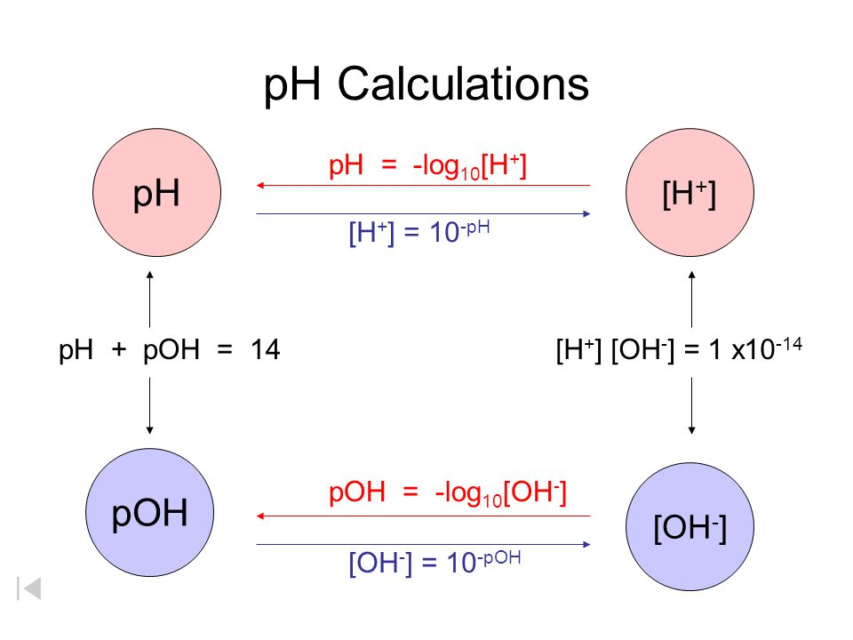

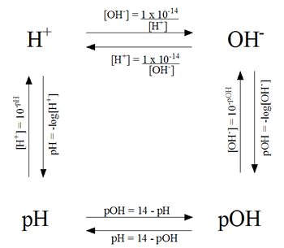

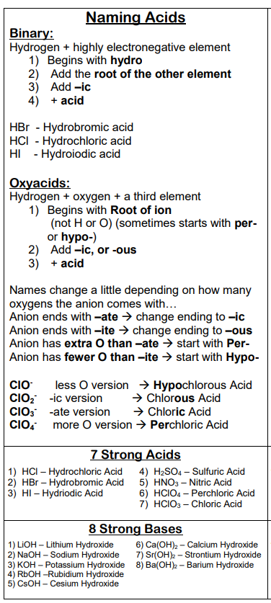N-47

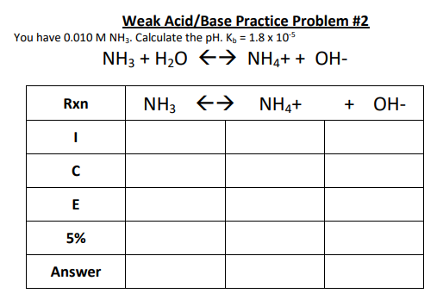N-48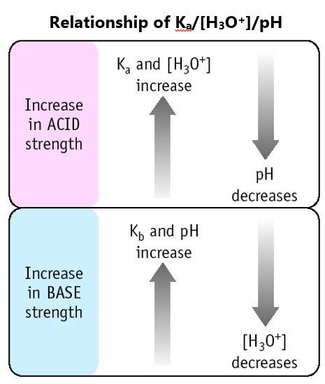

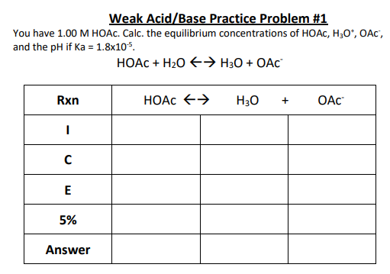

N-49

Steps to determine if a salt is acidic/basic/neutral

1. Identify ions that the salt came from
2. Determine if the ions will hydrolyze
   * Figure out if they came from a   
     strong or weak acid/base
     + From strong 🡪 ion won’t hydrolyze – neutral contribution
     + From weak 🡪 ion will hydrolyze –   
       acidic or basic contribution
3. If it hydrolyzes identify if the hydrolysis of the ion would form acid (H3O+)or base (OH-).
4. Figure out what the combo of each ion’s contribution would be to the solution
5. To determine the “winner” when acidic + basic
   * Compare the Ka and Kb values
   * The higher one means it is stronger, more dissociation so it will contribute more to the resulting solution

Steps to find the actual pH value of a salt solution

1. Do all the steps needed to determine which ion is the “strong” one – which one is being hydrolyzed?
2. Write the hydrolysis reaction for that ion (or ions)
3. ICE Table time! Yes! More ICE tables! They just won’t go away! ☺ Use your hydrolysis rxn for ICE Table
4. Find [H3O+] or [OH-] from ICE Tables
5. Continue on with normal pH type calculations using the concentrations you found from the ICE Table

|  |  |  |
| --- | --- | --- |
|  | **Makes the solution…** | |
| **Acidic + Neutral** | Acidic | |
| **Basic + Neutral** | Basic | |
| **Neutral + Neutral** | Neutral | |
| **Acidic + Basic** | Compare Ka and Kb to determine which “wins” | |
| Ka(ion) > Kb(ion) | Acidic |
| Ka(ion) < Kb(ion) | Basic |
| Ka(ion) = Kb(ion) | Neutral |
| **Remember:** Kw = Ka x Kb  Ka(acidic ion) =  Kb(basic ion) = | | |

|  |  |  |  |
| --- | --- | --- | --- |
|  | **Turns into a…** | **Hydrolyzes?** | **So the ion makes sol’n** |
| **Strong Acid** | **Weak** conjugate **base** | No | **Neutral** |
| **Weak Acid** | **Strong** conjugate **base** | Yes | **Basic** |
| **Strong Base** | **Weak** conjugate **acid** | No | **Neutral** |
| **Weak Base** | **Strong** conjugate **acid** | Yes | **Acidic** |