Heating Curve Name__________________
Homework Date____________Per____
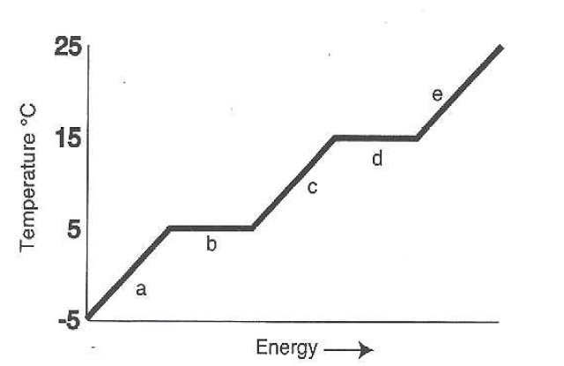

ANSWER THE FOLLOWING USING THE ABOVE HEATING CURVE

- What is the melting temperature of the above substance? _____

- What is the freezing temperature of the above substance? _____

- What is the boiling temperature of the above substance? _____

- The part of the graph labeled “e” represents temperatures at which gas is being heated. Describe what is happening for each of the other lettered sections of the graph:

- ___________________________________________________________
- ___________________________________________________________
- ___________________________________________________________
- ___________________________________________________________

- In which section of the graph are atoms moving the least? ___________
- In which section of the graph is this substance all liquid? ____________

ANSWER SHEET

ANSWER THE FOLLOWING USING THE ABOVE HEATING CURVE

- What is the melting temperature of the above substance? 5 C

- What is the freezing temperature of the above substance? 5 C

- What is the boiling temperature of the above substance? 15 C

- The part of the graph labeled “e” represents temperatures at which gas is being heated. Describe what is happening for each of the other lettered sections of the graph:

- The solid is warming but not melting.
- Melting.
- Liquid is warming.
- Boiling.

- In which section of the graph are atoms moving the least? A
- In which section of the graph is this substance all liquid? C

