Yet More Lewis Structures

For those of you that enjoy such things, some more Lewis structures to draw:

1) BSF

2) HBr

3) C₂H₅OH (ethanol)

4) N₂F₄

5) SF₆
Yet More Lewis Structures – Answers

For those of you that enjoy such things, some more Lewis structures to draw:

1) BSF

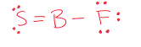

2) HBr

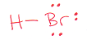

3) C₂H₅OH (ethanol)

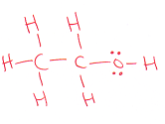

4) N₂F₄

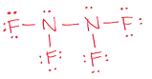

5) SF₆

