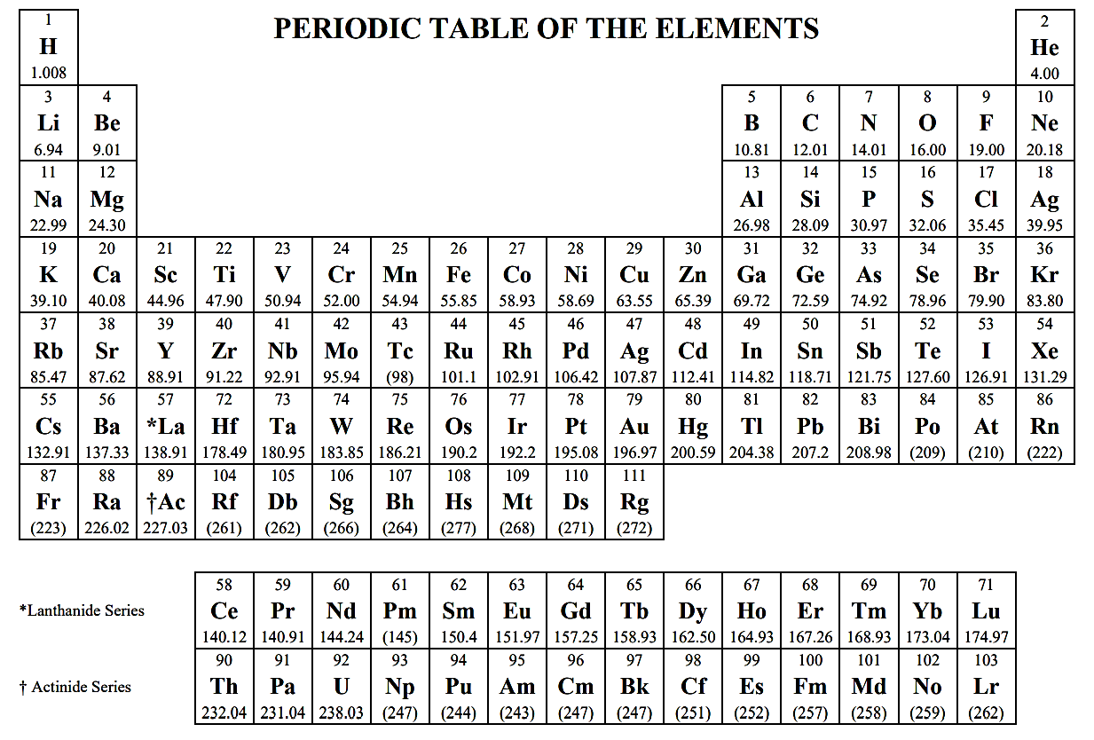

**ATOMIC STRUCTURE**

*E = hν c = λν* *ν* = frequency *λ* = wavelength

Planck’s constant, *h* = 6.626 × 10−34 J s

Speed of light, *c* = 2.998 × 108 ms−1

Avogadro’s number = 6.022 × 1023 mol-1  
Electron charge, *e* = −1.602 × 10−19 coulomb

**EQUILIBRIUM**

K*a* = [H+][A-]/[HA] , K*b* = [OH-][HB+]/[HA]

K*w* = [H+][OH−] = 1.0 × 10−14 at 25°C = K*a* × K*b*

pH = -log[H+] , pOH = -log[OH-] , 14=pH + pOH

pH = pK*a* + log [A-]/[HA]   
pK*a* = -logK*a* , pK*b* = -logK*b*

**KINETICS**

ln[A]*t* − ln[A]0 = −*kt* , 1/[A]t – 1/[A]0 = kt , t½ = 0.693/k

**GASES, LIQUIDS, SOLUTIONS**

*PV = nRT* , *PA = Ptotal* × XA , XA = mol A/total mol

*n = m/M* *m* = mass, *M* = molar mass

*D = m/V* , K = °C + 273 , *KE* = ½ *mv*2

*R*= 8.314 J mol-1K-1 = 0.08206 L atm mol-1K-1

= 62.36 L torr mol-1K-1

1atm = 760 mmHg = 760 torr  
*A = abc* *A* = absorbance, *a* = molar absorptivity,

*b* = path length, *c* = concentration

**THERMOCHEMISTRY/ELECTROCHEMISTRY**

*∆S°, ∆H°, ∆G° = Σproducts - Σreactants*

*q = mC∆T q = heat, C = specific heat*

*∆G° = ∆H° - T∆S° = -RT ln K = -nFE°*  
*F* = Faraday’s constant = 96,485 Coulombs/mol e-

*I = q/t* *I* = current (amps), *q* = charge(C), *t* = sec

1volt = 1 joule/1 coulomb