(Sub, Please make 110 double-sided copies of this (one for each student).)

CHEMISTRY -- EMERGENCY SUB ASSIGNMENT:

DIRECTIONS:
- Choose one (per day) of the projects below to complete. You cannot complete a project that you have already done before on another day.
- For more help / information, see the corresponding chapter in the textbook. Chapters and page numbers are listed.
- It is due to the sub by the end of THIS class period.
- It is for a GRADE.
- Write your name on the FRONT (if it is a poster).
- It is an INDIVIDUAL assignment. (No partner work.)
- You will be assessed on:
  - Accuracy and thoroughness of content (Solid facts and no “fake news”)
  - Organization & layout (you put effort and thought into it)
  - Catchy title
  - Creative
  - Effort
  - Clear, legible writing
  - Colorful
  - For a poster -- At LEAST 3 visuals / images (yes, you can try to draw!)
    - More visuals is always better!
  - For a writing assignment, it should be AT LEAST five paragraphs and fill a page.

TEXT: Living By Chemistry

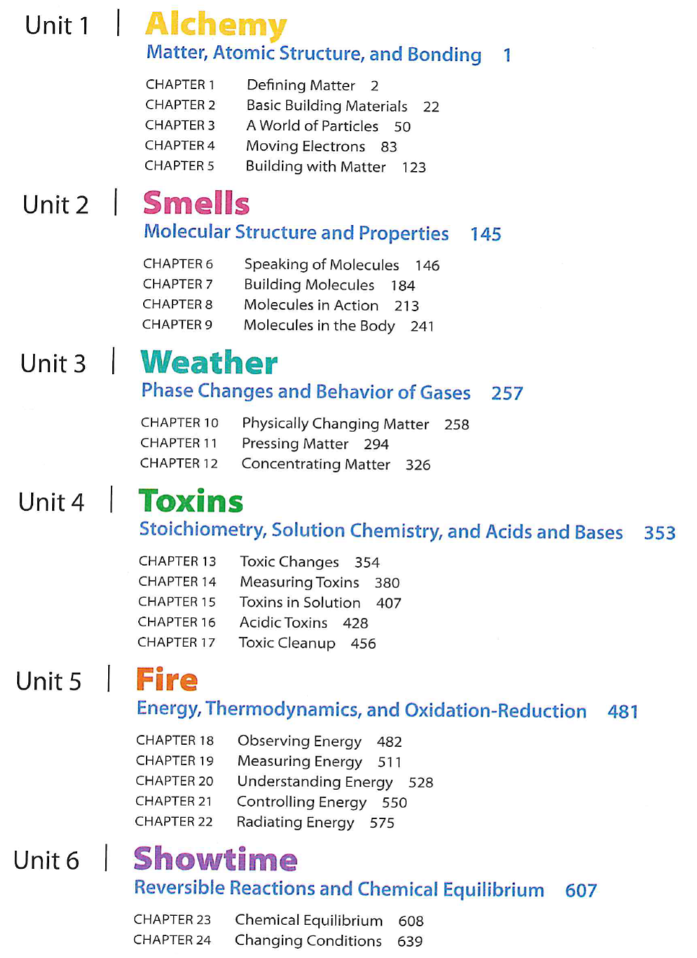
PROJECT OPTIONS:

CHAPTER 1: Defining Matter PROJECT -- (p. )
none

CHAPTER 2: Basic Building Materials PROJECT – Element Profile (p. 49)
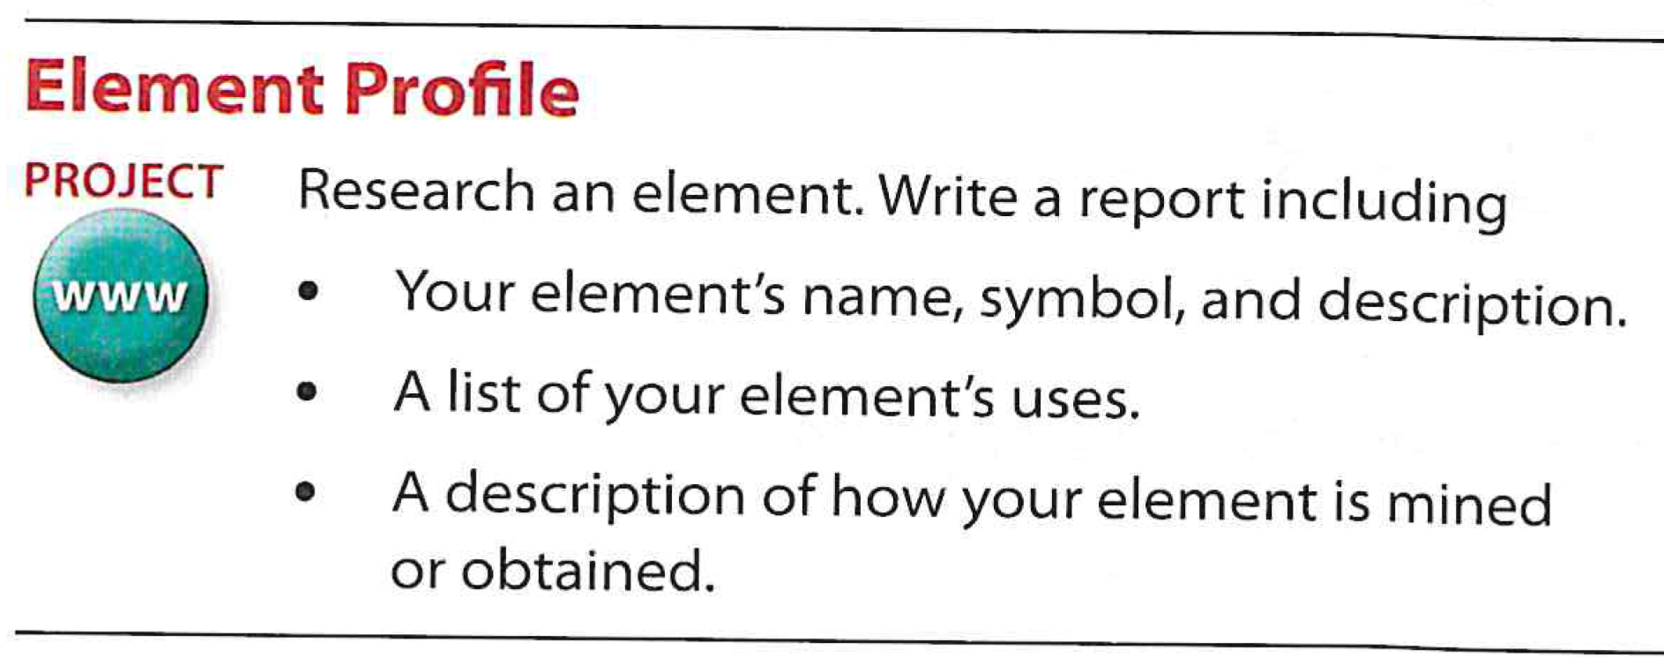

CHAPTER 3: A World of Particles PROJECT – Nuclear Power (p. 81)
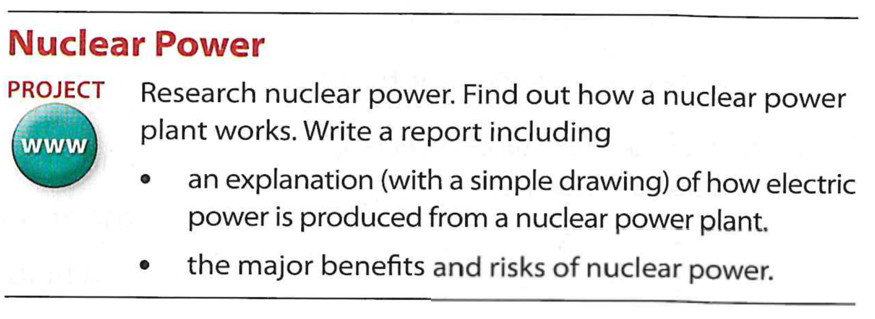

CHAPTER 4: Moving Electrons PROJECT -- (p. )
none

CHAPTER 5: Building with Matter PROJECT -- (p. )
none

CHAPTER 6: Speaking of Molecules PROJECT – Functional Groups (p. 183)
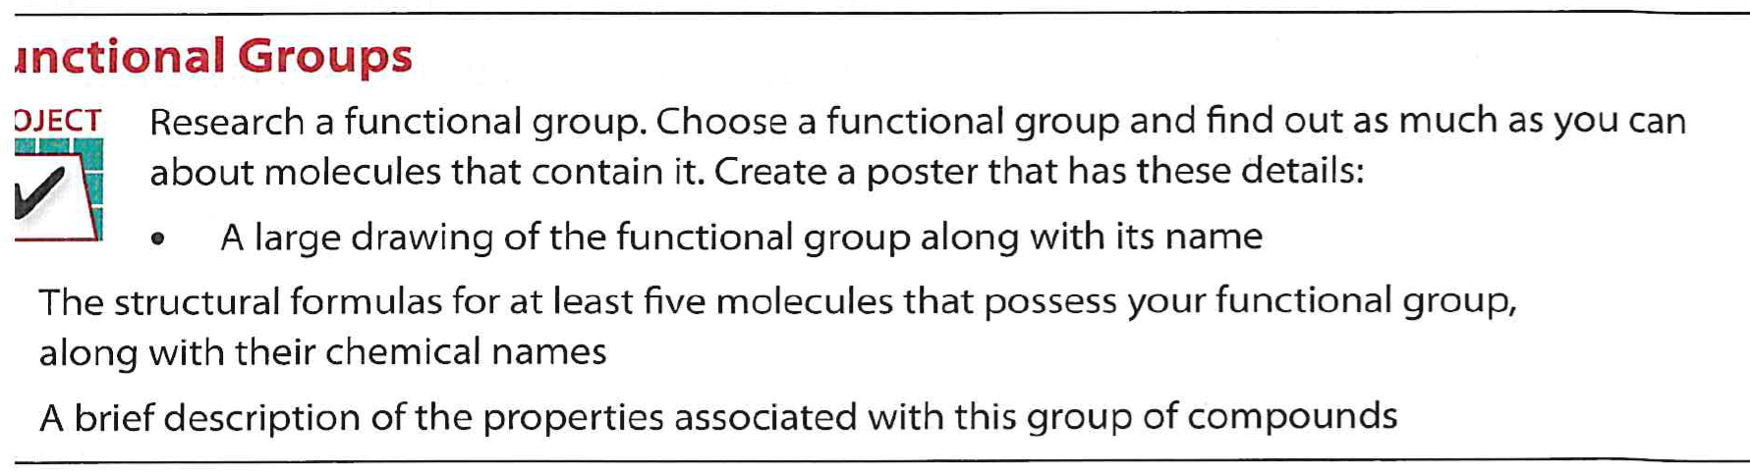

CHAPTER 7: Building Molecules PROJECT – Other Smell Classifications (p. 212)
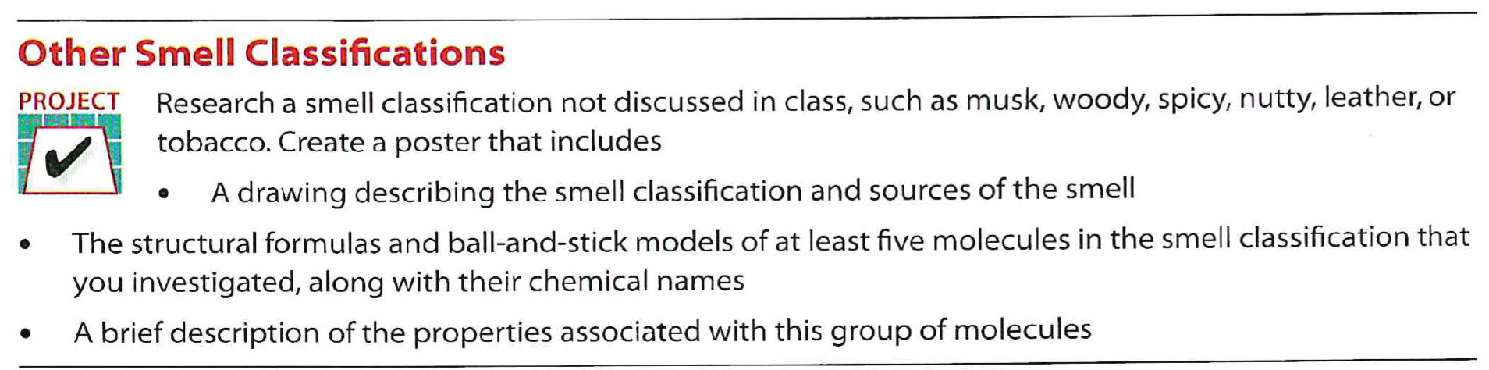

CHAPTER 8: Molecules in Action PROJECT – Sense of Smell Study (p. 240)
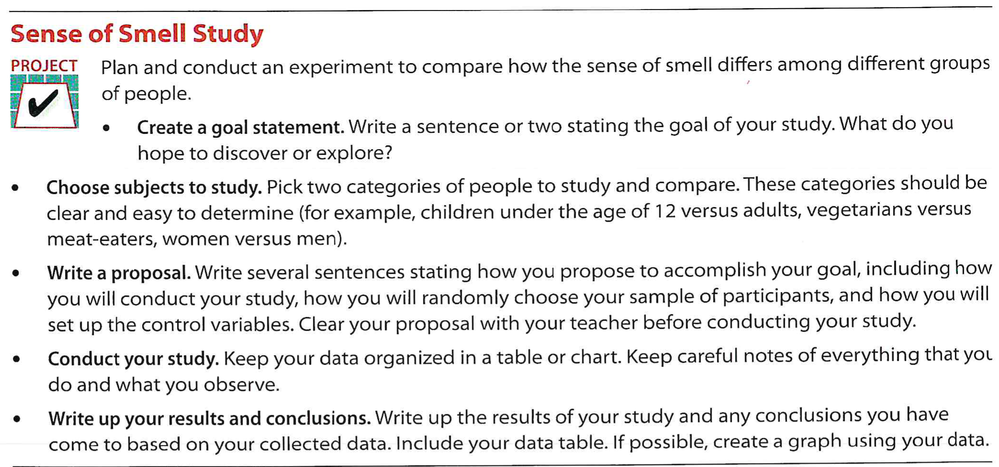

CHAPTER 9: Molecules in the Body PROJECT – Modeling a Receptor Site (p. 251)
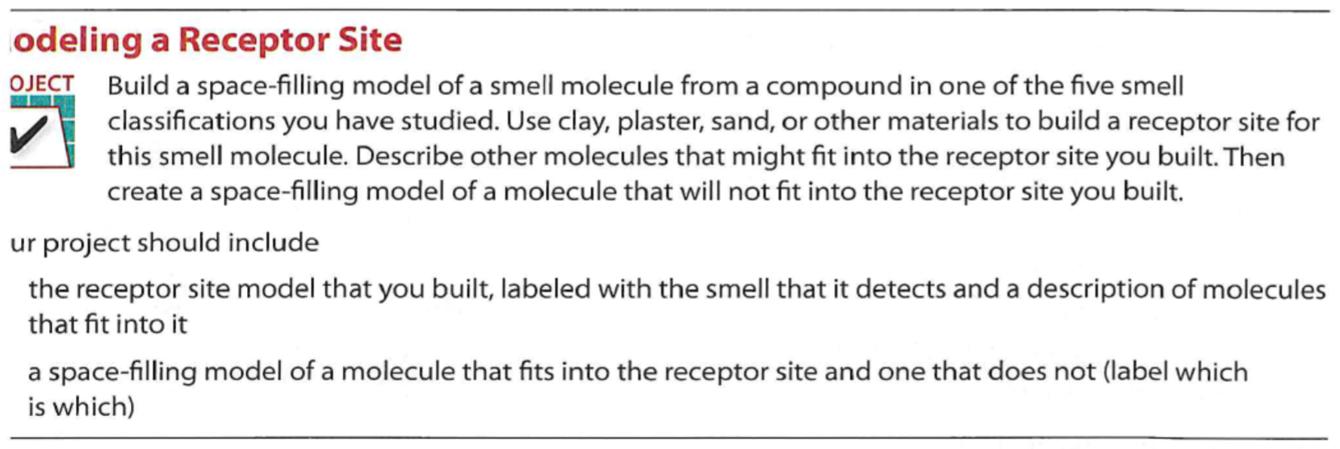

CHAPTER 10: Physically Changing Matter PROJECT – Different Thermometers (p. 293)
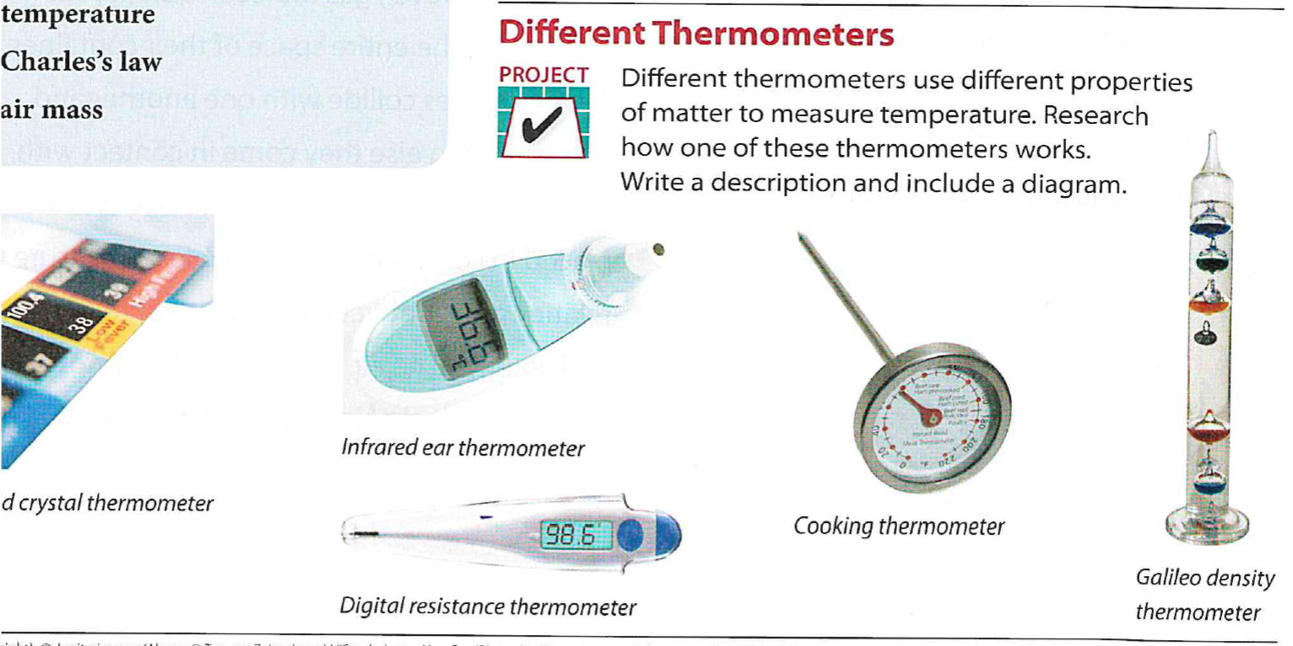

CHAPTER 11: Pressing Matter PROJECT – High and Low Pressure (p. 325)
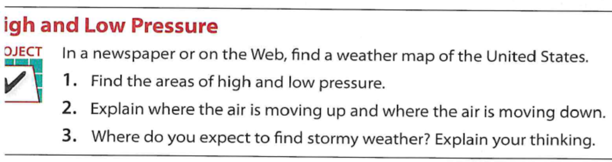

CHAPTER 12: Concentrating Matter PROJECT – Global Climate Change (p. 347)
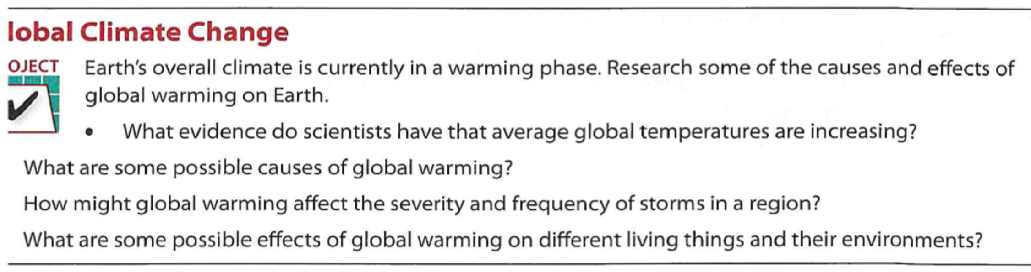

CHATER 13: Toxic Changes PROJECT -- Toxins in the Environment (p. 379)
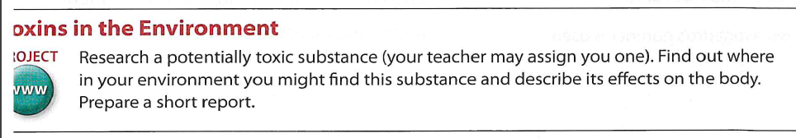

CHAPTER 14: Measuring Toxins PROJECT -- Lethal Dose of a Toxic Substance (p. 406)
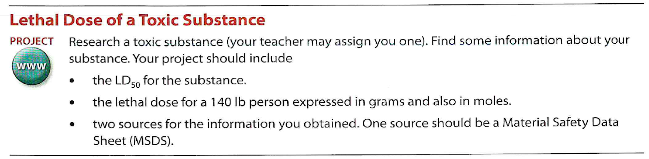

CHAPTER 15: Toxins in Solution PROJECT -- Types of Bonding (p. 427)
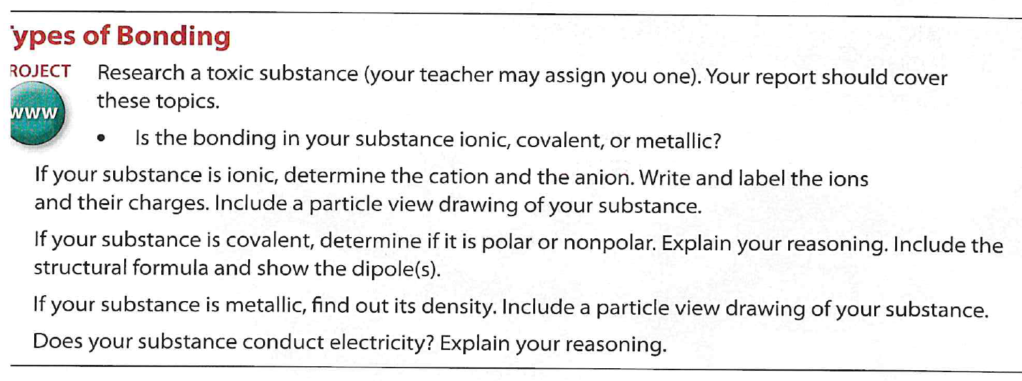

CHAPTER 16: Acidic Toxins PROJECT -- Dissolving Toxins (p. 455)
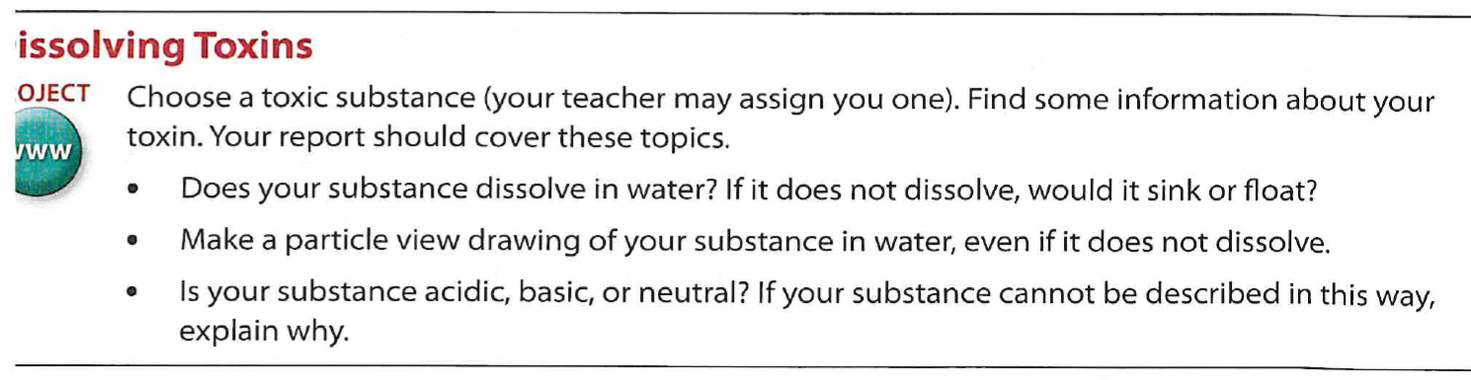

CHAPTER 17: Toxic Cleanup PROJECT -- Removing Toxins (p. 476)
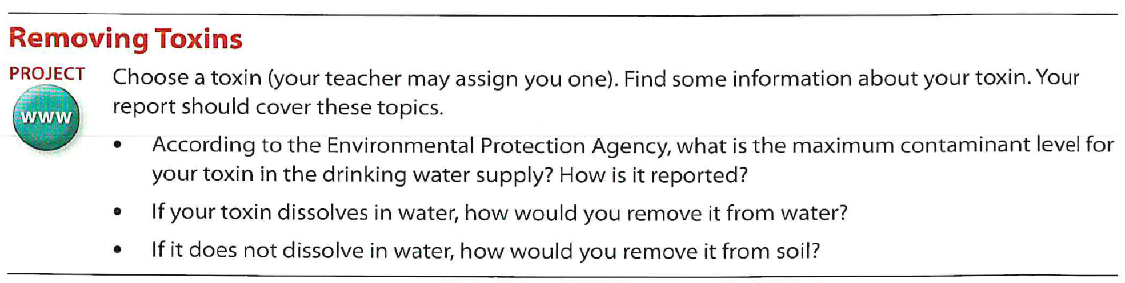

CHAPTER 18: Observing Energy PROJECT -- Uses of Fire (p. 510)
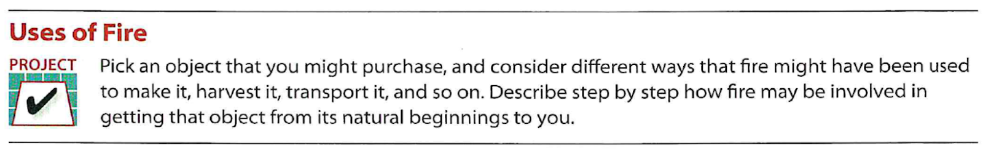

CHAPTER 19: Measuring Energy “Mini” PROJECT – Hydrogen Fuel (p. 526)

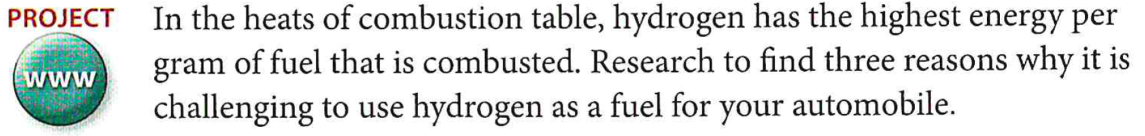

CHAPTER 20: Understanding Energy PROJECT – Uses of Fire (p. 549)
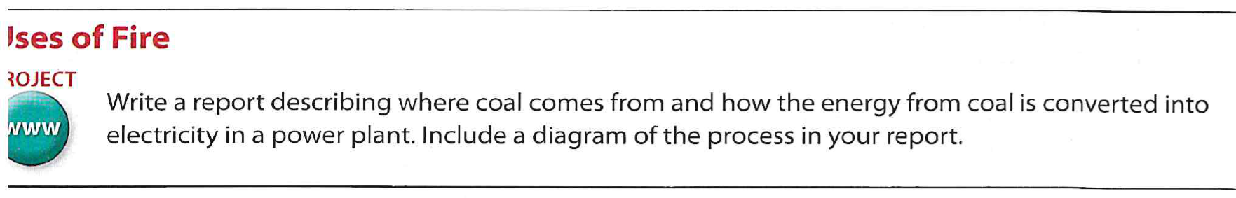

CHAPTER 21: Controlling Energy PROJECT -- (p. 574)
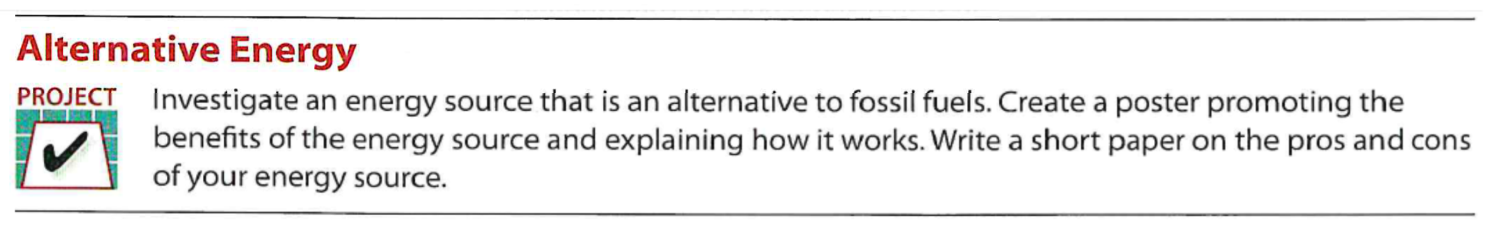

CHAPTER 22: Radiating Energy PROJECT – Wavelength and Energy (p. 600)
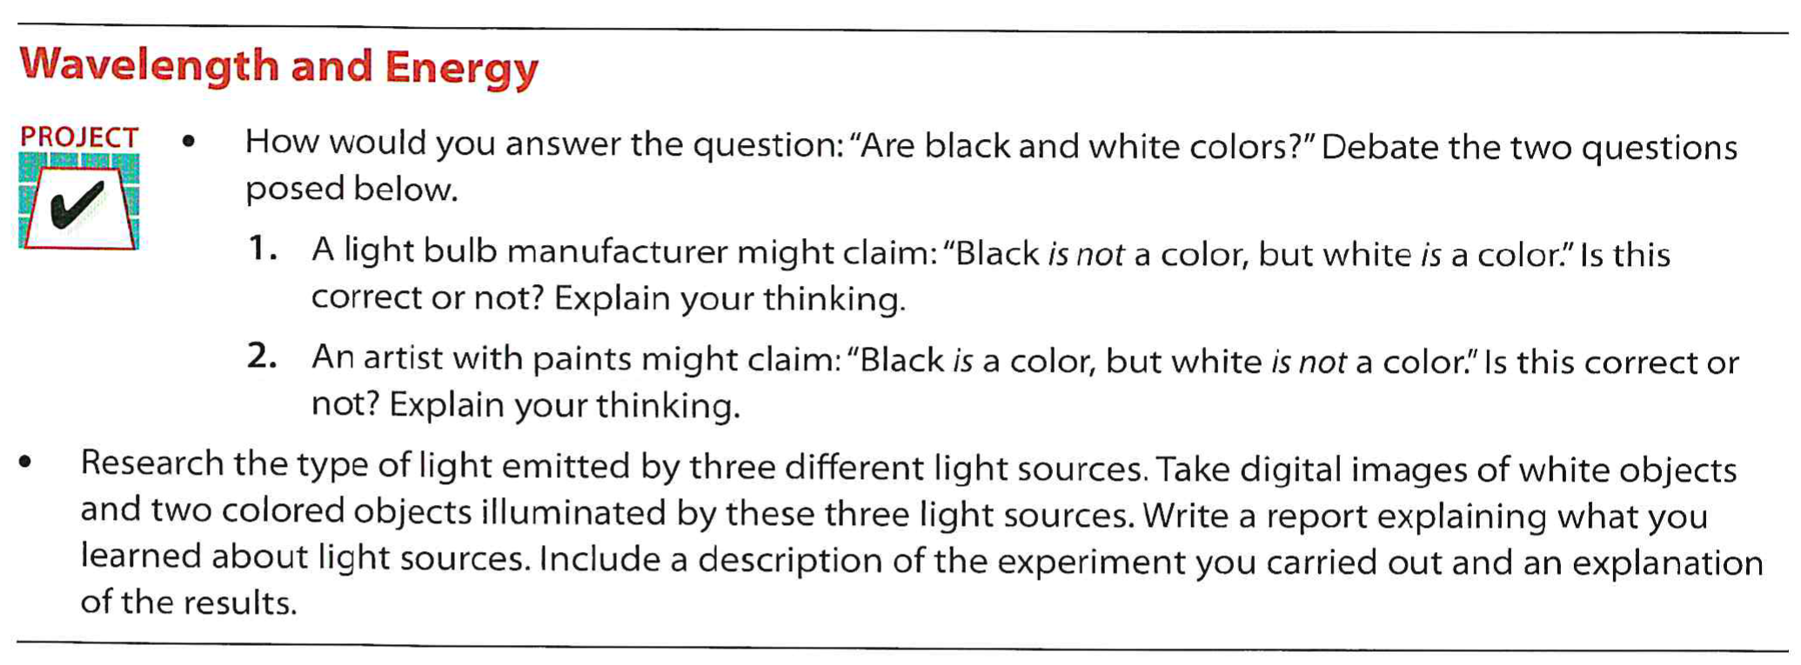

CHAPTER 23: Chemical Equilibrium PROJECT -- Neurotransmitters (p. 638)
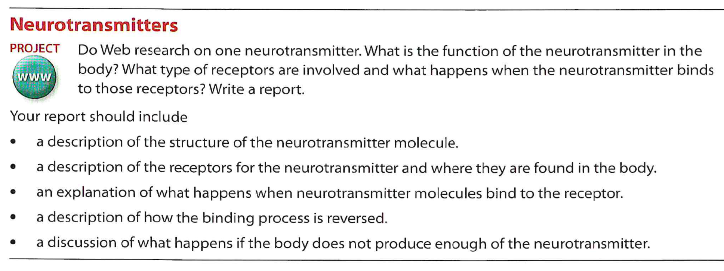

CHAPTER 24: Changing Conditions PROJECT – It’s Showtime! (p. 656)
