**Worksheet #2**

**Name: Period: Seat#:**

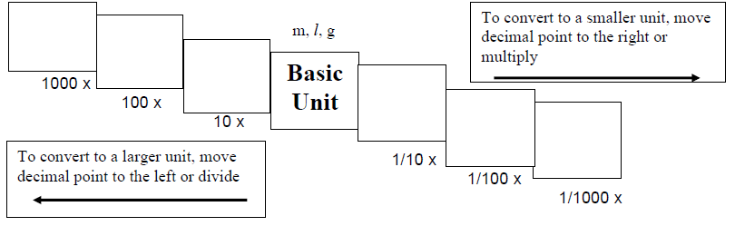

**Try these conversions using the ladder method:**

|  |  |  |
| --- | --- | --- |
| 1. 1000mg = _______ g | 1. 1L = _______ mL | 1. 160cm = _______ mm |
| 1. 14 km = _______ m | 1. 109g = _______ kg | 1. 250m = _______ km |

**Compare using <, >, or =:**

1. 56cm 6m **8)** 7g 698mg

**Write the correct abbreviation for each metric unit.**

1. Kilogram _____ **10)** Milliliter _____ **11)** Kilometer _____

**12)** Meter _____ **13)** Millimeter _____ **14)** Centimeter _____

**15)** Gram _____ **16)** Liter _____ **17)** Milligram _____

**Try these conversions, using the ladder method**

1. 2000 mg = ________ g

1. 104 km = ________ m
2. 480 cm = ________ m
3. 5.6 kg = ________ g
4. 8 mm = ________ cm
5. 5 L = ________ mL
6. 198 g = ________ kg
7. 75 mL = ________ L
8. 50 cm = ________ m
9. 5.6 m = ________ cm
10. 16 cm = _______ mm
11. 2500 m = _______ km
12. 65 g = _______ mg
13. 6.3 cm = _______ mm
14. 120 mg = ________ g

**Compare using <, >, or =:**

**33)** 63 cm 6 m **34)**  5 g 508 mg **35)** 1,500 mL 1.5 L

**36)**  536 cm 53.6 dm **37)** 43 mg 5 g **38)** 3.6 m 36 cm