Changes in Everyday Life – Just One of Those Days



**Directions:** Physical and chemical changes occur all around you every day.   
Read the story below and identify the physical and chemical changes you see within it.   
Circle physical changes in one color, and chemical changes in another color.   
Check your answers on the back when you are done – don’t peek ahead of time! ☺

Aaahhh. A brand new day. You go into the kitchen and open the fridge and pour a glass of milk. Before you even drink it you can tell from the smell that the milk has soured. You make a glass of ice water instead. Suddenly, you hear your cat screech. You run to help her and see she has stepped on a rusty tack (you know from science class that it rusted due to oxidation). You run to call the emergency traveling vet to come to your house. As you are walking back to the kitchen, you notice that some of your plants are dying and beginning to decay and that some saltwater has evaporated out of your fish tank. You make a mental note to take care of both after school.

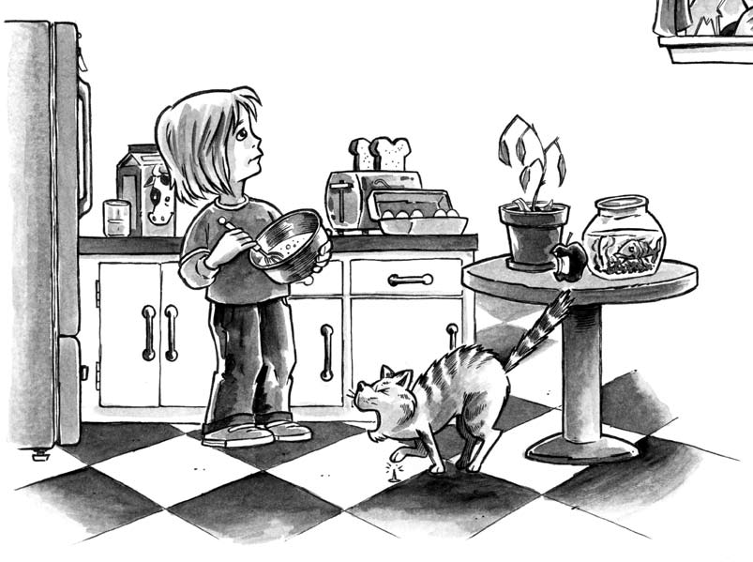You go back to get your ice water but find that the ice has melted. You are so thirsty you don’t care and drink it anyway. You suddenly realize how hungry you are and take an apple from the counter and bite into it. Yum. Then you hear glass breaking. (What kind of crazy day is this?!) You run to see what has happened and find that the traveling vet

accidentally broke a window. But he promises to pay for the damage before he takes your cat away to attend to her injury.

What a day, and it’s only just begun. You go back to the apple, but it has turned brown. You decide to make some eggs and toast instead. You first whip the eggs with a fork and then cook them. You pop a piece a bread in the toaster, which a few minutes later turns nice and brown. You melt some butter on the toast and add some grape jelly.

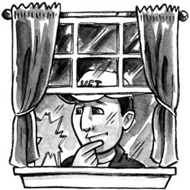You think about dyeing your hair purple but then remember how your parents reacted when your sister did that. So instead you just decide to finish breakfast and catch the bus, hoping the crazy part of your day has ended.

© 2007 WGBH Educational Foundation

**Just One of Those Days – KEY**

Students may note additional changes that are not mentioned here, such as the biting of the apple, the cracking of the eggs, or the jelly and butter mixing as being physical changes. Accept all reasonable answers.

* sour milk: *chemical*
* rusty tack: *chemical*
* decaying plants: *chemical*
* saltwater evaporation: *physical*
* ice melting: *physical*
* glass breaking: *physical*
* apple browning: *chemical*
* whipping eggs: *physical*
* cooking eggs: *chemical*
* browning bread: *chemical*
* melting butter: *physical*
* dyeing hair: *chemical*