Dimensional Analysis Maze

**Directions:** Solve the problems on your paper. Identify the correct answer. Use your marker to take that pathway on the maze.

Find your way to the end! Check your answers on the back when done – don’t peek ahead of time! ☺

15000 mL =  
? quarts

4823

6495 min =  
? days

START

5.25 weeks =   
? hours

840

184 ounces =   
? kg

5.99

1.3

4.777

5.48 x 10-2

882

5.48 x 104

14.5 gal =   
? mL

640 mi/day =  
? yd/min

9436 kg =  
? tons

46000

23.0 tons =   
? ounces

7.82 x 103

10.38

85305

33.6

736000

19575 sec =   
? hours

The   
End!

45375

2.58 x 10-4

258

3.744

389

0.04528

24212

15 m/s =   
? mi/hr

26 days =  
? min

9352

119

3.7 x 104

4.25 yd =  
? cm

2.850 km =   
? feet

1974 cm =   
? feet

0.258 kg =  
? grams

**KEY – Remember answers may vary based on what pathway you take!**

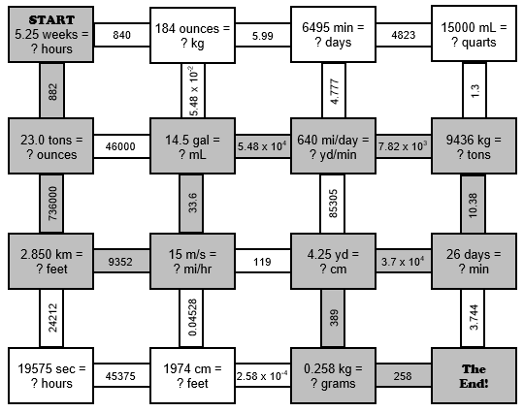

|  |  |  |  |
| --- | --- | --- | --- |
| **#1** | 5.25 wks | 7 days | 24 hours |
|  |  | 1 wk | 1 day |

|  |  |  |  |
| --- | --- | --- | --- |
| **#2** | 23.0 tons | 2000 lb | 16 oz |
|  |  | 1 ton | 1 lb |

|  |  |  |  |
| --- | --- | --- | --- |
| **#3** | 2.850 km | 1 mi | 5280 ft |
|  |  | 1.609 km | 1 mi |

|  |  |  |  |  |  |
| --- | --- | --- | --- | --- | --- |
| **#4** | 15 m | 1 km | 1 mi | 60 s | 60 min |
|  | s | 1000 m | 1.609 km | 1 min | 1 hr |

|  |  |  |  |
| --- | --- | --- | --- |
| **#5** | 14.5 gal | 3.78 L | 1000 mL |
|  |  | 1 gal | 1 L |

|  |  |  |  |  |  |
| --- | --- | --- | --- | --- | --- |
| **#6** | 640 mi | 5280 ft | 1 yd | 1 day | 1 hr |
|  | day | 1 mi | 3 ft | 24 hr | 60 min |

|  |  |  |  |
| --- | --- | --- | --- |
| **#7** | 9436 kg | 2.20 lb | 1 ton |
|  |  | 1 kg | 2000 lb |

|  |  |  |  |
| --- | --- | --- | --- |
| **#8** | 26 days | 24 hr | 60min |
|  |  | 1 day | 1 hr |

|  |  |  |  |  |
| --- | --- | --- | --- | --- |
| **#9** | 4.2 yd | 3 ft | 12 in | 2.54 cm |
|  |  | 1 yd | 1 ft | 1 in |

|  |  |  |
| --- | --- | --- |
| **#10** | 0.258 kg | 1000 g |
|  |  | 1 kg |