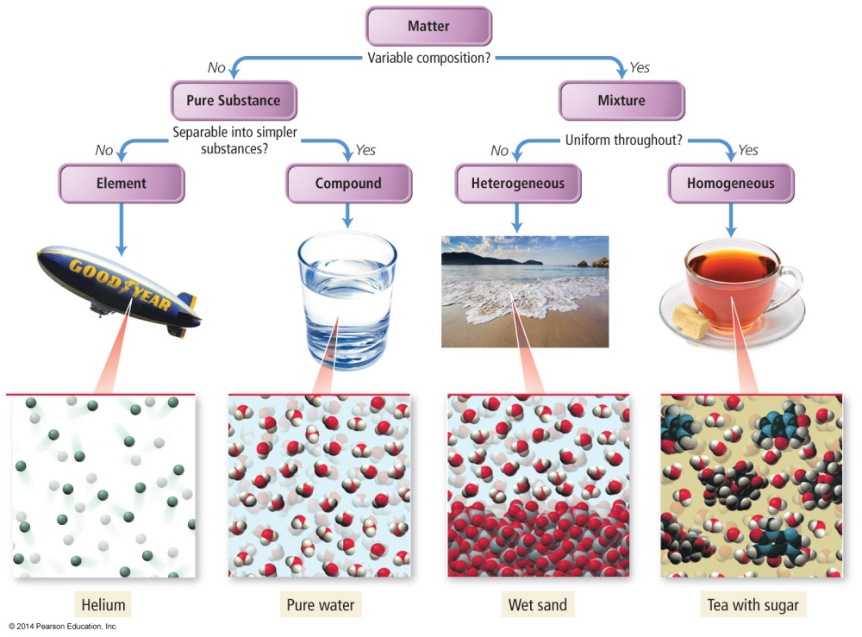

N-4



N-4



N-4



N-4