**Worksheet #8**

**Name: Period: Seat#:**

**Fill in the following definitions**

|  |  |  |
| --- | --- | --- |
|  | **Vocab Word** | **Definition** |
| **1)** | Physical Property |  |
| **2)** | Physical Change | *Change in which the identity of the substance does NOT change* |
| **3)** | Chemical Property |  |
| **4)** | Chemical Change |  |

**Identify each as either a chemical or a physical PROPERTY. Use C for chemical, P for physical.**

|  |  |  |  |
| --- | --- | --- | --- |
| **Statement** | **C or P** | **Statement** | **C or P** |
| 1. Blue color |  | 1. Density |  |
| 1. Flammability |  | 1. Solubility |  |
| 1. Supports combustion |  | 1. Sour taste |  |
| 1. Melting point |  | 1. Odor |  |
| 1. Luster |  | 1. Neutralize an acid |  |
| 1. Boiling point |  | 1. Hardness |  |
| 1. Reacts with acid to form H2 |  | 1. Reacts with water to form a gas |  |

**Identify each as either a chemical change or a physical CHANGE. Use C for chemical, P for physical.**

|  |  |  |  |
| --- | --- | --- | --- |
| **Statement** | **C or P** | **Statement** | **C or P** |
| 1. Glass breaking |  | 1. Hammering wood together |  |
| 1. A rusting bicycle |  | 1. Melting butter |  |
| 1. Separating sand from gravel |  | 1. Bleaching your hair |  |
| 1. Frying an egg |  | 1. Squeeze oranges for juice |  |
| 1. Melting ice |  | 1. Salt dissociating in water |  |
| 1. Mixing oil and water |  | 1. Water evaporating |  |
| 1. Cutting grass |  | 1. Burning leaves |  |
| 1. Fireworks exploding |  | 1. Cutting your hair |  |
| 1. Crushing a can |  | 1. Boiling water |  |
| 1. Combustion |  | 1. Melting |  |
| 1. Dissolving sugar |  | 1. Metabolizing |  |
| 1. Filtering |  | 1. Fermenting |  |
| 1. Decomposing |  | 1. Distilling |  |
| 1. A pellet of sodium is sliced into two pieces |  | 1. HCl reacts with NaOH to produce a salt, water, and heat |  |
| 1. Potassium chlorate decomposes to potassium chloride and oxygen gas |  | 1. Acid on lime stone produces carbon dioxide gas |  |
| 1. Ice melts |  | 1. Iron rusts |  |
| 1. Crack an egg |  | 1. Bake a cake |  |

**Directions:** Identify each lettered box with as many of the following terms that makes sense: atom, molecule, compound, solid, liquid, gas, pure substance, mixture, homogeneous mixture, heterogeneous mixture. Highlight the words that apply.

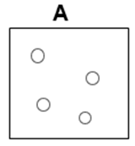

*Atom Solid Pure Substance*

*Molecule Liquid Mixture*

*Compound Gas Homogeneous*

*Heterogeneous*

**A**

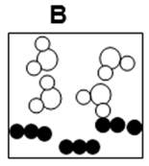

*Atom Solid Pure Substance*

*Molecule Liquid Mixture*

*Compound Gas Homogeneous*

*Heterogeneous*

**B**

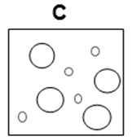

*Atom Solid Pure Substance*

*Molecule Liquid Mixture*

*Compound Gas Homogeneous*

*Heterogeneous*

**C**

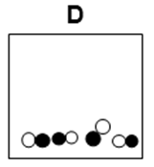

*Atom Solid Pure Substance*

*Molecule Liquid Mixture*

*Compound Gas Homogeneous*

*Heterogeneous*

**D**

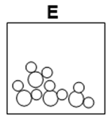

*Atom Solid Pure Substance*

*Molecule Liquid Mixture*

*Compound Gas Homogeneous*

*Heterogeneous*

**E**

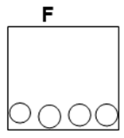

*Atom Solid Pure Substance*

*Molecule Liquid Mixture*

*Compound Gas Homogeneous*

*Heterogeneous*

**F**

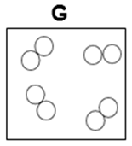

*Atom Solid Pure Substance*

*Molecule Liquid Mixture*

*Compound Gas Homogeneous*

*Heterogeneous*

**G**

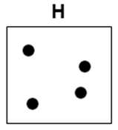

*Atom Solid Pure Substance*

*Molecule Liquid Mixture*

*Compound Gas Homogeneous*

*Heterogeneous*

**H**

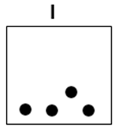

*Atom Solid Pure Substance*

*Molecule Liquid Mixture*

*Compound Gas Homogeneous*

*Heterogeneous*

**I**

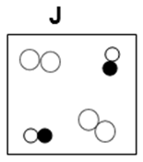

*Atom Solid Pure Substance*

*Molecule Liquid Mixture*

*Compound Gas Homogeneous*

*Heterogeneous*

**J**

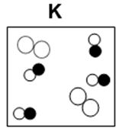

*Atom Solid Pure Substance*

*Molecule Liquid Mixture*

*Compound Gas Homogeneous*

*Heterogeneous*

**K**

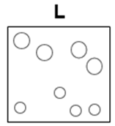

*Atom Solid Pure Substance*

*Molecule Liquid Mixture*

*Compound Gas Homogeneous*

*Heterogeneous*

**L**

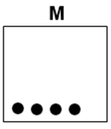

*Atom Solid Pure Substance*

*Molecule Liquid Mixture*

*Compound Gas Homogeneous*

*Heterogeneous*

**M**

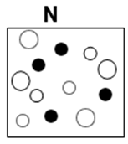

*Atom Solid Pure Substance*

*Molecule Liquid Mixture*

*Compound Gas Homogeneous*

*Heterogeneous*

**N**

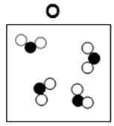

*Atom Solid Pure Substance*

*Molecule Liquid Mixture*

*Compound Gas Homogeneous*

*Heterogeneous*

**O**

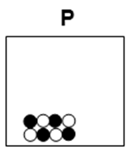

*Atom Solid Pure Substance*

*Molecule Liquid Mixture*

*Compound Gas Homogeneous*

*Heterogeneous*

**P**

**Group Review Activities** – Done in class.