Name: Period: Seat#:
Worksheet #7

MOLAR HEATS
- How much energy does it take to heat a 3.45 mole sample of silver from 15°C to 120°C if the specific heat of silver
is 0.240 J/g°C? 9378.18 J
- If the temperature of a 50.0 gram block of aluminum increases by 10.9K when heated by 500 Joules, calculate the specific heat of the aluminum block and the molar heat capacity of the aluminum block. 0.917 J/g°C, 24.8 J/mol°C
- The specific heat of gold is 0.128 J/g•K. Calculate the molar heat capacity. 25.21 J/mol•K
- Calculate the amount of heat necessary to melt 27 grams of ice if the molar heat of fusion of ice is 6.009 kJ/mol. Use the molar heat value given here (not regular latent heat in grams), and get your answer in kJ. 9.01 kJ
- If the molar heat capacity of Magnesium is 24.89 J/mol•K, calculate the energy required to heat 35 grams of magnesium from 30°C to 55°C. 895.9 J

HEATS OF REACTION
- B₂O₃ + 3H₂O 3O₂ + B₂H₆ ∆H = +2035 kJ
  - Is this reaction endo or exothermic?
  - Rewrite the equation with the heat written as a reactant or a product based on your answer to part A
  - How much energy is involved when 15 grams of B₂O₃ is reacted, and is it absorbed or released? 436.6 kJ
- If the ∆Hrxn for the combustion of tetracarbon decahydride is -5756 kJ/mol_{rxn}, how much energy is released when 50 grams of the fuel is combusted? -2475.9 kJ
- CH₄ + 2O₂ CO₂ + 2H₂O ∆H° = -890.4 kJ/mol_{rxn}
a. How much energy is given off when 2.50 mol of CH₄ are burned? -2226 kJ

b. How much energy is released when 22.4 g of O₂ are consumed while excess CH₄ is burned? -311.64 kJ

- Sometimes you don’t know what the heat of reaction is for a given equation. BUT if you know how much energy it takes to FORM each of the chemicals in the reaction, then you can figure out what the heat of reaction is for the equation you are interested in! ∆H°_{rxn} = ∆H°_{formation} Products - ∆H°_{formation} Reactants Don’t forget you want to take into account the number of moles of each product and reactant in the balanced equation!

  - Calculate the ∆H°_{rxn} for the combustion of methane using the “Heats of Formation” given below. -890.36 kJ
CH₄ + 2O₂ CO₂ + 2H₂O
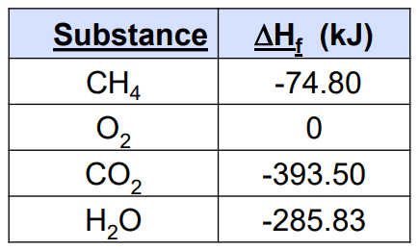

  - What do you notice about your answer to #9 and the ∆H° value you were given for the combustion of methane in #8 ?

- Ethanol is used as an additive in many fuels today. What is the ∆H°_{rxn} for the combustion of ethanol? -2470. kJ
2C₂H₅OH + 6O₂ 4CO₂ + 6H₂O
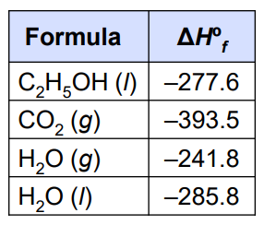
- What would ∆H° be for the reverse of the reaction below?  SrO _{(s)} + CO_{2 (g)} SrCO _{(s)} ∆H° = -234 kJ/mol | - What would ∆H° be for double the reaction below?  SrO _{(s)} + CO_{2 (g)} SrCO _{(s)} ∆H° = -234 kJ/mol
- Find ∆H° for the reaction below, using the steps provided. -58 kJ
2 NO₂ _{(g)} N₂O₄ _{(g)}

- N₂ _{(g)} + 2 O₂ _{(g)} 2 NO₂ _{(g))} ∆H° = 67.7 kJ
- N₂ _{(g)} + 2 O₂ _{(g)} N₂O_{4 (g)} ∆H° = 9.7 kJ

- Find ∆H° for the reaction below, using the steps provided. 15.3 kJ
2C _{(s)} + 2 H₂O _{(g)} CH₄ _{(g)} + CO₂ _{(g)}

- C _{(s)} + H₂O _{(g)} CO _{(g)} + H_{2 (g)} ∆H° = 131.3 kJ
- CO _{(g)} + H₂O _{(g)} CO_{2 (g)} + H_{2 (g)} ∆H° = -41.2 kJ
- CH_{4 (g)} + H₂O _{(g)} 3H_{2 (g)} + CO _{(g)} ∆H° = 206.1 kJ
- Find ∆H° for the reaction below, using the steps provided. -30 kJ
A + B C

- 2A 2D ∆H° = 110 kJ
- D + B C ∆H° = -85 kJ

BOND ENERGIES – use this table to perform any calculations.
- Fill in the blanks.
It ______________________
energy to break bonds

It ______________________
energy to form bonds

Breaking bonds is ______________________

Forming bonds is ________________________

Breaking bonds has a ____________________ algebraic sign for ∆H°

Forming bonds has a ______________________
algebraic sign for ∆H°
- Find ∆H° for the formation of water. 2 H₂ + O₂ 2 H₂O -482 kJ

H – H H – O – H
+ O = O
H – H H – O – H
- Find ∆H° for the combustion of methane. CH₄ + 2O₂ CO₂ + 2H₂O -808 kJ
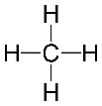
O = O H – O – H
+ O = C = O +
O = O H – O – H
- Find the ∆H° for the reaction: CH₄ + Cl₂ CH₃Cl + HCl -104 kJ
- Find the ∆H° for the reaction: -208 kJ
______CH₄ + ______Cl₂ ______CH₂Cl₂ + _____HCl

