Name: Period: Seat#:
Worksheet #7

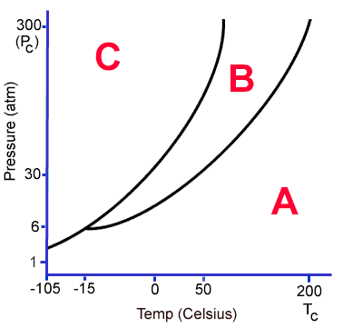 | - Which area of the graph represents the liquid phase? | - Which area of the graph represents the gas phase? | - A phase change from Phase A to Phase B is known as what?
 | - A phase change from Phase B to Phase C is known as what? | - A phase change from Phase C to Phase A is known as what? | - At 30 atmospheres pressure, the melting point of this substance is what?
- What phase change occurs when the temperature of the substance is held constant at -15 ºC, and the pressure increases from 1 atmosphere to 30 atmospheres? |  | - A phase change from Phase B to Phase A is known as what? | - A phase change from Phase C to B is known as what?
- Above 200°C what is the only phase that cannot exist for this substance? | - The triple point of this substance occurs at what temperature and pressure? | - At 30 atmospheres pressure, the boiling point of this substance is what? | - At -50°C, which phase cannot exist for this substance?
- Explain what the triple point is. |  | - Explain what the critical point is.
- Determine the final temperature when 18.0 g of ice at -10.0 °C mixes with 275.0 grams of water at 60.0 °C 51.1°C
- Determine the final temperature when 10.0 g of steam at 100.0 °C mixes with 500.0 grams of water at 25.0 °C. 37.07°C
- You have an unknown quantity of ice. You put all the ice into a cup with 110g of water. If the water temperature decreases by 14 degrees, and the final temperature is 12°C, what was the mass of the ice that you put in the cup? 16.76 g
- How much energy does it take to heat a 3.45 mole sample of silver from 15°C to 120°C if the specific heat of silver
is 0.240 J/g°C? 9378.18 J
- A 75 g piece of copper (which has a molar heat capacity of 24.8 kJ/mol•K) is heated to 68°C and dropped into a calorimeter containing water (specific heat capacity of water is 4.18 J/g°C) initially at 20°C. The final temperature of the water is 26.5°C. Calculate the mass of water in the calorimeter. 44698 g
- If the temperature of a 50.0 gram block of aluminum increases by 10.9K when heated by 500 Joules, calculate the specific heat of the aluminum block and the molar heat capacity of the aluminum block. 0.917 J/g°C, 24.8 J/mol°C
- The specific heat of gold is 0.128 J/g•K. Calculate the molar heat capacity. 25.21 J/mol•K
- Calculate the amount of heat necessary to melt 27 grams of ice if the molar heat of fusion of ice is 6.009 kJ/mol. Use the molar heat value given here (not regular latent heat in grams), and get your answer in kJ. 9.01 kJ
- The specific heat capacity for silver is 0.24 J/g°C. Calculate the molar heat capacity of silver. 25.89 J/mol•K
- If it takes 585 J of energy to raise the temperature of 125.6g Hg from 20°C to 53.5°C. Calculate the specific heat capacity and the molar heat capacity of Hg. 0.139 J/g°C, 27.89 J/mol°C
- If the molar heat capacity of Magnesium is 24.89 J/mol•K, calculate the energy required to heat 35 grams of magnesium from 30°C to 55°C. 895.9 J
- B₂O₃ + 3H₂O 3O₂ + B₂H₆ ∆H = +2035 kJ
  - Is this reaction endo or exothermic?
  - Rewrite the equation with the heat written as a reactant or a product based on your answer to part A
  - How much energy is involved when 15grams of B₂O₃ is reacted, and is it absorbed or released? 436.6 kJ
- If the ∆Hrxn for the combustion of tetracarbon decahydride is -5756 kJ, how much energy is released when 50 grams of the fuel is combusted? -2475.9 kJ

