**Calculate the energy released when 135g of aluminum are reacted in the below equation.**

2Al + Fe2O3 → 2Fe + Al2O3 ΔHrxn=−851.5kJ

Calculate ΔH for combustion of methane, CH4

**CH4(g) + 2O2(g) 🡪 CO2(g) + 2H2O(l)**

|  |  |
| --- | --- |
| **Substance** | **ΔHf  (kJ)** |
| CH4 | -74.80 |
| O2 | 0 |
| CO2 | -393.50 |
| H2O | -285.83 |

What is Δ*H*ºrxn (kJ) for combustion of ethanol?  
**2 C2H5OH (*l* ) + 6 O2 (*g*) → 4 CO2 (*g*) + 6 H2O (*l* )**

|  |  |
| --- | --- |
| **Formula** | **Δ*H*º*f*** |
| C2H5OH (*l*) | –277.6 |
| CO2 (*g*) | –393.5 |
| H2O (*g*) | –241.8 |
| H2O (*l*) | –285.8 |

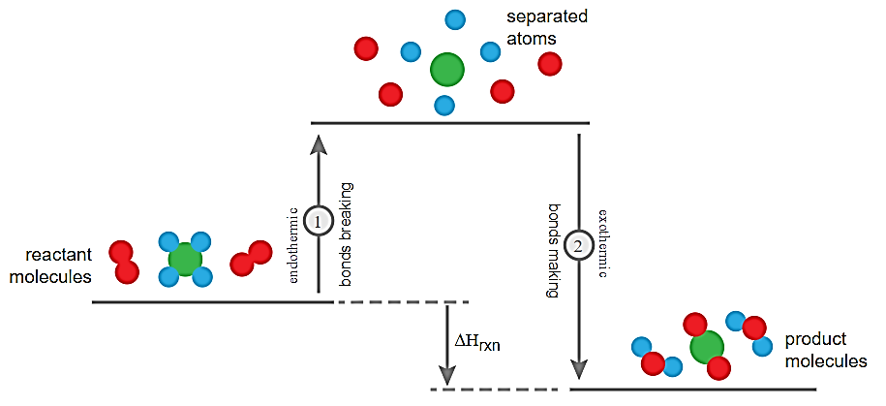

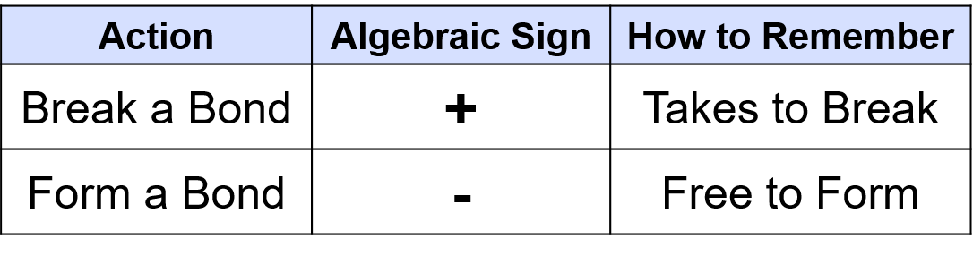

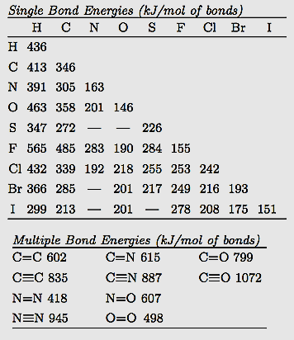

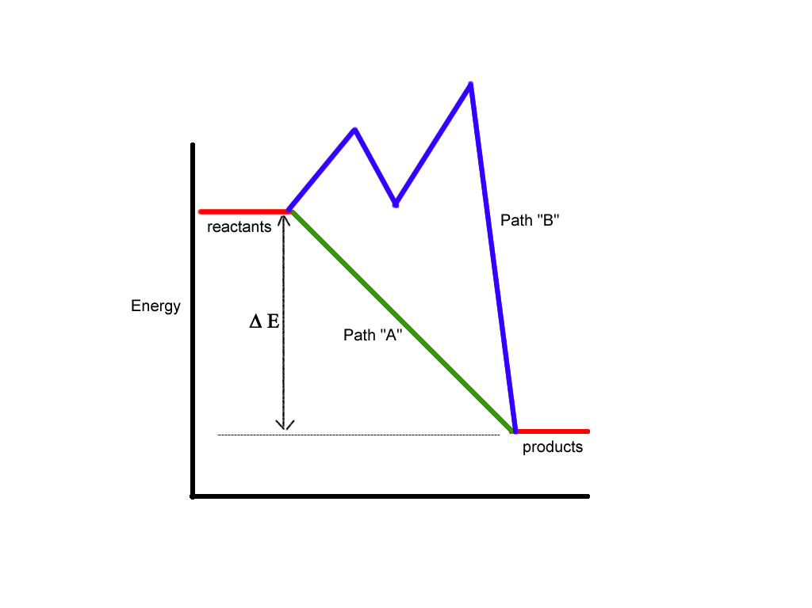

Calculate ΔH for combustion of CH4:

**CH4 + 2O2 🡪 CO2 + 2H2O**

|  |  |  |
| --- | --- | --- |
| **#** | **Reaction** | **ΔHo** |
| 1 | C + 2H2 🡪 CH4 | -74.80 kJ |
| 2 | C + O2 🡪 CO2 | -393.50 kJ |
| 3 | H2 + ½ O2 🡪 H2O | -285.83 kJ |

**2 NOCl (*g*) → N2 (*g*) + O2 (*g*) + Cl2 (*g*) Δ*H* = ?**

**Rxn #1) ½ N2(*g*) + ½ O2 (*g*) → NO (*g*)**

**Δ*H* = 90.3 kJ**

**Rxn #2) NO (*g*) + ½ Cl2 (*g*) → NOCl (*g*)**

**Δ*H* = –38.6 kJ**

**Calculate the energy released when 135g of aluminum are reacted in the below equation.**

2Al + Fe2O3 → 2Fe + Al2O3 ΔHrxn=−851.5kJ

Calculate ΔH for combustion of methane, CH4

**CH4(g) + 2O2(g) 🡪 CO2(g) + 2H2O(l)**

|  |  |
| --- | --- |
| **Substance** | **ΔHf  (kJ)** |
| CH4 | -74.80 |
| O2 | 0 |
| CO2 | -393.50 |
| H2O | -285.83 |

What is Δ*H*ºrxn (kJ) for combustion of ethanol?  
**2 C2H5OH (*l* ) + 6 O2 (*g*) → 4 CO2 (*g*) + 6 H2O (*l* )**

|  |  |
| --- | --- |
| **Formula** | **Δ*H*º*f*** |
| C2H5OH (*l*) | –277.6 |
| CO2 (*g*) | –393.5 |
| H2O (*g*) | –241.8 |
| H2O (*l*) | –285.8 |









Calculate ΔH for combustion of CH4:

**CH4 + 2O2 🡪 CO2 + 2H2O**

|  |  |  |
| --- | --- | --- |
| **#** | **Reaction** | **ΔHo** |
| 1 | C + 2H2 🡪 CH4 | -74.80 kJ |
| 2 | C + O2 🡪 CO2 | -393.50 kJ |
| 3 | H2 + ½ O2 🡪 H2O | -285.83 kJ |

**2 NOCl (*g*) → N2 (*g*) + O2 (*g*) + Cl2 (*g*) Δ*H* = ?**

**Rxn #1) ½ N2(*g*) + ½ O2 (*g*) → NO (*g*)**

**Δ*H* = 90.3 kJ**

**Rxn #2) NO (*g*) + ½ Cl2 (*g*) → NOCl (*g*)**

**Δ*H* = –38.6 kJ**

**Calculate the energy released when 135g of aluminum are reacted in the below equation.**

2Al + Fe2O3 → 2Fe + Al2O3 ΔHrxn=−851.5kJ

Calculate ΔH for combustion of methane, CH4

**CH4(g) + 2O2(g) 🡪 CO2(g) + 2H2O(l)**

|  |  |
| --- | --- |
| **Substance** | **ΔHf  (kJ)** |
| CH4 | -74.80 |
| O2 | 0 |
| CO2 | -393.50 |
| H2O | -285.83 |

What is Δ*H*ºrxn (kJ) for combustion of ethanol?  
**2 C2H5OH (*l* ) + 6 O2 (*g*) → 4 CO2 (*g*) + 6 H2O (*l* )**

|  |  |
| --- | --- |
| **Formula** | **Δ*H*º*f*** |
| C2H5OH (*l*) | –277.6 |
| CO2 (*g*) | –393.5 |
| H2O (*g*) | –241.8 |
| H2O (*l*) | –285.8 |









Calculate ΔH for combustion of CH4:

**CH4 + 2O2 🡪 CO2 + 2H2O**

|  |  |  |
| --- | --- | --- |
| **#** | **Reaction** | **ΔHo** |
| 1 | C + 2H2 🡪 CH4 | -74.80 kJ |
| 2 | C + O2 🡪 CO2 | -393.50 kJ |
| 3 | H2 + ½ O2 🡪 H2O | -285.83 kJ |

**2 NOCl (*g*) → N2 (*g*) + O2 (*g*) + Cl2 (*g*) Δ*H* = ?**

**Rxn #1) ½ N2(*g*) + ½ O2 (*g*) → NO (*g*)**

**Δ*H* = 90.3 kJ**

**Rxn #2) NO (*g*) + ½ Cl2 (*g*) → NOCl (*g*)**

**Δ*H* = –38.6 kJ**