**Name: Period: Seat#:**

**Worksheet #1**

**Directions:** Read this page and take notes and annotate it. There is potentially information in here you may not be familiar with. If you come across anything you do not understand you need to ask about it! At the end there are questions to check that you were able to follow and grasp the material talked about here. These are selections of reading by various people, credit given when possible.

**What is Thermochemistry?**

*-Perrot, Pierre (1998). A to Z of Thermodynamics. Oxford University Press*

Thermochemistry is the study the transfer of energy as heat from either chemical or physical changes. Heat is the energy that can be transferred between objects and is always transferred from high energy to low energy. It is important to note that heat and temperature are actually different! While heat is the amount of energy being transferred, temperature is just a measurement of the average kinetic energy of the molecules.

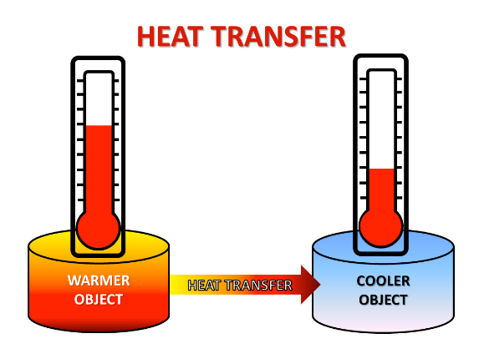

**Types of Heat Transfer**

There are three basic types of heat transfer:conduction, convection, and radiation.

Conduction: the transfer of heat through touch

Convection: the transfer of heat through fluids   
 (air is also a fluid!)

Radiation: the transfer of heat through electromagnetic   
 waves (also known as light)

*In the image to the right, label the empty boxes with the type of heat transfer present.*

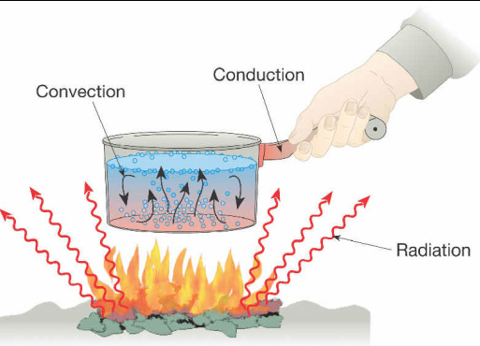

**1st Law of Thermodynamics**

The 1st Law of Thermodynamics states that energy is neither created, nor destroyed, it can only be transferred or converted into a different form - similar to the Law of Conservation of Energy. The total change of energy in a system must equal the work done by a system plus the heat that is gained or lost by the system. We will be focusing exclusively on the heat that is gained or lost. We will not worry about the work portion. This heat is given the variable (q) of (Q).

**Enthalpy (∆H)**

Enthalpy is the total energy of the system when taking into account heat, pressure and volume variables. However, for this class we will assume all our problems occur at constant pressure. When we make this assumption we can say that the enthalpy is equal to just the heat energy (Q)

q = ∆H

Exothermic Reaction - When the change in enthalpy is negative, it means that heat is being released*.* In the graph to the right you notice in the exothermic graph that the reactants have higher energy than the products

Endothermic - When the change in enthalpy is positive, it means that heat is being gained by the system. Notice that in the endothermic graph, the products now have higher energy than the reactants. As the temperature of a system increases, so does the enthalpy of the system.

**Specific Heat (C)**

All types of matter have a property known as specific heat capacity, or simply specific heat or even heat capacity.

Specific Heat - The amount energy needed to raise the temperature of one gram of a substance one degree Celsius. The units for specific heat are:

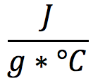

J is the variable for Joules, which is the SI unit of heat, as well as other forms of energy. We can use the specific heat capacity of substances to calculate how much energy would be transferred for every degree Celsius the temperature changes, for a given mass of a substance.

***q = m * C * ∆T***

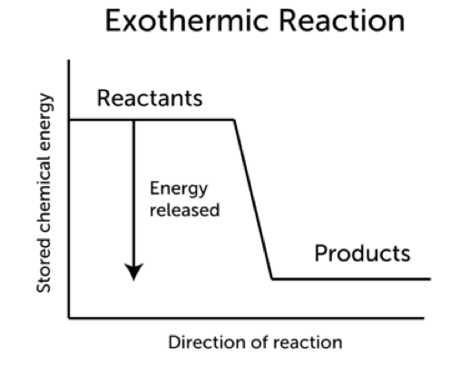

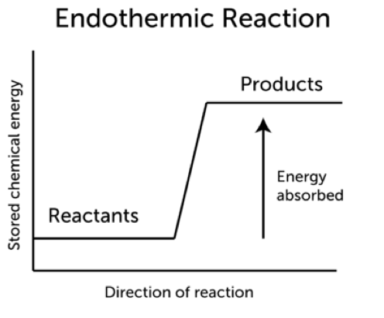

Identify what each variable stands for in the equation to the right and provide the units that would be used for that variable:

*q =*

*m =*

*C =*

*∆T =*

|  |  |  |  |  |  |  |
| --- | --- | --- | --- | --- | --- | --- |
| Thermochemistry Webquest | | | | | | |
| **Part 1 - Vocabulary** | | Click on the first letter of the word you are looking for the definition of: https://goo.gl/o93Uk7 | | | | |
| **1** | Kinetic Energy |  | | | | |
| **2** | Potential Energy |  | | | | |
| **3** | Endothermic |  | | | | |
| **4** | Exothermic |  | | | | |
| **5** | Activation Energy |  | | | | |
| **6** | Heat of Reaction |  | | | | |
| **7** | Enthalpy |  | | | | |
| **8** | Entropy |  | | | | |
| **9** | Specific Heat |  | | | | |
| **Part 2 - Watch a Video** | | Watch the Video at the link below. Then answer the questions. http://goo.gl/LHZTPO | | | | |
| **1** | What does it mean to have thermoenergy | |  | | | |
| **2** | What temperature would something need to be, in order to not have thermoenergy. | |  | | | |
| **3** | What is the difference between potential and kinetic energy? | |  | | | |
| **4** | What is thermodynamics? | |  | | | |
| **5** | What is the equation for change of energy to a system? | |  | | | |
| **6** | What is the difference between an exothermic and endothermic reaction? | |  | | | |
| **7** | Do you think the ΔE for an exothermic reaction would be positive or negative? | |  | | | |
| **Part 3 - Specific Heat** | | Use the following link to answer the questions below: https://goo.gl/IEbRz2 | | | | |
| **1** | Write the formula that can be used to calculate the heat energy being absorbed or released in a system | | |  | | |
| **2** | Describe each part of the equation: heat gained or lost =  Mass x Change in Temperature  x Specific Heat | | | Mass | Change in Temp | Specific Heat |
| **3** | Using the Table link at the bottom of the equation box, what solid substance has the highest specific heat? | | | | |  |

|  |  |
| --- | --- |
| Thermo Webquest – Follow Up Questions | |
| 1. Define the study of thermochemistry | 1. What is the first law of Thermodynamics? |
| 1. What is the difference between heat and temperature? | 1. What are the three types of heat transfer? |
| 1. Which type of heat transfer happens when you boil an egg? | 1. What type of heat transfer does the sun use to heat the earth? |
| 1. What is the temperature of boiling and freezing water in °C and in K? | 1. What is the difference between exothermic and endothermic change? |
| 1. How are exothermic and endothermic changes used in sports? | 1. Why are we keeping pressure constant for all the internal energy problems in this class? |
| 1. Give an example of a fluid that you did not know was a fluid before today. Explain why it is a fluid | 1. When you use an ice pack on a sore muscle, what is the exothermic reaction, and what is the endothermic reaction? |
| 1. Explain how heat is transferred | 1. What is wrong with this statement? “Would you like some ice to cool your drink down?” |
| 1. Scientifically, how would you reword the statement in #14? | 1. Can you think of another food besides popcorn that might use the three different heat transfers in cooking? |