**Name: Period: Seat#:**

**Worksheet #5\***

**Directions**: Any worksheet that is labeled with an * means it is suggested extra practice. We do not always have time to assign every possible worksheet that would be good practice for you to do. You can do this worksheet when you have extra time, when you finish something early, or to help you study for a quiz or a test. If and when you choose to do this Extra Practice worksheet, please do the work on binder paper. You will include this paper stapled into your Rainbow Packet when you turn it in, even if you didn’t do any of this. We want to make sure we keep it where it belongs so you can do it later if you want to (or need to). If you did the work on binder paper you can include that in your Rainbow Packet after this worksheet. If we end up with extra class time then portions of this may turn into required work. If that happens you will be told which problems are turned into required. Remember there is tons of other extra practice on the class website…and the entire internet! See me if you need help finding practice on a topic you are struggling with.



* **Show work for ANY math problem and include ALL units.**
* **Some answers provided at the end of the question. The answers are underlined.**

1. PowerPoint that covers “Intro to Thermochemistry” information:  
    https://bit.ly/2GhqwlY
2. Thermodynamics intro reading:

Thermodynamics is the study of heat energy and other types of energy, such as work, and the various ways energy is transferred within chemical systems. "Thermo-" refers to heat, while "dynamics" refers to motion.

*The First Law of Thermodynamics*

The first law of thermodynamics deals with the total amount of energy in the universe. The law states that this total amount of energy is constant. In other words, there has always been, and always will be, exactly the same amount of energy in the universe.

Energy exists in many different forms. According to the first law of thermodynamics, energy can be transferred from place to place or changed between different forms, but it cannot be created or destroyed. The transfers and [transformations](https://www.boundless.com/definition/transformation/) of energy take place around us all the time. For instance, light [bulbs](https://www.boundless.com/definition/bulb/) transform electrical energy into light energy, and gas stoves transform [chemical energy](https://www.boundless.com/definition/chemical-energy/) from natural gas into heat energy. Plants perform one of the most biologically useful transformations of energy on Earth: they convert the energy of sunlight into the chemical energy stored within [organic](https://www.boundless.com/definition/organic/) [molecules](https://www.boundless.com/definition/molecule/).

*[The first law of thermodynamics](https://www.boundless.com/users/158685/textbooks/campbell-biology-5f29b1ec-0573-4dcd-a163-9ae316fc4522/metabolism-8/the-laws-of-thermodynamics-79/the-first-law-of-thermodynamics-356-11484/images/fig-ch06_03_01/)*

Shown are two examples of energy being transferred from one system to another and transformed from one form to another. Humans can convert the chemical energy in food, like this ice cream cone, into kinetic energy by riding a bicycle. Plants can convert electromagnetic radiation (light energy) from the sun into chemical energy.

*The System and Surroundings*

*[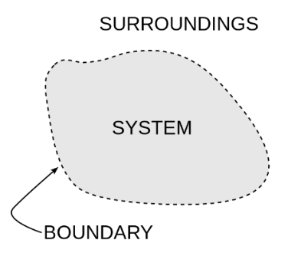](https://www.boundless.com/users/158685/textbooks/campbell-biology-5f29b1ec-0573-4dcd-a163-9ae316fc4522/metabolism-8/the-laws-of-thermodynamics-79/the-first-law-of-thermodynamics-356-11484/images/the-system-and-surroundings/)*Thermodynamics often divides the universe into two categories: the system and its surroundings. In chemistry, the system almost always refers to a given chemical [reaction](https://www.boundless.com/definition/reaction/) and the container in which it takes place. The first law of thermodynamics tells us that energy can neither be created nor destroyed, so we know that the energy that is absorbed in an [endothermic](https://www.boundless.com/definition/endothermic/) chemical reaction must have been lost from the surroundings. Conversely, in an exothermic reaction, the heat that is released in the reaction is given off and absorbed by the surroundings. Stated mathematically, we have: Δ*E*= Δ*Esys* + Δ*Esurr* = 0

*[The system and surroundings](https://www.boundless.com/users/158685/textbooks/campbell-biology-5f29b1ec-0573-4dcd-a163-9ae316fc4522/metabolism-8/the-laws-of-thermodynamics-79/the-first-law-of-thermodynamics-356-11484/images/the-system-and-surroundings/)*

A basic diagram showing the fundamental distinction between the system and its surroundings in thermodynamics.

*Heat and Work*

We know that chemical systems can either absorb heat from their surroundings, if the reaction is endothermic, or release heat to their surroundings, if the reaction is exothermic. However, chemical reactions are often used to do work instead of just exchanging heat. For instance, when rocket fuel burns and causes a space shuttle to lift off from the ground, the chemical reaction, by propelling the rocket, is doing work by applying a force over a distance.

If you've ever witnessed a video of a space shuttle lifting off, the chemical reaction that occurs also releases tremendous amounts of heat and light. Another useful form of the first law of thermodynamics relates heat and work for the change in energy of the internal system: Δ*Esys* = *Q* + *W* While this formulation is more commonly used in physics, it is still important to know for chemistry.

***Summarize in a small paragraph:***

1. 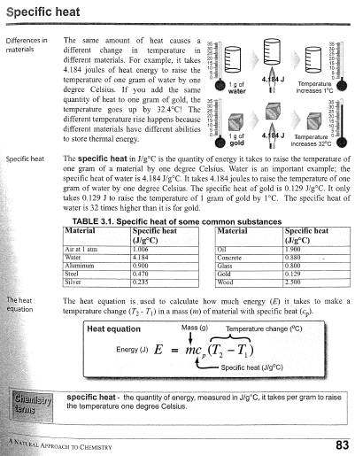Reading about Specific Heat:

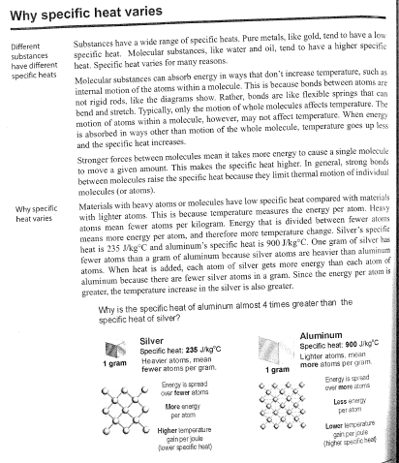

1. Define the following terms:

|  |  |  |  |
| --- | --- | --- | --- |
| Thermochemistry | Law of Conservation of Energy | Endothermic | Calorimetry |
| Energy | Heat | Calorie | Enthalpy |
| Potential Energy | Enthalpy/Heat of Reaction | Joule | Enthalpy/Heat of Combustion |
| Kinetic Energy | Temperature | Specific Heat | Molar Heat of Vaporization |
| Chemical Potential Energy | Exothermic | Calorimeter | Molar Heat of Fusion |

1. Explain why all reactions have an activation energy, using your knowledge of collision theory.
2. Describe how the activation energy of a reaction affects the overall rate of the chemical reaction.
3. It has been observed with one variety of paint that adding a small amount of “accelerant” can drastically increase the rate of paint drying. Based on what you know of catalysts, is it reasonable to think of this accelerant as being a catalyst? Explain.
4. How much heat (Q) is needed to raise the temperature of 8.00 g of lead by 10.0°C? *10.4 J*
5. The temperature of a 250.0-g ball of Iron increases from 19.0°C to 32.0°C. How much heat did the iron ball gain? *1462.5 J*
6. The temp of a 100.0-g block of ice increases by 3.00°C. How much heat does the ice receive? *618 J*
7. 10g of steam absorbs 60.0 J of heat. What is the temperature increase of the steam? *3°C*
8. A piece of lead loses 78.0 J of heat and experiences a decrease in temperature of 9.0°C. What is the mass of the piece of lead? *66.7 g*
9. The temp of a 700.0-g bar of iron decreases by 10.0°C when the iron is plunged into 500.0 g of water. What is the temp increase of the water, assuming that no heat is lost in the transfer? *1.5 °C*
10. What is the specific heat of a substance that absorbs 2.5 x 103 joules of heat when a sample of 1.0 x 104 g of the substance increases in temp from 10.0°C to 70.0°C? Cp = 0.0042 J/g°C
11. A 1.0 kg sample of metal with a specific heat of 0.50 KJ/Kg°C is heated to 100.0°C and then placed in a 50.0 g sample of water at 20.0°C. What is the final temperature of the metal and the water? *76°C*
12. A 2.8 kg sample of a metal with a specific heat of 0.43KJ/Kg°C is heated to 100.0°C then placed in a 50.0 g sample of water at 30.0°C. What is the final temperature of the metal and the water? *89.64°C*
13. How much heat is lost when a 640 g piece of copper cools from 375°C, to 26°C? (The specific heat of copper is 0.38452 J/g°C) *86000 J*
14. The specific heat of iron is 0.4494 J/g°C. How much heat is transferred when a 24.7 kg of iron is cooled from 880°C to 13°C? *9,600,000 J*
15. How many grams of water would require 2.20 x 104 calories of heat to raise its temperature from 34.0°C to 100.0°C? (Remember the specific heat of water is 1.00 cal/g°C) *333 g*
16. 8750 J of heat are applied to a piece of aluminum, causing a 56°C increase in its temperature. The specific heat of aluminum is 0.9025 J/g°C. What is the mass of the aluminum? *170 g*
17. Find the mass of a sample of water if its temperature dropped 24.8°C when it lost 870 J of heat. *8.4 g*
18. Find the specific heat of an unknown metal with an initial temperature of 16.0°C, when 3500 J are applied to a 40.0g sample and the final temperature is 81.0°C. *1.3°C*
19. What is the specific heat of a sample of an unknown material of 36.359g, when 59.912 J of heat are applied raising the temp 152.0°C? *Cp = 10.84 J/g °C*
20. A 12 oz. can of soda weighs about 450.0 g. How many joules are released when a can of soda is cooled from 25°C (room temperature) to 4 degrees Celsius (the temperature of a refrigerator). The heat capacity of liquid water is 4.184 J / g°C.*39.5 kJ*
21. How many joules are required to heat 250.0 g of liquid water from 0.000 to 1000°C ? *104.5 kJ*
22. How many joules are required to boil 150.0 grams of water? The heat of vaporization of water is 40.67 kJ / mole.*338.8 kJ*
23. How many joules are required to heat 200.0 grams of water from 25.0°C to 125°C? The heat capacity of steam is 1.840 J / g°C*523.9 kJ*
24. How many joules are required to heat 75.00 g of water from -85.0°C to 185°C? The heat capacity of steam is 1.840 J / g°C. *250.9 kJ*
25. When 15.0 g of steam drops in temperature from 275.0 °C to 250.0 °C, how much heat energy is released? *-701.25 J*
26. How much energy is required to heat 120.0 g of water from 2.00 °C to 24.0 °C? *11.045 KJ*
27. How much heat (in kJ) is given out when 85.0 g of lead cools 200.0 °C to 10.0 °C? Clead = 0.129 J/g °C *-2.0833 KJ*
28. If it takes 41.72 joules to heat a piece of gold weighing 18.69 g from 10.0 °C to 27.0 °C, what is the specific heat of the gold? *0.131 J/g°C*
29. It takes 333.51 joules to melt exactly 1 gram of H2O. What is the molar heat of fusion for water, from this data? *6.01 KJ/mol*
30. You have a sample of H2O with a mass 23.0 g at a temperature of -46.0°C. How many kJ of heat energy are necessary to carry out each step? Also, please calculate the total amount of energy needed and make a time-temperature graph.
    1. heat the ice to 0.0 °C?
    2. melt the ice?
    3. heat the water from 0.0 °C to 100.0 °C?
    4. boil the water?
    5. heat steam from 100.0 °C to 109.0 °C?
31. Calculate the energy released when 10.0 g of steam at 120.0 °C are converted into ice at minus 20.0 °C.
32. How much energy is required to convert 100.0 g of water at 20.0 °C completely to steam at 100.0 °C? *259.583 KJ*
33. If 10.0 g water at 0.0 °C is mixed with 20.0 g of water at 30.0 °C, what is the final temp of a mixture?
34. Determine the energy required (in Joules) when the temp of 3.21 grams of water increases by 4.0 °C while remaining liquid. *53.72 J*
35. Determine the energy needed when 55.6 g of water at 43.2 °C is heated to 78.1 °C. *8118.8 J*
36. Determine the energy required (in kilojoules) when cooling 456.2 grams of water at 89.2 °C to a final temperature of 5.9 °C. *-158.99 KJ*
37. Determine the final temp when 450.2 grams of aluminum at 95.2 °C is placed in an insulated calorimeter with 60.0 grams of water at 10.0 °C.
38. Determine the mass of iron heated to 85.0 °C to add to 54.0 g of ice to produce water at 12.5 °C.   
    Ciron = 0.045 J/g °C. *6377.4 g*
39. Another sample of cobalt, B, with a mass of 7.00 g, is initially at 25.0 °C. If sample B gains 5.00 J of heat, what is the final temperature of sample
40. 50.0 g of copper at 200.0 °C is placed in ice at 0 °C. How much of ice will melt? *11.7 g*
41. The specific heat of glass is 0.739 J/g·ºC.
    1. If a 352 g piece of glass is heated from 22.0ºC to 162ºC, how much heat is required? *36.418 KJ*
    2. If 2530 J of heat are used to increase the temperature of the piece of glass in part a, what will be the final temperature of the glass? (The initial temperature is 22.0ºC.) *31.7°C*
42. 23.5 g of water at 10.5ºC and 31.7 g of water at 38.2ºC are mixed. Calculate the final temperature of the water. *26.41°C*
43. 50.0 g of iron that has an initial temp of 225.0°C and 50.0 g of gold that has an initial temperature of 25.0 °C are brought into contact with one another. Assuming no heat is lost to the surroundings, what will be the temperature when the two metals reach thermal equilibrium? *The specific heat capacity of iron = 0.449 J/g°C and gold = 0.128 J/g°C.180°C*
44. A 25.0 g piece of iron at 398 K is placed in a styrofoam coffee cup containing 25.0 mL of water at 298 K. Assuming that no heat is lost to the cup or the surroundings, what will the final temp of the water be? *The specific heat of iron = 0.449 J/g°C 34.69°C*
45. A 0.050kg metal bolt is heated to an unknown initial temperature. It is then dropped into a beaker containing 0.15kg of water with an initial temperature of 21.0°C. The bolt and water then reach a final temperature of 25.0°C. If the metal has a specific heat capacity of .899 J/g°C, find the initial temperature of the metal. *81.48°C*
46. How much ice could be melted by 100.0 g of water at 20.0°C if the final temp is 0.0.0°C? *25 g Ice*
47. A 2.43 g lead weight, initially at 10.7°C, is submerged in 7.47 g of water at 53.0°C in an insulated container. What is the final temperature of both substances at thermal equilibrium? Specific Heat of Lead = 0.130 J/g°C. *52.58°C*
48. CaO(s) + H2O(l) → Ca(OH)2(s) + 65.2kJ
    1. Is the reaction above endo or exothermic?
    2. Should ∆Hrxn be written as a positive or negative value?
    3. If 45 grams of CaO is reacted, how much heat will be released?
49. 2Al + 3NH4NO3 🡪 3N2 + 6H2O + Al2O3   
    ΔH = -2030kJ
    1. Is the reaction above endo or exothermic?
    2. Should the energy be written as a product or reactant?
    3. If you made 185grams of water, how much energy was also released?
50. A phase diagram worksheet can be found here: <https://tinyurl.com/y6ck5qtv>
51. *Read your notes! Read your Reference Sheets! Don’t forget to study conceptual stuff too!* ☺