**Name: Period: Seat#:**

**Worksheet #8**

**Directions:** Complete the following on binder paper. *Clearly* label the question number, show all work, don’t forget units, box your final answer, and be careful about answers having correct units and correct algebraic signs! Some answers are provided at the end of the problems, they are underlined. Remember the answers may be rounded differently!

1. Sketch and label a phase diagram for water. Be sure to include the following:
   1. Label the areas with solid, liquid, gas
   2. Label the triple point and critical point
   3. Color code the three phase change boundaries to be different colors (make a key showing which color represents which phase change)
2. A metal with a C of 0.780 J/g°C requires 45.0 J of heat to raise the temperature by 2.00°C. What is the mass of the metal? *28.8 g*
3. A metal with a specific heat of 0.70 J/g°C and a mass of 8.00g absorbs 48.0J of heat. What will be the temp change? *8.57 °C*
4. What would be the final temperature of a 73.174g sample of cobalt with an initial temperature of 102.0°C, after it loses 6800 J? (Note the specific heat of cobalt is 0.4210 J/g°C) *TF = -120°C*
5. How much heat is gained when a 50.32 g piece of aluminum is heated from 9.0°C to 16°C? *320 joules*
6. A 250 g sample of water with an initial temp of 98.8°C loses 7500 joules of heat. What is the final temperature of the water? *92°C*
7. Copper has a specific heat of 0.38452 J/g°C. How much change in temperature would the addition of 35,000 Joules of heat have on a 538.0 gram sample of copper? *170°C*
8. How many joules are required to melt 100.0 grams of ice?
9. How many joules are given off when 120.0 grams of water are cooled from 25°C to -250C?*-115332 J*
10. How many joules are released when 450.0 grams of water are cooled from 4 x 107 °C (the hottest temperature ever achieved by man) to 1 x 10-9 K (the coldest temp achieved by man) Note – our calculators struggle with how many decimals this goes out to. So use -273°C as your coldest temp for the purposes of our calculator. *3.4 x 1010 J*
11. How many joules are required to raise the temperature of 100.0 grams of water from -269°C (the current temperature of space) to 1.6 x 1015 °C (the estimated temperature of space immediately after the big bang)? *2.94 x 1017 J*
12. How much energy must be absorbed by 20.0 g of steam to increase its temperature from 283.0°C to 303.0 °C? *748 J*
13. If 720.0 g of steam at 400.0 °C absorbs 800.0 kJ of heat energy, what will be its increase in temperature? *594.2 °C*
14. A certain mass of water was heated with 41,840 Joules, raising its temp from 22.0 °C to 28.5 °C. Find the mass of water. *1.538 Kg*
15. How many joules of heat are needed to change 50.0 grams of ice at -15.0 °C to steam at 120.0°C. Make a graph to indicate this change.
16. Calculate the joules given off when 32.0 g of steam cools from 110.0 °C to ice at -40.0 °C. Make a graph to indicate this change.
17. If 150.0 grams of iron at 95.0 °C, is placed in an insulated container containing 500.0 grams of water at 25.0 °C, and both are allowed to come to the same temperature, what will that temperature be (Final Temp)? The specific heat of water is 4.18 J/g °C and the specific heat of iron is 0.444 J/g °C
18. When 80.0 grams of a certain metal at 90.0 °C was mixed with 100.0 grams of water at 30.0 °C, the final equilibrium temperature of the mixture was 36.0 °C. What is the specific heat (Joules/gram°C) of the metal? *0.581 J/g°C*
19. Calculate the specific heat of a metal if a 55.0 g sample of an unknown metal at 99.0 °C causes a 1.7 °C temperature rise when added to 225.0 g of water at 22.0 °C. *0.386 J/g°C*
20. What amount of ice must be added to 540.0 g of water at 25.0 °C to cool the water to 0.0 °C and have no ice remaining? *168.9 g*
21. What mass of ice could be melted by the energy obtained as 18.0g of steam is condensed at 100.0°C and cooled to 0.0°C?*144.8 g*
22. 15.0 g of water at 0.0 °C are added to 40.0 g of water at 40.0 °C. What is the final temperature of the mixture?
23. Determine the energy required to:
    1. melt 5.62 moles of ice at 0 °C.
    2. boil 0.345 moles of water at 100.0 °C.
24. Determine the final temp when 14.2 g of ice at -16.2 °C is placed in 250.0 grams of water at 70.0 °C.
25. A student places 42.3 grams of ice at 0.0 °C in an insulated bottle. The student adds 255.8 grams of water at 90.0 °C. Determine the final temperature of the mixture. *65.9 °C*
26. The graph below shows a pure substance which is heated by a constant source of heat supplying 2000.0 joules per minute. Identify the area described in the questions below and complete the necessary calculations.

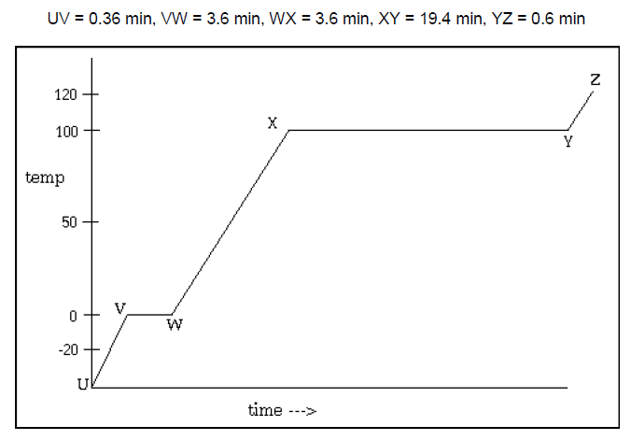

a. being warmed as a solid ___________

b. being warmed as a liquid ___________

c. being warmed as a gas ___________

d. changing from a solid to a liquid ___________

e. changing from a liquid to a gas ___________

f. What is its boiling temperature? ___________

g. What is its melting temperature? ___________

h. How many joules were needed to change the   
 liquid to a gas? ____________

i. Where on the curve do the molecules have the   
 highest kinetic energy? ___________

j. If the sample weighs 10.0 g, what is its heat of   
 vaporization in J/g? ___________

1. Equal amounts of heat are used to heat a 25.0 g sample of water and a 25.0 g sample of alcohol. The temperature of the water rises from 23.1ºC to 27.9ºC, while the temperature of the alcohol rises from 21.6ºC to 29.9ºC. Calculate the specific heat of alcohol. *2.42 J/g°C*
2. 31.5 g of water at 22.3ºC is placed into a beaker. Some hot water is then poured into the beaker. The total mass of the water in the beaker is found to be 48.9 g, and the final temperature (after mixing) is 29.1ºC. What was the temperature of the hot water? *41.4°C*
3. What is the smallest number of ice cubes at 0.00°C, each containing one mole of water, necessary to cool 500.0 g of liquid water initially at 20.0°C to 0.00°C? *7 cubes*
4. At a bar, there is a bucket containing ice, some of which has melted. A bartender gets an ice cube weighing 20.0 grams from the ice bucket and puts it into an insulated cup containing 100 grams of water at 20.0°C. Will the ice cube melt completely? What will be the final temperature of the water in the cup? *Yes, 3.38°C*
5. Consider a rigid insulated box containing 20.0 g of He(g) at 44.6°C and 1.00 atm in one compartment and 20.0 g of N2(g) at 115.0°C and 2.00 atm in the other compartment. These compartments are connected by a partition which transmits heat. What will be the final temperature in the box at thermal equilibrium? CHe = 12.5 J/K·mol, CN2 = 20.7 J/K·mol) *58°C*