Name: Period: Seat#:
Worksheet #7

Purpose: Use serial dilutions to dilute a stock solution of 1.0 M down to 0.70 M, then 0.40 M, then 0.10 M using serial dilution. Use a spectrophotometer to determine how accurate each concentration you make is.

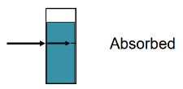
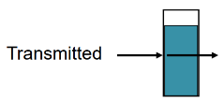
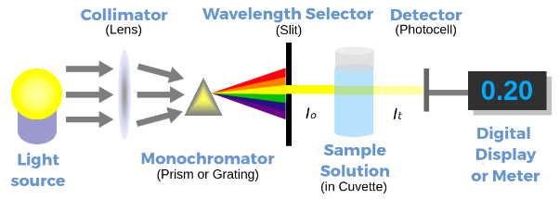
Introduction:
A spectrophotometer is a useful tool used in both the biological and chemical sciences. It works by shining a beam of light through a sample and detecting how much light is absorbed/transmitted as it passes through the solution. Not all compounds absorb/transmit the same wavelengths of light so a spectrophotometer allows you send a specific wavelength (or a narrow range of wavelengths) through the sample. Since different compounds absorb different patterns of wavelengths, you can use the information to identify substances. Additionally, the amount of light absorbed/transmitted
If 100% of the light is transmitted, then 0% was absorbed. If 0% of the light is transmitted, then 100% of the light was absorbed.
is directly proportional to the concentration of the sample. The more
concentrated, the more light absorbed and the less light transmitted.
Therefore, a spectrophotometer can be used to determine concentrations
of compounds in solution.

Method:
You will be given a 1.0 M STOCK solution that you will then use to prepare 100 mL of each of the following concentrations by using the serial dilution method learned about in class. 0.70 M, 0.40 M, and 0.10 M. You will use the dilution equation to help you calculate how much of each solution you need to perform the next dilution step. M₁V₁ = M₂V₂. You will then take a sample of each diluted solution and put each one in the spectrophotometer to obtain the absorbance readings. You will compare your absorbance readings to the accepted values provided by your teacher. We will compare to see who got closest for each concentration, and who got the most accurate final concentration. The closer you are to the accepted values, the better your dilution technique was.

Materials:

- Beaker filled with 1.0 M blue solution made by your teacher
- 150mL beaker x3
(labeled for each dilution)
- Graduated cylinder
- 100mL volumetric flask
- Pipette
- Distilled water
- Label tape
- Cuvette
- Spectrophotometer (up front with the teacher)

Procedure: Show all calculations neatly and clearly! Box each answer!
- Label the beakers 0.70 M, 0.40 M, 0.10 M
- Calculate how many mL of the 1.0 M blue STOCK solution you will need to prepare 100mL of a 0.70 M solution. Put your final answer in the box to help make your lab work easier.
mL of 1.0 M STOCK solution needed
to make 100mL 0.70 M solution

- Measure out that many mL of 1.0 M STOCK solution into the graduated cylinder.
- Add it to the 100mL volumetric flask.
- Add enough distilled water to reach the 100mL mark on the flask.
- Put the stopper on the flask, and invert several times to mix it well.
- Pour the diluted solution into one of the labeled 150mL beakers.
- Use a little bit of your new diluted solution to rinse out the cuvette up front. Pour it into the waste beaker.
- Refill the cuvette with more of your diluted solution. Take the absorbance reading. Empty out the cuvette.
- Calculate how many mL of the 0.70 M solution you will need to prepare 100mL of a 0.40 M solution.
Put your final answer in the box to help make your lab work easier.
mL of 0.70 M solution needed
to make 100mL 0.40 M solution

- Repeat steps 3-9 using your 0.70 M diluted solution instead of the stock solution to make the 0.40 M solution. Obtain the absorbance reading for your 0.40 M solution. Record the value in the data table at the end of this handout.

- Calculate how many mL of the 0.40 M solution you will need to prepare 100mL of a 0.10 M solution.
Put your final answer in the box to help make your lab work easier.
mL of 0.40 M solution needed
to make 100mL 0.10 M solution

- Repeat steps 3-9 using your 0.40 M diluted solution instead of the stock solution to make the 0.10 M solution. Obtain the absorbance reading for your 0.10 M solution. Record the value in the data table at the end of this handout.

- Dispose of all your diluted solutions down the drain with plenty of water. DO NOT dispose of the STOCK solution, that can be used by another class period.
Post-Lab Questions:
- Describe the physical appearance of each solution from the stock solution of 1.0 M, all the way down to the
0.10 M solution. Explain the connection between the physical appearance, the concentration, and the absorbance and transmittance of light for the solutions you made.

- Using the dilution equation, how many mL of the 1.0 M stock solution would you have needed to make 100mL of the 0.10 M solution if you went straight from the stock to the 0.10 M without doing the serial dilution of other concentrations first?

Data Table:
Concentration | Experimental  Absorbance Reading | Accepted  Absorbance Reading | % Error
0.70
0.40
0.10

