Name: Period: Seat#:
Worksheet #1

Conceptual Questions
- Define: Solvent | - Define: Solute |  |  | - Define: Solution
- Which of the following ionic compounds are insoluble in water? (Remember your solubility chart!) Explain what general “rule” from the chart gave you the clue that it was insoluble.  KCl, AgNO₃, BaSO₄, (NH₄)₃PO₃ |  | - Match each solute with its most appropriate solvent. Explain why you matched them the way you did.  Solute: Solvent:  Table Salt (NaCl) Pentane (C₅H₁₂)  Wax (C₃₁H₆₄₎ Butanol (C₄H₉OH)
- Which of these is NOT a solution? What is it instead? Explain/Define what it is since it isn’t a solution.  Clean air, Milk, Gatorade, Gold Alloy |  | - Which of these is NOT an electrolyte? Why is it not an electrolyte but the others are?  HCl, NaOH, NH₄Br, C₁₂H₂₂O₁₁
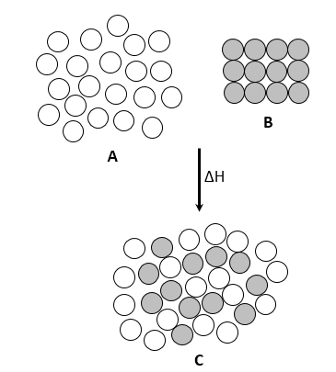
- The diagram below is an atomic level representation of a small amount of solid powder being dissolved in a large amount of liquid. Complete the statement below the diagram using the words solute, solvent, solution.

A is the _________________________

B is the _________________________

and C is the _________________________

- Give an example for each type of solution that was NOT in your notes. Two of these types are rather rare, you were told which ones during notes. You can use the examples from your notes for those two rare ones. You can look up examples online if needed.
- Gas in Gas  - Gas in Liquid  - Gas in Solid  - Liquid in Gas  - Liquid in Liquid |  |  | - Liquid in Solid  - Solid in Gas  - Solid in Liquid  - Solid in Solid
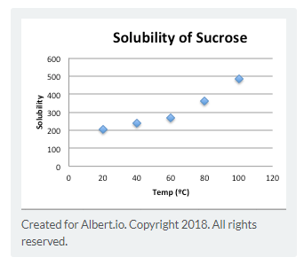
- According to apiarists (beekeepers), a ratio of 454g of table sugar (sucrose) dissolved in 1 L of water is used to feed bees in the spring and summertime. A ratio of 2000g of sucrose dissolved in 1 L of water is used in the fall. Apiarists have found that this ratio of sugar to water encourages the bee behavior of building honeycombs. Consider the plot of sucrose solubility in $\frac{grams sucrose}{100 grams water}$ as a function of temperature, shown below. Then answer the following question: If a beekeeper wanted to quickly mix up a batch of fall feed, to what temperature water does she need to heat the water?
- Which of the following are examples of colloidal dispersions (also called simply colloids)? Explain what makes them a colloid and not a solution.
milk, paint, salt water, smoke, whipped cream
- Define dissolving |  |  | - Define dissociating
- Which of the following is NOT a step in the dissolving process? Draw a diagram of how things dissolve.
  - Separating the solute into its individual components
  - Breaking solvent molecules into smaller pieces
  - Overcoming intermolecular forces in the solvent to make room for the solute
  - Allowing the solute and solvent to interact to form the solution
Directions:  Use the following Solubility Curve to answer Questions #15-23  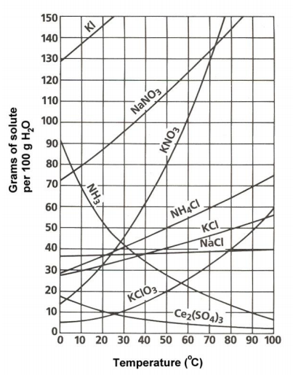 |  |  | - According to the following graph, the solubility of the substances change as  _______________ changes.
 |  |  | - How many grams of NH₄Cl can be dissolved at °5C?
 |  |  | - Which compound is least soluble in water at 10°C?
- Are the following solutions unsaturated, saturated, or supersaturated?
  - 45g of NaNO₃ in 100g of water at 30°C

  - 60g of KClO₃ in 100 g of water at 60°C

 |  |  | - How many grams of NH₄Cl are required to saturate 100 g of water at 90°C
 |  |  | - At what temperature would 25g of potassium chlorate dissolve?
 |  |  | - 89 g of NaNO₃ is prepared at 30°C. Will all of the salt dissolve?
- Explain how much KCl will dissolve, and how much will remain undissolved at the bottom of the test tube if you put 120g of KCl in 100g of water at 80°C

- NH₃ is a gas. Explain what happens to its solubility as the temperature goes from 20°C to 80°C. If someone wanted to increase the solubility of NH₃ gas in water, what are two ways they could do this?

