Practice Problem #1: What is the instantaneous rate at 30 seconds for the decomposition of hydrogen peroxide?  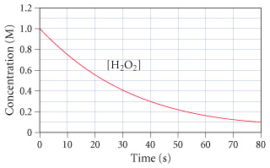 |  | Practice Problem #1: What is the instantaneous rate at 30 seconds for the decomposition of hydrogen peroxide?
Practice Problem #1: What is the instantaneous rate at 30 seconds for the decomposition of hydrogen peroxide? |  | Practice Problem #1: What is the instantaneous rate at 30 seconds for the decomposition of hydrogen peroxide?

