Practice Problem: What is the instantaneous rate at 30 seconds for the decomposition of hydrogen peroxide?  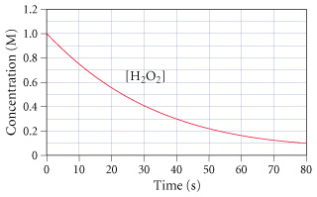 |  | Practice Problem: What is the instantaneous rate at 30 seconds for the decomposition of hydrogen peroxide?
STEPS FOR FINDING RATE LAWS  - Write your “skeleton rate law”  - Look at your experimental data (chart)  - Find two trials in which:  - The [ ] of one substance is held constant  - The [ ] of another substance is being changed  - Look to see how the rate changes when you vary the [ ] of ONLY one substance.  - Figure out what exponent on the [ ] change would result in the observed change to rate – that’s the “order”  - Repeat for each additional reactant  - Pick a row (row 1 is good!), plug in all values and solve for the value and units of k  *NOTE* If you don’t have two trials that hold everything but one reactant constant, solve for the orders you can, then pick two trials and plug in the values you do know to determine what you couldn’t figure out! |  | STEPS FOR FINDING RATE LAWS  - Write your “skeleton rate law”  - Look at your experimental data (chart)  - Find two trials in which:  - The [ ] of one substance is held constant  - The [ ] of another substance is being changed  - Look to see how the rate changes when you vary the [ ] of ONLY one substance.  - Figure out what exponent on the [ ] change would result in the observed change to rate – that’s the “order”  - Repeat for each additional reactant  - Pick a row (row 1 is good!), plug in all values and solve for the value and units of k  *NOTE* If you don’t have two trials that hold everything but one reactant constant, solve for the orders you can, then pick two trials and plug in the values you do know to determine what you couldn’t figure out!
N-42
N-42

