**Name: Period: Seat#:**

**Worksheet #1**

**Directions:** Read this page and take notes and annotate it. There is potentially information in here you may not be familiar with. If you come across anything you do not understand you need to ask about it! There may be questions along the way, or at the end, to check that you were able to follow and grasp the material talked about here. These are selections of reading by various people, credit given when possible.

**What is Kinetics?**

Kinetics is the branch of chemistry that focuses on measuring and studying the rateat which chemical reactions happen.

**Measuring Rate in an Every Day Example**

People often confuse the units we use for measuring rates/speeds and the ***equations*** we use for measuring rates. For example, when driving a car the units we use in this country would be $\frac{miles}{hour}$, but if we were in parts of Europe the units that we would be using would be $\frac{kilometers}{hour}$. While the units are allowed to change, we are actually using the same *equation.* The equation is $\frac{∆distance}{∆time}$.

**Measuring Rate for a Chemical Reaction**

When we calculate the overall rate of a reaction we have to come up with the equation we will be using, similar to the equation we used above when calculating the speed of a car. Our chemical reaction is going to progress as time goes on so we can keep the *∆time* portion, but we obviously will not have a *∆distance* portion. Instead of using *∆distance* we can use the change in concentration for the various chemicals present in the reaction which will be *∆concentration* or also written *∆[X]*. So our rate equation turns out to be $\frac{∆concentration}{∆time}$ or typically written as $\frac{∆[X]}{∆t}$. The units for our rate expression turn out to usually be $\frac{Molarity}{second}$. You may also see it written as *M•s-1*.

**Positive and Negative Rates**

Rates of chemical reactions can either be positive or negative. This is because we can either be measuring the rate at which a product is being formed (positive rate), or we can measure the rate at which a reactant is disappearing (negative rate). Sometimes it is logistically easier to measure the appearance of a product, and sometimes it is logistically easier to measure the disappearance of a reactant.

**Question #1** Use the data below to determine the rate at which the car is moving in miles per second. Show your work in the format of $\frac{∆distance}{∆time}$

|  |  |
| --- | --- |
| *Time* | *Distance driven* |
| 20 seconds | 0.347 miles |
| 40 seconds | 0.693 miles |
| 60 seconds | 1.041 miles |

**Question #2** Use the data below to determine the rate of reaction. Show your work in the format of $\frac{∆[CO2]}{∆time}$

|  |  |
| --- | --- |
| *Time* | *[CO2]* |
| 5 seconds | 0.15 M |
| 10 seconds | 0.30 M |
| 15 seconds | 0.45 M |

**Question #3** Looking at the chemical reaction below, identify which rates would be positive and which rates would be negative. You can write a ( + ) or a ( – ) under each formula.

2 H2 + O2 🡪2 H2O

**Rate Affecting Factors**

Sometimes we want to speed up or slow down the rate at which a reaction happens. There are four ways to do this. These are called “Rate Affecting Factors.” An increase in any of the following factors (typically) results in an increased rate of reaction. Sometimes there is a limit to which you can increase the rate; things can only go so fast! Raise the temperature too much and you can cause the molecules to break down. Raise the concentration too far and the molecules can actually crowd each other out and make it hard for them to “find” each other.

1. Temperature
2. Concentration
3. Surface Area
4. Catalysts

**Collision Theory**

Collision Theory states that in order for reactant molecules to actually react, for the reaction to take place, molecules must:

1. Collide with enough energy (hit hard enough)
2. They must collide in the proper orientation

The Rate Affecting Factors listed above all work by either increasing the number of collisions that can take place between reactant molecules, or by helping the reactant molecules achieve the correct orientation so that they are aligned properly for the formation of the product molecule. By increasing the number of collisions and having proper orientation, they help the reactant molecules get over the activation energy curve. It is all about increasing the number of EFFECTIVE collisions!

1. Temperature

*Increasing temperature makes molecules move faster   
 so more collisions take place.*

1. Concentration

*More molecules present means higher chance of   
 bumping into each other, more collisions take place.*

*Remember – increasing pressure on a gas is the equivalent of increasing the concentration! Sometimes it is listed as a separate “rate affecting factor.”*

1. Surface Area

*Increased surface area means more molecules are   
 exposed, so more collisions can take place*

1. Catalysts

*Helps align the molecules in the right orientation which   
 lowers the activation energy needed, so they can get   
 over the activation curve easier, therefore faster rate.*

**Question #4:** Circle the scenario that would result in a faster reaction and say which “rate affecting factor” is being considered. Each bullet point is a separate question.

* Trying to dissolve in a cup of coffee:  
    
  *Granulated sugar vs. Sugar cube*  
    
  Rate Affecting Factor: ________________________
* Trying to dissolve sugar in a cup of tea:  
    
  *Iced Tea vs. Hot Tea*  
    
  Rate Affecting Factor: ________________________
* Trying to find a date to the prom:  
    
  *A school with only vs. A school with   
  100 students 3000 students*  
    
  Rate Affecting Factor: ________________________

**Question #5:** Explain how a catalyst is different than the other rate affecting factors – it does not increase the rate in the same way as the others! The graph below shows you visually what is happening - explain why it happens and also explain how the other three factors affect the rate instead.

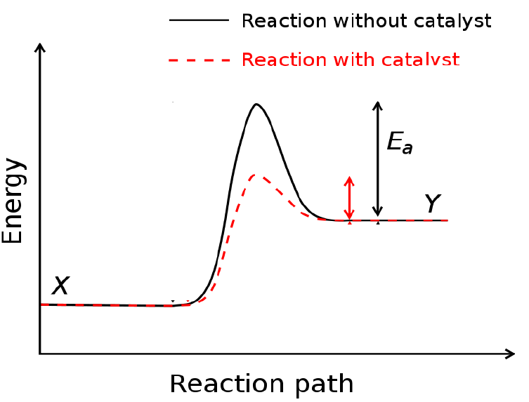

**Videos:** Watch the videos and take notes on or write paragraph summaries for each. These are part of the notes so make sure you are focused and learning from them! ☺



**Video #1** Watch video! Take notes! <http://tinyurl.com/nwnd5z4>

**Video #2** Watch video! Take notes! <http://tinyurl.com/y2clyoxl>

**Video #3** Watch video! Take notes! <http://tinyurl.com/y23bmg6l>

**Video #4** Watch video! Take notes! <http://tinyurl.com/y2kk37o5>

**Video #5** Watch video! Take notes! <http://tinyurl.com/y2l6asc2>