**Name: Period: Seat#:**

**Worksheet #2**

**Note:** Some of the links you will visit contain animations that may take some time to load. So, be patient. ☺   
 I don’t know if the links will work on cell phones or not. Short and brief answers are acceptable.

**Task A**  *(Link checked 7/15/21)*

[www.chemguide.co.uk/physical/basicrates/introduction.html](http://www.chemguide.co.uk/physical/basicrates/introduction.html)   
Read the information describing the collision theory. Answer the questions that follow.

1. Define the Collision Theory in your own words.
2. It is pretty obvious that if you have a situation involving two reactants they can only react together if they come into contact with each other. They first have to collide, and then they *may* react. Why "*may* react"? What are the *two* criteria that must be met to create an EFFECTIVE COLLISION?
3. What is activation energy?

Top of Form

Bottom of Form

**Top of Form**

**Bottom of Form**

**Task B**  *(Link checked 7/15/21)*Watch the videos.

<https://youtu.be/J0bx2BuxT-I>

<https://youtu.be/WLqRBc4oxDk>   
<https://youtu.be/dLXJV4A6KPE>

1. What is ozone?
2. What is the importance of the ozone layer?
3. How is ozone destroyed?
4. In reaction CFCl3 + UV Light 🡪 CFCl2 + Cl, there is only one reactant (CFCl3) and no collision. So, why did a reaction take place?

Top of Form

Bottom of Form

**Task C**  *(Link checked 7/15/21)  
It is ok that the Flash Animations don’t work anymore. You don’t need them. Just watch the videos,read the text, and look at the pictures.*[www.kentchemistry.com/links/Kinetics/FactorsAffecting.htm](http://www.kentchemistry.com/links/Kinetics/FactorsAffecting.htm)

1. What is a catalyst?
2. List 2 things that a catalyst does in a reaction? Explain each of these actions in detail.
3. What determines whether a substance can be considered a catalyst or not?
4. Also review these websites and Find and insert 2 reaction coordinate graphs. One exothermic reaction with and without a catalyst (label all parts) and an endothermic reaction with and without a catalyst.

**Task D** Review the data from an experiment below and answer the questions:

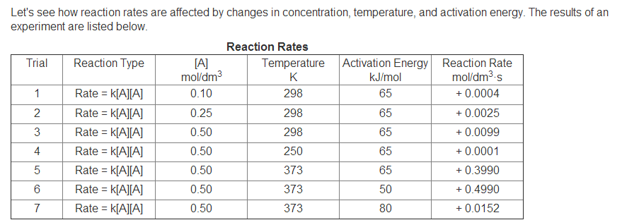

**Data Analysis**

1. Compare the reaction rates for Trials 2 and 3. When the concentration of A doubles, the reaction rate increases by what factor?
2. Compare the reaction rates for Trials 1 and 3. When the concentration of A increases by a factor of 5, the reaction rate increases by what factor?
3. Compare Trials 3-5. What effect does temperature have on reaction rate?
4. Compare Trials 5-7. What effect does activation energy have on reaction rate?
5. Which trial could represent how reaction rate is affected by the presence of a catalyst? Explain.
6. Inhibitors act like catalysts, but they slow down reactions rather than speeding them up. Which trial could represent how reaction rate is affected by the presence of an inhibitor? Explain.

Top of Form