Name: Period: Seat#:
Worksheet #5

Mathematical Questions

- Show your work when applicable! Show units!
- Get an actual answer, including units! Box your answer!
- Some answers are provided. They are underlined at the end.
- For rate order type problems – be sure to include the following information. Your work does not need to be in chart format like this, but it does need to have all the information clearly identified if not using the chart format. Here is an example of what needs to be shown.
Trials being used | Which [ ] is held constant | Which [ ] is being changed and by what factor is it changed by | What factor is the rate changed by | Order based on rate data
1 & 3 | [H₂] | [O₂] x 2 | x 2 | 1

- An unknown reaction has been found to have the equation 2A B + 2C Looking at the rate data below, identify which line is A, B and C |  |  |  | - Rate data for the following reaction was graphed.  BrO₃ + 5Br⁻ + 6H⁺ 3Br₂ + 3H₂O  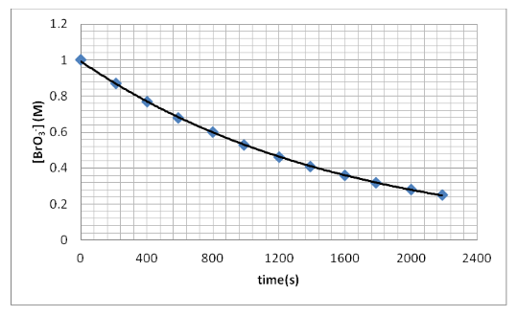  - What is the average rate of reaction over the first 1200 seconds?  - What is the instantaneous rate at 800 seconds?  - If the rate of appearance of H₂O is 2.5 x 10⁻⁴ M⁻¹s⁻¹, what is the rate of disappearance of Br⁻?
- Determine rate law and rate constant:
- Determine rate law and rate constant: |  |  | - Determine rate law and rate constant:
- Determine rate law and rate constant: |  |  | - Determine rate law and rate constant:
- What happens to the rate of a reaction if the temperature is increased by 30°C? |  |  | - Calculate the rate of reaction for H₂, Cl₂ and HCl when hydrogen gas reacts with chlorine gas to form hydrogen chloride.  Time (s) [H₂] (M) [Cl₂] M [HCl] (M)  0.00 0.030 0.050 0.000  4.00 0.020 0.040 0.020
- What happens to the rate of a reaction if the temperature is increased from 300K to 340K?
- Nitrogen monoxide gas and hydrogen gas react according to the rate law: Rate = k[NO]²[H₂]  How does the rate change if:  - The concentration of hydrogen is doubled?  - The concentration of NO is doubled?  - The concentration of hydrogen is cut in half?  - The volume of the container is cut in half? |  | - The volume of the container is doubled?  - The temperature is increased?  - The concentration of NO is doubled while the concentration of H₂ is cut in half?  - The concentration of H₂ is doubled while the concentration of NO is cut in half?
- The rate law of a particular reaction between gases X, Y, and Z is found to be Rate = k[X]⁰[Y]²[Z]  How does the rate change if:  - The concentration of X is doubled?  - The concentration of Y is tripled?  - The concentration of Z is quadrupled?  - The volume of the container is cut in half? |  | - The volume of the container is doubled?  - The temperature is increased?  - [X] is quadrupled while [Y] and [Z] are doubled?  - [Z] is cut in half while [Y] is doubled?  - [Y] and [Z] are tripled while [X] is cut in thirds?
- Rate data for the gaseous phase decomposition of dinitrogen pentoxide into nitrogen dioxide and oxygen gas is given below.
Time | [O₂] (M)
0 | 0
600 | 0.002
1200 | 0.004
1800 | 0.005
3000 | 0.006
4200 | 0.0072
- Write the rate expression for the reaction
- Calculate the rate for [O₂] over each interval (from 0-600, 600-1200, etc)
- Calculate the average rate over the time frame of the entire reaction

