Name: Period: Seat#:
Worksheet #6

Mathematical Questions

- Show your work when applicable! Show units!
- Get an actual answer, including units! Box your answer!
- Some answers are provided. They are underlined at the end.
- For rate order type problems – be sure to include the following information. Your work does not need to be in chart format.
Trials being used | Which [ ] is held constant | Which [ ] is being changed and by what factor is it changed by | What factor is the rate changed by | Order based on rate data
1 & 3 | [H₂] | [O₂] x 2 | x 2 | 1

- What happens to the rate if you increase the surface area? | - What does temperature measure? |  | - What is activation energy? What is the energy being used for?
- What is a transition state (sometimes called an activated complex)? | - What is a catalyst? |  | - Why can average rates be negative, but the rates when using a rate law are always positive?
- Given the following experimental data, find the rate law and the rate constant for the reaction: k = 2.1 M⁻¹s⁻¹
NO _{(g)} + NO₂ _{(g)} + O₂ _{(g)} N₂O₅ _{(g)}
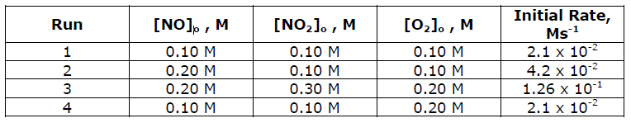
- The reaction between bromate ions and bromide ions in acidic aqueous solution is
BrO₃⁻ _{(aq)} + 5Br⁻ _{(aq)} + 6H⁺ _{(aq)} → 3Br_{2(l)} + 3H₂O_{(l)}
Using the data from 4 experiments shown below determine the orders of the rate of reaction for all three reactants, the overall reaction order, and the value of the rate constant k. k = 8.0 L³/mol³∙s
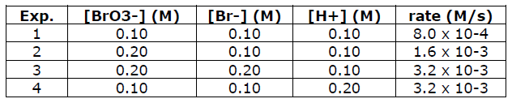
- The initial rate of the reaction 2A + 2B C + D is determined for different initial conditions, with the results listed in the following table: k = 0.103 M⁻² s⁻¹
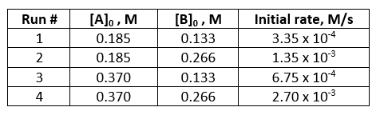
- The initial rate of the reaction: BrO₃⁻_{(aq)} + 5 Br⁻_{(aq)} + 8 H⁺_{(aq)} 3 Br_{2(l)} + H₂O_{(l)}
has been measured at the reactant concentrations shown (in mol/L). Write the rate law and solve for k with units.
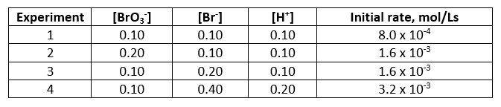
- The reaction of iodide ion with hypochlorite ion, OCl⁻ (which is found in liquid bleach), follows the equation
OCl⁻ + I⁻ OI⁻ + Cl⁻ It is a rapid reaction that gives the following rate data. What is the rate law for the reaction. Determine the value of the rate constant.
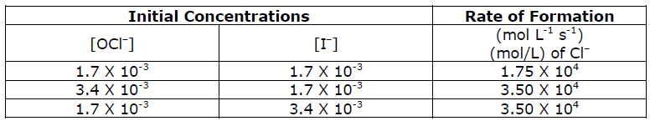
- Determine the items below given the following data for this reaction:  __NH₄⁺_{(aq)} + __NO₂⁻_{(aq)} __N_{2(g)} + __H₂O_{(l)}  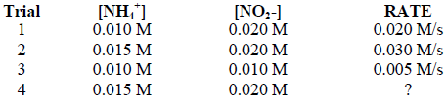  - General/skeleton/generic rate law  - Rate orders |  | - Overall order  - Rate constant  - Rate for trial #4
- Write expressions for the rate of formation of the product(s) in each of the following. Indicate the units of the rate constant. (Assume each are single step reactions)  - H₂ + Cl₂ 2 HCl  - 2 O₂ + S₂ 2 SO₂ |  | - 3 O O₃  - 2 HI + Cl₂ 2 HCl + I₂  - C₆H₆ + Cl₂ C₆H₅Cl + HCl
- Determine the items below given the following data for this reaction:  2A + 2B C + D  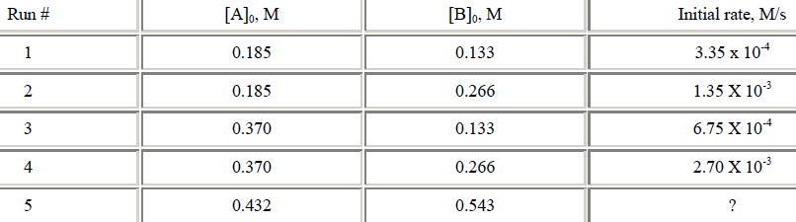  - General/skeleton/generic rate law  - Rate orders |  | - Overall order  - Rate constant  - Rate for trial #5
- For the following reaction: A + B 2C, it is found that doubling the amount of A causes the reaction rate to double, while doubling the amount of B causes the reaction rate to quadruple. What is the best rate low equation for this reaction? Justify your answer by making up pretend data to show that rate law results in the doubling/quadrupling pattern described above.
  - Rate = k [A]²[B]
  - Rate = k [A][B]
  - Rate = k [A][B]²
  - Rate = k[A] ^{½} [B]
- What would it mean for a reactant to have an order of -1? |  | - What would it mean for a reactant to have an order of -2?
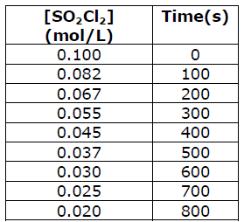
- The following data were collected for the reaction SO₂Cl₂ SO₂ + Cl₂ at a certain temperature. Make a graph of concentration versus time and determine the rate of the reaction at t = 200 seconds and t = 600 seconds. (I suggest using EXCEL. If you would like me to show you how to do it, come see me! If you cannot use Excel then you can print graph paper here: https://tinyurl.com/y2wyjuja Make sure your graph has the following items:
- Descriptive title
- Labeled axis – name and units!
- Consistent scale that is labeled
- Smooth line of best fit in one color
- Tangent line in a second color
- Show your actual calculations here
in this box
- Staple your graph to the back of this
WS #6 packet

