**Name: Period: Seat#:**

**Worksheet #7**

**Mathematical Questions**

* Circle your final answer on the handout. Show your work on binder paper! Show units!
* Answers are provided at the end. Don’t cheat! Check when finished!
* For rate order type problems – be sure to include the required work as shown on previous worksheets.

1. For the reaction A + 3B 🡪2C, how does the rate of disappearance of B compare to the rate of production of C?
   1. the rate of disappearance of B is 1/2 the rate of appearance of C
   2. the rate of disappearance of B is 3/2 the rate of appearance of C
   3. the rate of disappearance of B is 2/3 the rate of appearance of C
   4. the rate of disappearance of B is 1/3 the rate of appearance of C
2. For the reaction 2A + 3B → 4C + 5D, the rate of the reaction in terms of ΔA would be written as:
   1. –ΔA/Δt
   2. –1/2 ΔA/Δt
   3. +ΔA/Δt
   4. +1/2 ΔA/Δt
   5. –2 ΔA/Δt
3. 3. For the reaction 2A + 3B → 4C + 5D, the rate of the reaction in terms of ΔB would be written as
   1. –ΔB/Δt
   2. +ΔB/Δt
   3. –1/3 ΔB/Δt
   4. +1/3 ΔB/Δt
   5. –3 ΔB/Δt
4. For the reaction 2A + 3B → 4C + 5D, the rate of the reaction in terms of ΔC would be written as
   1. +ΔC/Δt
   2. +4 ΔC/Δt
   3. +1/4 ΔC/Δt
   4. –4 ΔC/Δt
   5. –1/4 ΔC/Δt
5. In the combustion of methane, CH4*(g)* + 2 O2*(g)* → CO2*(g)* + 2 H2O*(g)*, which reactant has the greatest rate of disappearance?
   1. CH4
   2. O2
   3. CO2
   4. H2O
   5. CH4 and O2 have the same rate of disappearance.
6. Which of the following is not a possible graph of concentration versus time for a reactant?

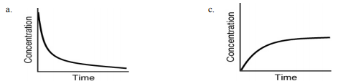

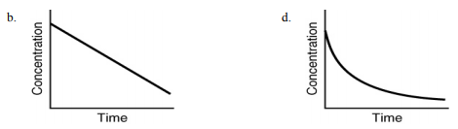

1. Assuming that each of the following graphs has the same concentration and time axes, which has the greatest initial rate of disappearance of reactant?

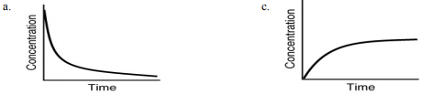  
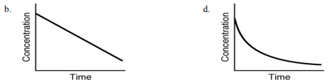

1. 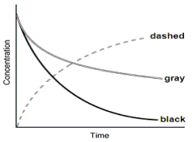The following graph shows the kinetics curves for the reaction   
   of oxygen with hydrogen to form water: O2*(g)* + 2H2*(g)* → 2H2O*(g)*.   
   Which curve is hydrogen?
   1. the dashed curve
   2. the gray curve
   3. the black curve
   4. either the gray or the black curve
   5. Any of these curves could be hydrogen
2. A scientist conducts an experiment to determine the rate of the following reaction: N2*(g)* + O2*(g)* → 2NO*(g)* If the initial concentration of N2 was 0.500 M and the concentration of N2 was 0.450 M after 0.100 s, what is the rate of the reaction?
   1. -0.500 M/s
   2. -1.00 M/s
   3. -5.00 M/s
   4. -10.0 M/s
   5. -0.250 M/s
3. A scientist conducts an experiment to determine the rate of NO formation in the reaction: N2*(g)* + O2*(g)* → 2NO*(g)* If the initial concentration of N2 was 0.500 M and the concentration of N2 was 0.450 M after 0.100 s, what is the rate of NO formation?
   1. 0.500 M/s
   2. 1.00 M/s
   3. 5.00 M/s
   4. 10.0 M/s
   5. 0.250 M/s
4. If the rate of appearance of O2 in the reaction: 2O3*(g)* → 3O2*(g)* is 0.250 M/s over the first 5.50 s, how much oxygen will form during this time?
   1. 1.38 M
   2. 4.13 M
   3. 0.69 M
   4. 0.25 M
   5. 0.46 M
5. HI dissociates to form I2 and H2: 2HI*(g)* → H2*(g)* + I2*(g)* If the concentration of HI changes at a rate of –0.45 M/s, what is the rate of appearance of I2*(g)*?
   1. 0.90 M/s
   2. 0.45 M/s
   3. 0.23 M/s
   4. 1.00 M/s
   5. 0.13 M/s
6. If the rate of formation of ammonia is 0.345M/s, what is the rate of disappearance of N2? N2*(g)*+3H2*(g)*🡪 2NH3*(g)*
   1. 0.173 M/s
   2. 0.345 M/s
   3. 0.690 M/s
   4. 245 M/s
   5. 0.518 M/s
7. If the rate of formation of ammonia is 0.345M/s, what is the rate of disappearance of H2? N2*(g)*+3H2*(g)* → 2NH3*(g)*
   1. 0.173 M/s
   2. 0.345 M/s
   3. 0.0522 M/s
   4. 245 M/s
   5. 0.518 M/s
8. For the reaction 2A + B + 2C 🡪 D + 2E, rate =k[A]2 [B]1 [C]1 Which of the following statements is false:
   1. the reaction is second order in [A]
   2. the reaction is first order in [B]
   3. the reaction is second order in [C]
   4. the reaction is 4th order overall
9. For the reaction 1A + 2B + 1C 🡪 2D + 1E, rate law is: rate =k [B]2 [C]1 Which of the following statements is false:
   1. the reaction is first order in [A]
   2. the reaction is second order in [B]
   3. the reaction is first order in [C]
   4. the reaction is third order overall
10. For the rate law Rate = k[A]1/2[B], the partial order with respect to A is __________, the partial order with respect to B is __________, and the total order is __________.
    1. 1/2; 0; 1/2
    2. 1/2; 1; 1
    3. 1/2; 1; 3/2
    4. 1/2
    5. The orders cannot be determined without a chemical reaction.
11. For the rate law Rate = k[A][B]3/2, the order with respect to A is __________, the order with respect to B is __________, and the overall reaction order is __________.
    1. 0; 3/2; 3/2
    2. 1; 3/2 ; 1
    3. 1; 3/2 ; 5/2
    4. 1; 3/2; 7/2
    5. The orders cannot be determined without a chemical reaction.
12. The reaction A + 2B → C is first order in B and A. The overall order of the reaction is __________
    1. first
    2. second
    3. third.
    4. zero
    5. fourth
13. The reaction CHCl3*(g)* + Cl2*(g)* → CCl4*(g)* + HCl*(g)* has the following rate law: Rate = k[CHCl3][Cl2]. If the concentration of CHCl3 is increased by a factor of five while the concentration of Cl2 is kept the same, the rate will
    1. double
    2. triple.
    3. stay the same
    4. increase by a factor of five
    5. decrease by a factor of one-fifth
14. The reaction 2NO(g) + O2(g) → 2NO2(g) has the following rate law: Rate = k[O2][NO]2 . If the concentration of NO is reduced by a factor of two, the rate will __________
    1. double
    2. quadruple
    3. be reduced by one-quarter
    4. be reduced by one-half
    5. remain the same
15. The rate of a reaction is found to double when the concentration of one reactant is quadrupled. The order of the reaction with respect to this reactant is __________
    1. first
    2. second
    3. one-quarter
    4. one-half
    5. third
16. Given the following data, determine the order of the reaction with respect to Cl2. 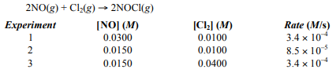
    1. First
    2. Second
    3. Third
    4. Fourth
    5. Fifth
17. Given the following data, determine the order of the reaction with respect to H2. 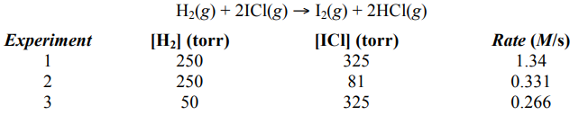
    1. one-half
    2. second
    3. first
    4. third
    5. three-halves
18. Given the following data, determine the order of the reaction with respect to NO(g).

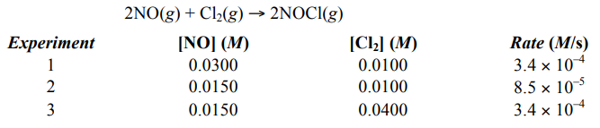

* 1. first
  2. second
  3. third
  4. fourth
  5. fifth

1. Determine the overall order of the reaction: H2*(g)* + 2ICl*(g)* → I2*(g)* + 2HCl*(g)* from the following data:  
   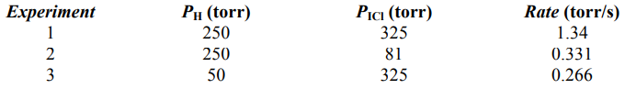
   1. first
   2. second
   3. third
   4. fourth
   5. zeroth
2. Determine the overall order of the reaction 2NO*(g)* + Cl2*(g)* → 2NOCl*(g)* from the following data: 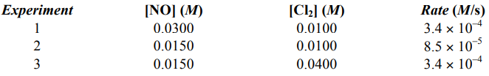
   1. first
   2. second
   3. third
   4. fourth
   5. fifth
3. Given the following data, determine the rate law for the reaction 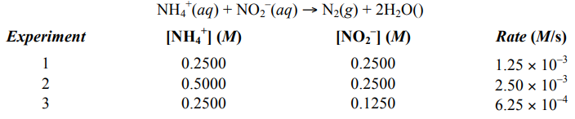
   1. k[NH4+] [NO2–]
   2. k[NH4+]2 [NO2–]
   3. k[NH4+] [NO2–]1/2
   4. k[NH4+]1/2 [NO2–]2
   5. k[NH4+] [NO2–]2
4. Given the following data, determine the rate law for the reaction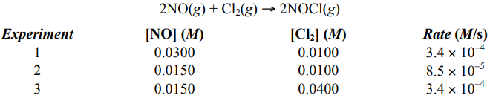
   1. Rate = k[NO] [Cl2]
   2. Rate = k[NO] [Cl2]2
   3. Rate = k[NO]2 [Cl2]
   4. Rate = k[NO]2 [Cl2]2
   5. Rate = k[NO] [Cl2]1/2
5. What is the rate law for the reaction 2A + 2B + 2C 🡪 products  
   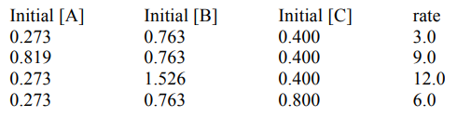
   1. a. rate = k[A] [B] [C]
   2. b. rate = k[A] [B]2 [C]
   3. c. rate = k[A]3 [B]4 [C]2
   4. d. rate = k[A]2 [B]2 [C]2
6. The initial rate data for the reaction 2N2O5*(g)* → 4NO2*(g)* + O2*(g)* is shown in the following table. Determine the value of the rate constant for this reaction.   
   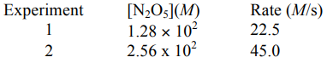
   1. 4.09 s–1
   2. 0.176 s–1
   3. 0.0569 s–1
   4. 0.225 s–1
   5. 80.1 s–1
7. Given the following data, determine the rate constant of the reaction  
   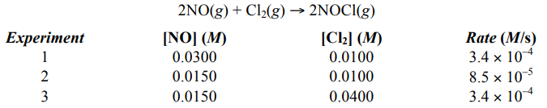
   1. 1.13 M–2 s–1
   2. 9.44 M–2 s–1
   3. 37.8 M–2 s–1
   4. 0.0265 M–2 s–1
   5. 59.6 M–2 s–1
8. Which point as labeled by an asterisk (*) on the following energy profile is the transition state? 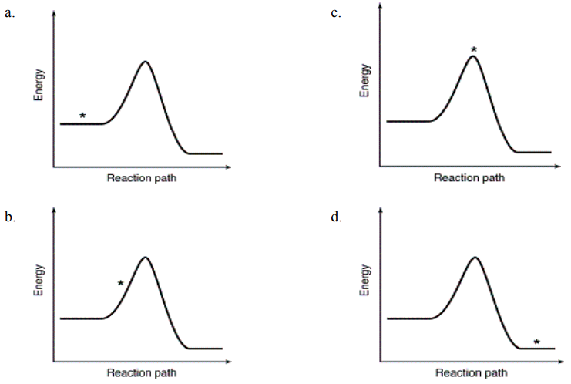
9. The energy profiles for four different reactions are shown. Which reaction requires the most energetic collisions to reach the transition state? 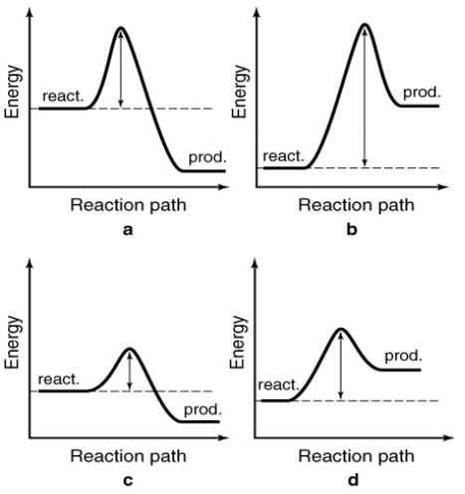
10. The following energy profiles for four different reactions are shown. Which reaction is the most endothermic?   
    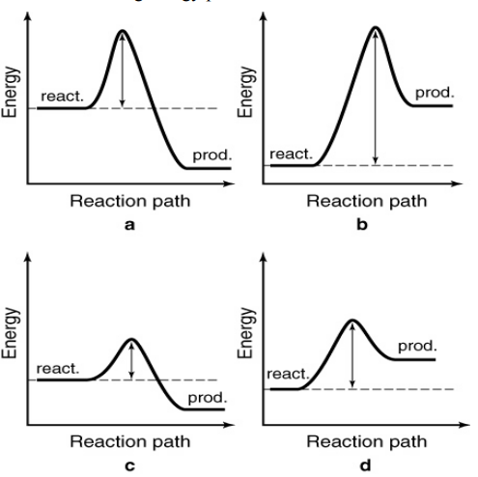
11. The following energy profiles for four different reactions are shown. Which reaction is the most exothermic?  
    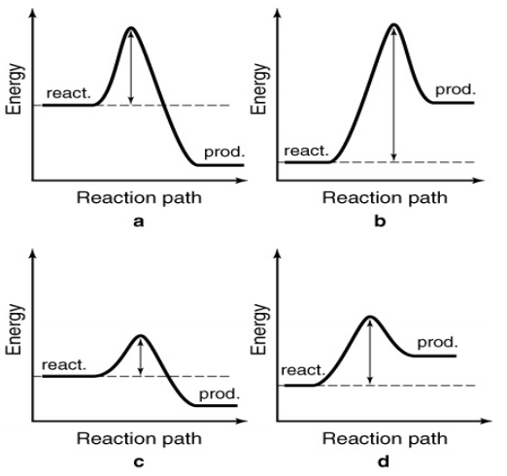
12. Collision theory assumes that the rate of a reaction depends on __________
    1. the energy of collisions.
    2. the orientation of colliding molecules.
    3. the energy of collisions and the orientation of colliding molecules.
    4. the change in energy between the products and the reactants.
    5. the change in free energy between the reactants and products
13. The energy needed for a reaction to proceed from reactants to products is called __________
    1. collision energy
    2. kinetic energy
    3. activation energy
    4. potential energy
    5. thermodynamic energy
14. 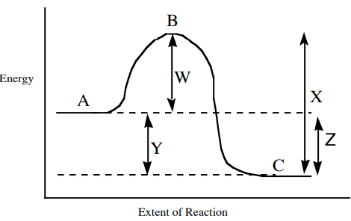For the reaction diagram shown, which of the following statements is true?
    1. Line W represents the ∆H for the forward reaction; point B represents the transition state
    2. Line W represents the activation energy for the forward reaction; point B represents the transition state
    3. Line Y represents the activation energy for the forward reaction; point C represents the transition state
    4. Line X represents the ∆H for the forward reaction; point B represents the transition state
15. A proposed mechanism for the photodecomposition of ozone in the atmosphere is   
     Step 1: O3*(g)* + *hν* → O2*(g)* + O*(g)*   
     Step 2: O3*(g)* + O*(g)* → 2O2*(g)*   
    Which of the following species is an intermediate?   
    (*An intermediate is something that is produced in one step, but then used up in a later step. Therefore, it doesn’t show up in the “overall” balanced equation.)*
    1. O3
    2. *hν (light)*
    3. O2
    4. O
    5. This mechanism has no intermediates.
16. A proposed mechanism for the decomposition of ozone in the atmosphere is   
     Step 1: Cl*(g)* + O3*(g)* → ClO*(g)* + O2*(g)*   
     Step 2: ClO*(g)* + O3*(g)* → Cl*(g)* + 2 O2*(g)*   
    Which of the following species is an intermediate?
    1. Cl
    2. O3
    3. ClO
    4. O2
    5. This mechanism has no intermediates.
17. The reaction NO2*(g)* + CO*(g)* → NO*(g)* + CO2*(g)* is thought to occur by the following mechanism:   
     Step 1: NO2*(g)* + NO2*(g)* → NO3*(g)* + NO*(g)*   
     Step 2: NO3*(g)* + CO*(g)* → NO2*(g)* + CO2*(g)* Which of the following species is an intermediate?
    1. NO2
    2. NO
    3. NO3
    4. CO2
    5. This mechanism has no intermediates.
18. A proposed mechanism for the decomposition of ozone in the stratosphere is:   
     Step 1: Cl*(g)* + O3*(g)* → ClO*(g)* + O2*(g)*   
     Step 2: ClO*(g)* + O3*(g)* → Cl*(g)* + 2O2*(g)*   
    What is the order of Step 1?
    1. 0
    2. 1
    3. 2
    4. 3
    5. More information is needed to answer this question.
19. A proposed mechanism for the reduction of nitrogen as NO by hydrogen is:

Step 1: H2*(g)* + 2NO*(g)* → N2O*(g)* + H2O*(g)*

Step 2: N2O*(g)* + H2*(g)* → N2*(g)* + H2O*(g)*

What is the order of Step 1?

* 1. 1
  2. 2
  3. 3
  4. 0
  5. More information is needed to answer this question

1. The mechanism for the reaction 2H2O2*(aq)* → 2H2O*(l)* + O2*(g)* in the presence of I– (aq) is proposed to be:

Step 1: H2O2*(aq)* + I–*(aq)* → H2O*(l)* + OI–*(aq)* (slow)

Step 2: H2O2*(aq)* + OI–*(aq)* → H2O*(l)* + O2*(g)* + I–*(aq)* (fast)

What is the order of the rate-determining step?

* 1. 0
  2. 1
  3. 2
  4. 3
  5. More information is needed to answer this question.

1. A proposed mechanism for the reduction of nitrogen as NO by hydrogen is:

Step 1: H2*(g)* + 2NO*(g)* → N2O*(g)* + H2O*(g)* (slow)

Step 2: N2O*(g)* + H2*(g)* → N2*(g)* + H2O*(g)* (fast)

What is the rate law?

1. Rate = k[H2] [NO]
2. Rate = k[H2]2 [NO]
3. Rate = k[H2] [NO]2
4. Rate = k[H2]2 [NO]2
5. More information is needed to answer this question.
6. The mechanism for the reaction 2H2O2*(aq)* → 2H2O*(l)* + O2*(g)* in the presence of I–*(aq)* is proposed to be

Step 1: H2O2*(aq)* + I–*(aq)* → H2O*(l)* + OI–*(aq)* (slow)

Step 2: H2O2*(aq)* + OI–*(aq)* → H2O*(l)* + O2*(g)* + I–*(aq)* (fast)

What is the rate law for the overall reaction?

* 1. Rate = k[H2O2]
  2. Rate = k[H2O2]2
  3. Rate = k[H2O2] [I– ]
  4. Rate = k[H2O2] [OI– ]
  5. Rate = k[H2O2]2 [I– ]/[H2O]

1. Which of the following statements about catalysts is false:
   1. catalysts do not appear in the balanced equation
   2. catalysts reduce the activation energy for a reaction
   3. biological catalysts are called enzymes
   4. catalysts do not alter the mechanism of the reaction and never appear in the rate law
   5. since catalysts are recycled, even a small amount of catalyst can accelerate a reaction
2. Which of the following statements is false:
   1. Changing the temperature does not change the activation energy for a reaction
   2. At higher temperature a higher percentage of reactants have enough energy to get over the transition state
   3. The mechanism, rate law, and activation energy will all change when a catalyst is added.
   4. The general rate law for a reaction does not changes with temperature, but the rate constant does change
   5. The rate constant “k” for a reaction does not change when the temperature increases.
3. A proposed mechanism for the following reaction is shown below. Identify the catalyst in the reaction.   
   2H2O2*(aq)* → 2H2O*(aq)* + O2 in the presence of I–*(aq)*   
    Step 1: H2O2*(aq)* + I–*(aq)* → H2O*(l)* + OI–*(aq)* (slow)   
    Step 2: H2O2*(aq)* + OI–*(aq)* → H2O*(l)* + O2*(g)* + I–*(aq)* (fast)
   1. H2O2
   2. OI–
   3. I–
   4. H2O
   5. O2
4. The steps in a reaction mechanism are as follows. Which species is acting as a catalyst?   
    Step 1: Ag+*(aq)* + Ce4+*(aq)* ↔ Ag2+*(aq)* + Ce3+*(aq)*   
    Step 2: Tl+*(aq)* + Ag2+*(aq)* → Tl2+*(aq)* + Ag+*(aq)*   
    Step 3: Tl2+*(aq)* + Ce4+*(aq)* → Tl3+*(aq)* + Ce3+*(aq)* 
   1. Ag+
   2. Tl+
   3. Ce3+
   4. Ag2+
   5. Tl3+

**Answer Key** (answers have not been checked! Please tell me if something seems off!)

1. B
2. B
3. C
4. C
5. B
6. C
7. A
8. C
9. A
10. B
11. A
12. C
13. A
14. E
15. C
16. A
17. C
18. C
19. B
20. D
21. C
22. D
23. A
24. C
25. B
26. B
27. C
28. A
29. C
30. B
31. B
32. C
33. C
34. B
35. B
36. A
37. C
38. C
39. B
40. D
41. C
42. C
43. C
44. C
45. C
46. C
47. C
48. D
49. E
50. C
51. A