**Name: Period: Seat#:**

**Worksheet #1**

**Directions:** Read this page and take notes and annotate it. There is potentially information in here you may not be familiar with. If you come across anything you do not understand you need to ask about it! There may be questions along the way, or at the end, to check that you were able to follow and grasp the material talked about here. These are selections of reading by various people, credit given when possible.

**Reversible Reactions**

Some reactions will keep going until all, or most, of the reactants are turned into products, but this is not always the case. Some reactions are reversible - as reactants are turning into products, some of the products are turning back into the reactants. A reversible reaction is indicated by a forwards and backwards reaction arrow as seen below.

H2 (g) + I2 (g) ↔ 2HI (g)

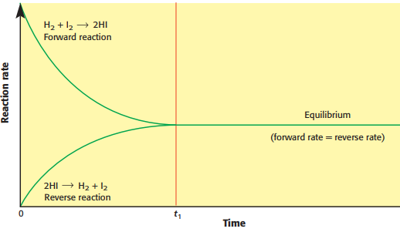When the *rate* of the forward reaction starts to slow down and the rate of the backwards reaction speeds up, there is a point at which those rates will become equal. You will be making products at the same speed you are turning them back into reactants. Examine the graph to the right.

Since this is happening at the same *rate* the *quantity* of reactants and the *quantity* of products is staying the same. This does NOT mean that we have the same amount of reactants as products, the quantities of reactants and products are not necessarily equal, it just means we are “making and breaking” them at the same speed so our overall amounts don’t appear to be fluctuating anymore. Remember – quantity and rate are not the same thing!

**What is Equilibrium?**

The forward and backwards reactions are happening at the same time! It does NOT mean that the reaction comes to a standstill or stops. When the rate of the forward reaction and the rate of the backwards reaction are the same, the reaction is said to be at **equilibrium**. From our perspective it may look like nothing is changing anymore, but if you zoomed in you would see molecules still undergoing the forward and backwards reactions, just at the same rate – you “make one and break one” at the same time.

**Le Chatelier’s Principle**

Once a reaction reaches equilibrium it does not want to be “stressed.” If you “stress” a reaction it will shift where equilibrium lies in order to once again reach a point where the forward and backwards reactions are happening at the same rate. We talk about this as “equilibrium shifting.” It can shift to the right (making more products) or to the left (making more reactants). Le Chatelier’s Principle states that “certain changes to the system will result in predictable and opposing changes in the system in order to achieve a new equilibrium state.” In other words, “whatever you do needs to be undone.”

* Add more of something?
  + Shift away from it to use it up.
* Take something away?
  + Shift towards it to make more of it.

**Stresses that Affect Equilibrium**

You can stress a reaction at equilibrium by changing one or more of the following:

1. Concentration
2. Heat
3. Pressure (only for gases)
4. Volume (which can change concentration and/or pressure)

Increasing the concentration of reactants will “crowd” the reaction with those reactants causing the equilibrium to shift towards the products. Increasing the concentration of products will cause the reaction at equilibrium to shift towards the reactants. $$\underset{←}{\begin{aligned}Add {CO}_{2} \\ Shift to the LEFT to use it up!\end{aligned}}$$

$$H_{2}CO_{3 (aq)}↔CO_{2 (aq)}+ H_{2}O_{ (l)}$$

$$\overset{→}{\begin{aligned}Remove {CO}_{2} \\ Shift to the RIGHT to replace it!\end{aligned}}$$

The effect that a temperature change has will depend on whether the reaction is endo or exothermic. In exothermic reactions we can think of heat like a product, and in endothermic reactions we can think of it like a reactant. If you heat it up, the reaction will shift away from the side with heat in order to use up the extra. If you cool it down, the reaction will shift towards the side with heat to make more of it. $$\underset{←}{\begin{aligned}Remove Heat (cool it down) \\ Shift to the LEFT to make more heat!\end{aligned}}$$

$$2SO_{3 (g)}+ Heat ↔2SO_{2 (g)}+ O_{2 (g)}$$

$$\overset{→}{\begin{aligned}Add Heat \\ Shift to the RIGHT to use it up!\end{aligned}}$$

*Note: Changes in pressure and its effects on reactions at equilibrium will be discussed in class.*

**Question #1:** Why do you think pressure will only affect the equilibrium of gases?

**Question #2:** Using the equation: A + B ↔ C

Which way would equilibrium shift if you:

1. Added more of compound B?
2. Added more of compound C?
3. Took away some of compound A?
4. Which side should you write the heat if it was an exothermic reaction?
5. Assuming exothermic, which way would it shift if you cooled the reaction down?