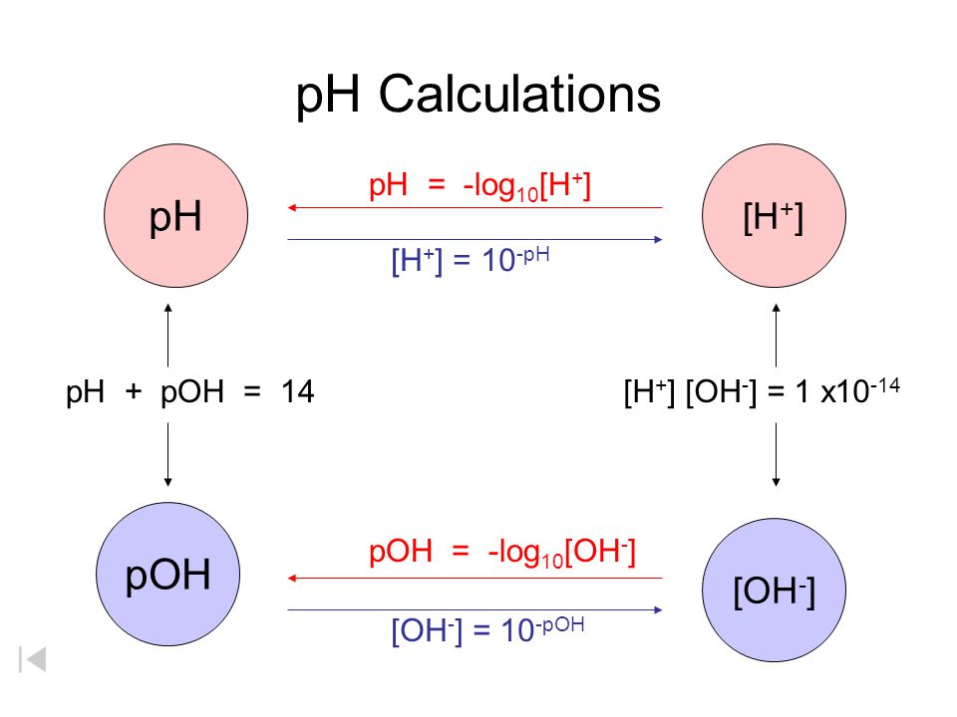

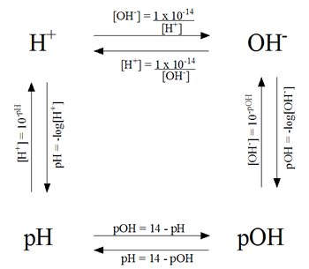

N-46

N-46

|  |  |
| --- | --- |
| **pH = -log [H+]** | **pOH = -log [OH-]** |
| **[H+] = 10-pH** | **[OH-] = 10-pOH** |
| **pH + pOH = 14** | |
| **[H+][OH-] = 1 x 10-14** | |

|  |  |
| --- | --- |
|  |  |
|  |  |
|  | |
|  | |

|  |  |
| --- | --- |
| **pH = -log [H+]** | **pOH = -log [OH-]** |
| **[H+] = 10-pH** | **[OH-] = 10-pOH** |
| **pH + pOH = 14** | |
| **[H+][OH-] = 1 x 10-14** | |





N-46

N-46