Relationship of K_{a}/[H₃O⁺]/pH  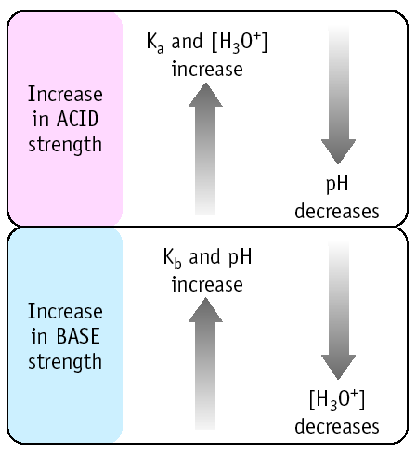 |  | Relationship of K_{a}/[H₃O⁺]/pH
N-48
N-48

Relationship of K_{a}/[H₃O⁺]/pH |  | Relationship of K_{a}/[H₃O⁺]/pH
N-48
N-48

