**Name: Period: Seat#:**

**Worksheet #4**

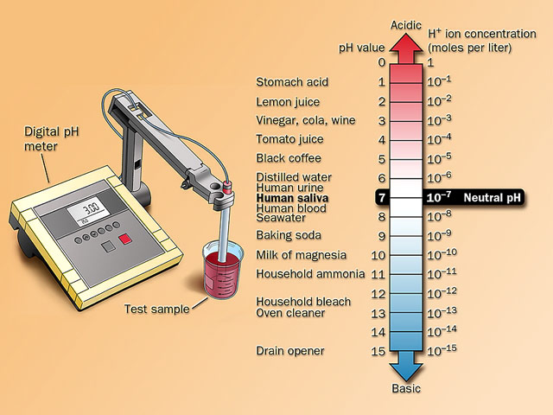**Directions:** Some of the questions on this worksheet you may be able to answer without checking the websites by using prior knowledge or your notes. However, make sure to browse the list of resource websites OR search on Google, so you are aware of what information is available and to make sure you are learning the details as well. Some of this will be new information, and this is an introduction before it is lectured on.

|  |  |  |
| --- | --- | --- |
| **#** | **Resources (don’t forget Google also!)** | |
| 1 | General Acid-Base Information | <https://tinyurl.com/y26v3vtw> |
| 2 | Acid-Base Tutorial & Problems | <https://tinyurl.com/4rwk5b5s> |
| 3 | pH  Information | <https://tinyurl.com/ycfwxaul> |
| 4 | Strong vs. Weak Acids | <https://tinyurl.com/whjn95jr> |
| 5 | Strong vs. Weak Bases | <https://tinyurl.com/3jsmpzs6> |
| 6 | pH Logarithmic Scale | <https://tinyurl.com/28fxu579> |
| 7 | Acid Base Indicators#1 | <https://tinyurl.com/5ca8dmde> |
| 8 | Acid Base Indicators#2 | <https://tinyurl.com/474aj5vw> |
| 9 | Searchable Acid Base FAQ database | <https://tinyurl.com/yp9njyhv> |

1. Define an Acid and a Base.
2. Describe five physical properties, of Acids and of Bases.
3. Give 3 examples of Strong Acids and Bases.

Acids

1.

2.

3.

Bases

1.

2.

3.

1. Acids turn pH paper this color:  
    Bases turn pH paper this color:
2. Go to link 2.
   1. Click on Question #1 – what is the answer?
   2. Click on Question #2 – what is the answer?
3. Why is the pH of an Acid a low number and that of a Base a high number?
4. Why does water have a pH of 7?
5. What do all strong acids and strong bases produce in water?
6. How do you neutralize an acid or a base?
7. How can pH be determined experimentally?
8. How are strong Acids or Bases different then weak Acids or Bases?
9. What reason is there for the double arrow used in weak acid and base dissociation reactions?
10. Why is a single arrow used in strong acid or base dissociation reactions?
11. What is the ratio of H+ or OH- to strong acid or strong base respectively in a dissociation reaction?
12. What is used to measure pH?
13. What is the difference between pH and pOH?
14. What do we call rain with a low pH and why?
15. Describe titration.
16. What is the equivalence point?
17. How is a universal indicator produced?
18. What universal indicator can be made at home?
19. What are the Ka and Kb equations?