**Name: Period: Seat#:**

**Worksheet #8**

**Directions:**

* Use the following information and the chart to help you walk through the thought process that is needed in order to determine if a salt is acidic, basic, or neutral  
  + - Strong Acid $\underset{→}{turns into a}$ Weak Conjugate Base   
       *(not much effect on pH)*
    - Weak Acid $\underset{→}{turns into a}$ Strong Conjugate Base  
       *(potential effect on pH)*
    - Strong Base $\underset{→}{turns into a}$ Weak Conjugate Acid  
       *(not much effect on pH)*
    - Weak Base $\underset{→}{turns into a}$ Strong Conjugate Acid

*(potential effect on pH)*

* + - Ion from a Strong Acid $\underset{→}{makes the sol'n}$ Neutral   
      (*is a weak conj. base*)
    - Ion from a Weak Acid $\underset{→}{makes the sol'n}$ Basic   
      (*is a strong conj. base*)
    - Ion from a Strong Base $\underset{→}{makes the sol'n}$ Neutral   
      (*is a weak conj. acid*)
    - Ion from a Weak Base $\underset{→}{makes the sol'n}$ Acidic   
      (*is a strong conj. acid*)
    - Cation is a charged metal ion, and anion is from a strong acid $\underset{→}{makes a}$ Acidic metal hydrate + Neutral anion - salt is acidic

* + - Neutral + Acidic = Acidic
    - Neutral + Basic = Basic
    - Neutral + Neutral = Neutral
    - Acidic + Basic = ?   
      *Use Ka and Kb to determine* Ka > Kb 🡪 Acidic

Ka < Kb 🡪 Basic  
Ka = Kb 🡪 Neutral

* + - Kw = Ka x Kb Kw = 1.0 x 10-14 (*if at 25 °C, may be different if not at 25°C*)

If you are looking for the Ka of an acidic conjugate ion, use Kw and the Kb of the base it came from

$$K_{acidic conj. ion}= \frac{K_{w}}{K_{b (of the base that the ion came from)}}$$

If you are looking for the Kb of a basic conjugate ion, use Kw and the Ka of the acid it came from

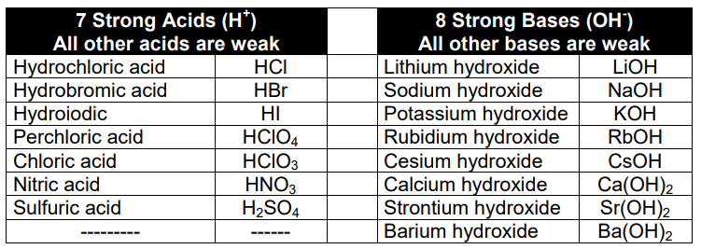

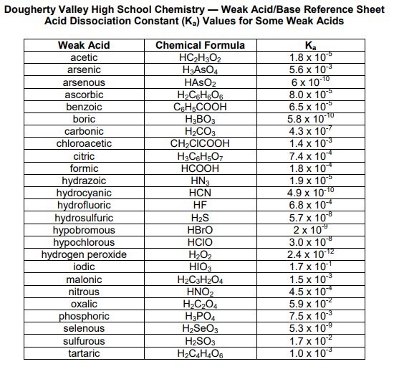

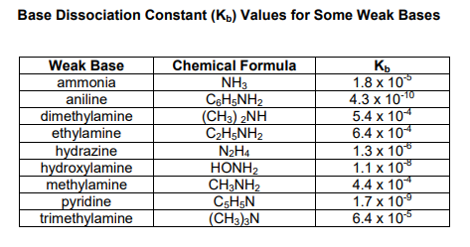 

|  |  |  |  |  |  |  |
| --- | --- | --- | --- | --- | --- | --- |
| **Salt** | | **Cation came from…** | **So Cation is…** | **Anion came from…** | **So Anion is…** | **So Salt is…Acidic, Basic, or Neutral?** |
| NH4CN | | *NH3* | *Acidic* | *HCN* | *Basic* | *Think it through…*  *Ka(ion) < Kb(ion)* |
| *Cation is:*    *NH4+* | *Anion is:   CN-* | *Which is a:*  *Weak base  Kb = 1.8 x 10-5* | *Ka(ion) or Kb(ion) if needed:*  *Ka = (1.0x10-14)/(1.8x10-5)*  *= 5.56 x 10-10* | *Which is a:*  *Weak acid  Ka = 4.9 x 10-10* | *Ka(ion) or Kb(ion) if needed:*  *Kb = (1.0x10-14)/( 4.9x10-10)*  *= 2.04 x 10-5* | *Basic* |
| NaNO2 | | *NaOH* | *Neutral* | *HNO2* | *Basic* | *Think it through…*  *Neutral + Basic* |
| *Cation is:*  *Na+* | *Anion is:*  *NO2-* | *Which is a:*  *Strong base* | *Ka(ion) or Kb(ion) if needed:*  *---* | *Which is a:*  *Weak acid* | *Ka(ion) or Kb(ion) if needed:*  *---* | *Basic* |
| NH4OCl | | *NH3* | *Acidic* | *HOCl* | *Basic* | *Think it through…*  *Ka(ion) < Kb(ion)* |
| *Cation is:*  *NH4+* | *Anion is:*  *OCl-* | *Which is a:*  *Weak base  Kb = 1.8 x 10-5* | *Ka(ion) or Kb(ion) if needed:*  *Ka = (1.0x10-14)/(1.8x10-5)*  *= 5.56 x 10-10* | *Which is a:*  *Weak acid*  *Ka = 3.0 x 10-8* | *Ka(ion) or Kb(ion) if needed:*  *Kb = (1.0x10-14)/( 3.0 x 10-8)*  *= 3.33 x 10-7* | *Basic* |
| CH3NH3CN | | *CH3NH2* | *Acidic* | *HCN* | *Basic* | *Think it through…*  *Ka(ion) > Kb(ion)* |
| *Cation is:*  *CH3NH3+* | *Anion is:*  *CN-* | *Which is a:*  *Weak base*  *Kb = 4.4 x 10-4* | *Ka(ion) or Kb(ion) if needed:*  *Ka = (1.0x10-14)/( 4.4 x 10-4)*  *= 2.27 x 10-11* | *Which is a:*  *Weak Acid*  *Ka = 4.9 x 10-4* | *Ka(ion) or Kb(ion) if needed:*  *Kb = (1.0x10-14)/( 4.9 x 10-4)*  *= 2.04 x 10-11* | *Acidic* |

|  |  |  |  |  |  |  |
| --- | --- | --- | --- | --- | --- | --- |
| **Salt** | | **Cation came from…** | **So Cation is…** | **Anion came from…** | **So Anion is…** | **So Salt is…Acidic, Basic, or Neutral?** |
| KF | | *KOH* | *Neutral* | *HF* | *Basic* | *Think it through…*  *Neutral + Basic* |
| *Cation is:*  *K+* | *Anion is:*  *F-* | *Which is a:*  *Strong base* | *Ka(ion) or Kb(ion) if needed:*  *---* | *Which is a:*  *Weak acid* | *Ka(ion) or Kb(ion) if needed:*  *---* | *Basic* |
| NH4NO2 | | *NH3* | *Acidic* | *HNO2* | *Basic* | *Think it through…*  *Ka(ion) > Kb(ion)* |
| *Cation is:*  *NH4+* | *Anion is:*  *NO2-* | *Which is a:*  *Weak base*  *Kb = 1.8 x 10-5* | *Ka(ion) or Kb(ion) if needed:*  *Ka = (1.0x10-14)/(1.8x10-5)*  *= 5.56 x 10-10* | *Which is a:*  *Weak acid*  *Ka = 4.5 x 10-4* | *Ka(ion) or Kb(ion) if needed:*  *Kb = (1.0x10-14)/( 4.5 x 10-4)*  *= 2.22 x 10-11* | *Acidic* |
| HONH3ClO4 | | *HONH2* | *Acidic* | *HClO4* | *Neutral* | *Think it through…*  *Acidic + Neutral* |
| *Cation is:*  *HONH3+* | *Anion is:*  *ClO4-* | *Which is a:*  *Weak base* | *Ka(ion) or Kb(ion) if needed:*  *---* | *Which is a:*  *Strong acid* | *Ka(ion) or Kb(ion) if needed:*  *---* | *Acidic* |
| Na2CO3 | | *NaOH* | *Neutral* | *H2CO3* | *Basic* | *Think it through…*  *Neutral + Basic* |
| *Cation is:*  *Na+* | *Anion is:*  *CO32-* | *Which is a:*  *Strong base* | *Ka(ion) or Kb(ion) if needed:*  *---* | *Which is a:*  *Weak acid* | *Ka(ion) or Kb(ion) if needed:*  *---* | *Basic* |

|  |  |  |  |  |  |  |
| --- | --- | --- | --- | --- | --- | --- |
| **Salt** | | **Cation came from…** | **So Cation is…** | **Anion came from…** | **So Anion is…** | **So Salt is…Acidic, Basic, or Neutral?** |
| NaBr | | *NaOH* | *Neutral* | *HBr* | *Neutral* | *Think it through…*  *Neutral + Neutral* |
| *Cation is:*  *Na+* | *Anion is:*  *Br-* | *Which is a:*  *Strong base* | *Ka(ion) or Kb(ion) if needed:*  *---* | *Which is a:*  *Strong acid* | *Ka(ion) or Kb(ion) if needed:*  *---* | *Neutral* |
| C6H5NH3Cl | | *C6H5NH2* | *Acidic* | *HCl* | *Neutral* | *Think it through…*  *Acidic + Neutral* |
| *Cation is:*  *C6H5NH3+* | *Anion is:*  *Cl-* | *Which is a:*  *Weak base* | *Ka(ion) or Kb(ion) if needed:*  *---* | *Which is a:*  *Strong acid* | *Ka(ion) or Kb(ion) if needed:*  *---* | *Acidic* |
| LiC2H3O2 | | *LiOH* | *Neutral* | *HC2H2O2* | *Basic* | *Think it through…*  *Neutral + Basic* |
| *Cation is:*  *Li+* | *Anion is:*  *C2H2O2-* | *Which is a:*  *Strong base* | *Ka(ion) or Kb(ion) if needed:*  *---* | *Which is a:*  *Weak acid* | *Ka(ion) or Kb(ion) if needed:*  *---* | *Basic* |
| Na2SO3 | | *NaOH* | *Neutral* | *H2SO3* | *Basic* | *Think it through…*  *Neutral + Basic* |
| *Cation is:*  *Na+* | *Anion is:*  *SO32-* | *Which is a:*  *Strong base* | *Ka(ion) or Kb(ion) if needed:*  *---* | *Which is a:*  *Weak acid* | *Ka(ion) or Kb(ion) if needed:*  *---* | *Basic* |

|  |  |  |  |  |  |  |
| --- | --- | --- | --- | --- | --- | --- |
| **Salt** | | **Cation came from…** | **So Cation is…** | **Anion came from…** | **So Anion is…** | **So Salt is…Acidic, Basic, or Neutral?** |
| K2C2O4 | | *KOH* | *Neutral* | *H2C2O4* | *Basic* | *Think it through…*  *Neutral + Basic* |
| *Cation is:*  *K+* | *Anion is:*  *C2O42-* | *Which is a:*  *Strong base* | *Ka(ion) or Kb(ion) if needed:*  *---* | *Which is a:*  *Weak acid* | *Ka(ion) or Kb(ion) if needed:*  *---* | *Basic* |
| NaOBr | | *NaOH* | *Neutral* | *HOBr* | *Basic* | *Think it through…*  *Neutral + Basic* |
| *Cation is:*  *Na+* | *Anion is:*  *OBr-* | *Which is a:*  *Strong base* | *Ka(ion) or Kb(ion) if needed:*  *---* | *Which is a:*  *Weak acid* | *Ka(ion) or Kb(ion) if needed:*  *---* | *Basic* |
| (CH3NH3)H2PO4 | | *CH3NH2* | *Acidic* | *H3PO4* | *Basic* | *Think it through…* |
| *Cation is:*  *CH3NH3+* | *Anion is:*  *HPO42-* | *Which is a:*  *Weak base*  *Kb = 4.4 x 10-4* | *Ka(ion) or Kb(ion) if needed:*  *Ka = (1.0x10-14)/( 4.4 x 10-4)*  *=2.27 x 10-11* | *Which is a:*  *Weak acid*  *Ka = 7.5 x 10-3* | *Ka(ion) or Kb(ion) if needed:*  *Kb = (1.0x10-14)/( 7.5 x 10-3)*  *=1.33 x 10-12* |  |
| NH4I | | *NH3* | *Acidic* | *HI* | *Neutral* | *Think it through…*  *Acidic + Neutral* |
| *Cation is:*  *NH4+* | *Anion is:*  *I-* | *Which is a:*  *Weak base* | *Ka(ion) or Kb(ion) if needed:*  *---* | *Which is a:*  *Strong acid* | *Ka(ion) or Kb(ion) if needed:*  *---* | *Acidic* |

|  |  |  |  |  |  |  |
| --- | --- | --- | --- | --- | --- | --- |
| **Salt** | | **Cation came from…** | **So Cation is…** | **Anion came from…** | **So Anion is…** | **So Salt is…Acidic, Basic, or Neutral?** |
| KNO2 | | *KOH* | *Neutral* | *HNO2* | *Basic* | *Think it through…*  *Neutral + Basic* |
| *Cation is:*  *K+* | *Anion is:*  *NO2-* | *Which is a:*  *Strong base* | *Ka(ion) or Kb(ion) if needed:*  *---* | *Which is a:*  *Weak acid* | *Ka(ion) or Kb(ion) if needed:*  *---* | *Basic* |
| C2H5NH3Cl | | *C2H5NH2* | *Acidic* | *HCl* | *Neutral* | *Think it through…*  *Acidic + Neutral* |
| *Cation is:*  *C2H5NH3+* | *Anion is:*  *Cl-* | *Which is a:*  *Weak base* | *Ka(ion) or Kb(ion) if needed:*  *---* | *Which is a:*  *Strong acid* | *Ka(ion) or Kb(ion) if needed:*  *---* | *Acidic* |